Agency – “…the fiduciary relationship that arises when one person (a “principal”) manifests assent to another person (an “agent”) that the agent shall act on the principal’s behalf and subject to the principal’s control, and the agent manifests assent or otherwise consents so to act.” (R3A § 1)
  - Manifestation – an objective, observable action; inference that the principal faces a lot of exposure (won’t be liable if don’t manifest)

Liability of Principal to Third Parties in Contract –
RULE: a principal is liable to third parties who are injured by breaches of contracts entered into by an agent acting w/in the scope of the agency. (Cargill)
To Rebut an Agency Relationship – supply alternative relationship (see Cargill where failed).

Gay Jensen Farms v. Cargill – farmers who sold grain to Gay Jenson (Warren) going after Cargill for payment. Outcome – agency relationship found b/c (i) contractual relationship; (ii) effectively a purchasing intermediary/agent for Cargill; (iii) control.

(1) Actual Authority –
RULE – “An agent acts with the actual authority when, at time of taking action that has legal consequences for principal, agent reasonably believes, in accordance with principal’s manifestations to agent, that the principal wishes the agent to so act.” (R3A §2.01).
- Power expressly or implicitly conferred by principal.
- Mill Street Church – Outcome – Bill acted w/ actual authority b/c he reasonably believed that he had the authority to hire Sam, means Sam is employee of the church and eligible for Workman’s Comp.

(2) Apparent Authority –
RULE – “Apparent authority is the power held by an agent or other actor to affect a principal’s legal relations with third parties when a third party reasonably believes the actor has authority to act on behalf of the principal and that belief is traceable to the principal’s manifestations.” (R3A §2.03).
- Three-Seventy Leasing v. Ampex – Kays, employee of Ampex, made agreement with 370 for sale of computers. Outcome – Kays acted w/in scope under apparent authority, contract is binding.

(3) Undisclosed Principal –
RULE - “An undisclosed principal is subject to liability to third party who is justifiably induced to make a detrimental change in position by an agent acting on the principal’s behalf and without actual authority, if the principal, having notice of the agent’s conduct and that it might induce others to change their positions, did not take reasonable steps to notify them of the facts.” (R3A §2.06(1)).
- Liability of undisclosed principal limited to activities usually done by agent of that business in the course of that business.
- Watteau v. Fenwick – Outcome Humble found to be acting as agent of Fenwick when purchased Bovril and cigars.

(4) Ratification –
RULE – “(1) Ratification is affirmance of a prior act done by another, whereby the act is given effect as if done by an agent acting with actual authority; (2) A person ratifies an act by (a) manifesting assent that the act shall affect the person’s legal relations, or (b) conduct that justifies a reasonable assumption that the person so consents.” (R3A §4.01).
- Botticello v. Stefanovicz – Husband and wife tenants in common and leased land to Botticello w/ option to purchase. Outcome – wife found not to have ratified.

(5) Estoppel –
RULE – “A person who has not made a manifestation that an actor has authority as an agent and who is not otherwise liable as a party to a transaction purportedly done by the actor on that person’s account is subject to liability to a third party who justifiably is induced to make a detrimental change in position because the transaction is believed to be on the person’s account if (1) the person intentionally or carelessly caused such belief; or (2) having notice of such belief and that it might induce others to change their positions, the person did not take reasonable steps to notify them of the facts.” (R3A §2.05).
- Hoddeson v. Koos Brothers – unsophisticated person buys furniture from distinguished-looking man who turns out not to be a salesman. Outcome – court found that store had acted in a way to imply Koos was a salesman by not checking who he was, store has duty to make sure no fake salesmen in store.

Liability of Agent (NOT Principal) for Contracts Negotiated on Behalf of Principal –

Disclosed Principals: “Unless otherwise agreed, a person making or purporting to make a contract with another as agent for a disclosed principal does not become a party to the contract.” (R2 § 320)
- Risk/cost sharing reasons, etc.; principals are better cost bearers

Undisclosed Principals: “An agent purporting to act upon his own account, but in fact making a contract on account of an undisclosed principal, is a party to the contract.” (R2 § 322)
- Makes sense to have agents personally liable, cost is low to agent b/c can just disclose the principal (harder for principal to avoid liability), agents are better cost bearers

Partially Disclosed Principals: “Unless otherwise agreed, a person purporting to make a contract with another for a partially disclosed principal is a party to the contract.” (R2 §321)
- Both parties can easily protect themselves – third party has someone (agent) on the hook, agent could just reveal principal and disclaim any liability and fall under R2A §320.
- Atlantic Salmon v. Curran – Agent held self out as representative of the principal (non-existent or dissolved at some point, defendant maintained false records and advertisements). Outcome – court held agent personally liable because was unreasonably difficult for third party to figure out who the partially disclosed principal is.

Liability of Principal to Third Parties in Tort –
RULE: principal can be sued when agent acting w/in scope of agency harms a third party. Third party has claims against both agent and principal. (Gordon v. Doty)

Gordon v. Doty – teacher lent car to coach to get kids to game, car crash. Outcome – coach found to be agent of teacher, so teacher as principal also liable to third party.

(1) Liability of Franchisors – master/servant relationship vs. independent contractor relationship.
RULE - Look to level of day-to-day operational control exercised by the alleged principal (franchisor / master / employer). Look to whether the alleged principal had any control / ability to prevent the conduct leading to the tort claim. Identify any Dark Matter.

Humble Oil v. Martin – woman leaves car at gas station, car rolls and injures someone. Outcome – liability for franchisor (Humble), factors indicated Humble had “enough” control to make Schneider an employee/agent.

Hoover v. Sun Oil – gas station fire due to smoking, Outcome – no liability for franchisor (Sun Oil) since franchisee usually has control over employee actions. See appendix for factors for and against franchisor liability.

Murphy v. Holiday Inns – person hurt slipping on water from air conditioners. Outcome – no liability for franchisor (Holiday Inns). See appendix for factors for and against franchisor liability.

(2) Tort Liability and Apparent Agency – “One who represents that another is his servant or other agent and thereby causes a third person justifiably to rely upon the care or skill of such apparent agent is subject to liability to the third person for harm caused by the lack of care or skill of the one appearing to be a servant or other agent as if he were such.” (R2A §267).

Miller v. McDonald’s Corp – OUTLIER. Person finds jewel in hamburger. Court looked to R2A §267 (apparent agency in tort): if principal creates the appearance that someone is his agent and a third party deals with them under this appearance and gets injured then principal is liable. Outcome – liability for franchisor an extension of the franchisor/franchisee system to say that mere creation of a franchise implies that all employees are competent under R2 §267.

(3) Scope of Employment (Torts) –

Traditional Doctrine – Is conduct of employee within scope of his employment? If yes, then employer liable. “Conduct of servant is w/in the scope of employment if, but only if,
(a) it is of the kind he is employment to perform;
(b) it occurs substantially w/in the authorized time and space limits;
(c) it is actuated, at least in part, by a purpose to serve the master;
(d) if force is intentionally used by the servant against another, the use of force is not unexpectable by the master.” (R2A §228(1))

Manning v. Grimsley – Manning heckles Grimsley (Oriole’s pitcher) prior to game, Grimsley deliberately throws pitch at Manning and injures him. Outcome – Even though employer (Orioles) didn’t sanction Grimsley’s action, Orioles liable under 228(1)(d).
- MA Rule – “What must be shown is that the employee’s assault was in response to the plaintiff’s conduct, which was presently interfering with the employee’s ability to perform his duties successfully.”

Strict Liability – “A business enterprise cannot justly disclaim responsibility for accidents which may fairly be said to be (ii) characteristic of its activities.”
- Bushey v. US – drunk sailor turned valves on dry dock and damaged ship. Outcome – US found liable: although actions were not w/in scope of employment, employer (US) could have (i) foreseen that sailor would behave this way.

(4) Scope of Employment (Statutory Claims)
RULE – “An employee acts w/in the scope of employment when performing work assigned by the employer or engaging in a course of conduct subject to the employer’s control. An employee’s act is not within the scope of employment when it occurs within an independent course of conduct not intended by the employee to serve any purpose of the employer.” (R3A §707(2))

Case Law Factors to Determine Scope of Employment – (Arguelo v. Conoco)
(i) The time, place and purpose of the act.
(ii) The act’s similarity to the other acts which are authorized for the employee.
(iii) Whether the act is commonly performed by employees.
(iv) The extent of departure from normal methods.
(v) Whether the employer would reasonably expect the act to occur.

Arguello v. Conoco – Was discrimination within scope of employees’ employment? Outcome – court found employer could not have expected slurring to occur, under R3A §707(2).

(5) Liability for Torts of Independent Contractors –
RULE: Counterparties are not (generally) liable for torts of independent contractors committed in scope of contract. BUT Counterparties are liable if:
- (i) Counterparty retains control of job
- (ii) Counterparty selects an incompetent contractor
- (iii) Job is nuisance per se (inherently dangerous) (ensures have someone to compensate high judgment if contractor is not sufficiently solvent, can impose incentive to monitor)

Considerations –control, expertise, monitoring cost, sharing liability.

Majestic Realty Associates – Parking Authority hired contractor, contractor miss-swung wrecking ball and the falling building damaged someone else’s building. Outcome – contractor was negligent and liable, Parking authority also liable under (iii) above.

Fiduciary Obligations of Agents (liability of Agent to Principal) –
(1) Two possible claims against Agent –

Contractual Liability – “A person who makes a contract with another to perform services as an agent for him is subject to a duty to act in accordance with his promise.” (R2A §377)

Tort Liability – tort for breach of fiduciary relationship (duty of care or duty of loyalty), higher damages than in contracts.

(2) Agent’s Duty of Care – also exists as part of a contract.
“An agent must:
- act with care and skill
- not bring disrepute on principal
- keep principal reasonably informed
- keep and render accounts
- not act beyond the scope of the agency.” (R2A §379-383)

(3) Agent’s Duty of Loyalty –
“An agent must:
- give profits to principal
- not act for an adverse party
- not compete with principal
- not use or disclose confidences.” (R2A §387-396)
when have high cost of harm, then place large duty on agent for disclosure. Line is whether company will take advantage of / use opportunity if agent discloses. (Rash)

Business Opportunity Doctrine – “An agent shall not misappropriate a business opportunity belonging to the principal.”
- Policy for – employers spend resources to develop opportunities, worry that they will underinvest in generating opportunities if employees can take them, worry they may underinvest in training employees.
- Policy against – need for flexibility, competition, job mobility.

Reading v. Regem (1944, English case): plaintiff is sergeant in British army, was paid by civilians to transport things via lorry across lines while wearing his sergeant uniform. Outcome – activity while wearing uniform “…violates his duty of honesty and good faith to make a profit for himself…”

Rash v. JV Intermediate: Rash works for JV Intermediate and has authority to hire contractors. Rash starts scaffolding company and picks himself for a corporate opportunity. JV Intermediate had own scaffolding company that was never picked. Outcome – liability for Rash under violation of business opportunity doctrine / duty of loyalty.
- HYPO – what if Rash’s bid was lower? Still not okay, cost to company of redundant business vs. cost to agent of disclosure of conflict.

(4) Liability after Termination of Agency Relationship (Grabbing and Leaving) –
RULE – Investments in training and conspiring w/ other employees to leave while not on company’s time are not protected (job mobility concerns). Information/trade secrets are protected (here: customer lists).

Town & Country v. Newberry: Town & Country was cleaning service, defendants left T&C and created own service. Outcome (1) – okay that engaged in meetings (i.e. conspiracy), permitted to talk to other employees to leave en mass (job mobility concerns), provided that don’t do on company time. Outcome (2) – not okay that Newberry used customer list. Issue with taking work product of former employer, not with leaving and competing.

Partnerships – “…an association of two+ persons to carry on (activity of business) as co-owners of a business for profit.” (Uniform Partnership Act (UPA) §6(1)). Easy to fall into without knowing, don’t need state approval.

Other Factors Bearing on Existence of Partnership – (Fenwick v. Unemp. Comp. Commission)
- agreement of the parties
- sharing of profits
- sharing of losses
- sharing on dissolution
- sharing of management
- holding out to third parties
- policies of applicable law
Intent – want to give businessmen opportunity to structure businesses as they want, but also to protect third parties from detrimental reliance from “holding out.”

(1) Partner or Employee? –

Co-Ownership? –
- Share in management?
- Share in losses?
- Share on dissolution?
- Share in profits?
- “The receipt by a person of a share of the profits of a business is prima facie evidence that he is a partner in the business, but no such inference shall be drawn if such profits were received in payment…as wages of an employee…” (UPA 7(4)(b))

Fenwick v. Unemployment Compensation Committee – Outcome – court holds cashier is not a partner: demonstrated intent (tax filings, title of agreement), has all elements of UPA 6(1) EXCEPT co-ownership, only shares in profits BUT UPA 7(4)(b).

(2) Partner or Lender? –
RULE – “All partners are liable…jointly for all debts and obligations of the partnership.” (UPA 15(b))

Martin v. Peyton - Investment bank fails. Friends lend good securities in exchange for promises. Outcome – Court held that friends were lenders NOT partners, and so not liable. Factors: had agreement, shared in profits, indirectly shared in losses, don’t know about dissolution, BUT management powers deemed not a share of management (deemed creditor relationship).

Partner or Independent Contractor?

Southex v. RIBA – Southex wants to renegotiate contract, RIBA wants out of contract. Outcome – Court found RIBA could get out of contract. Factors: preamble says are partners, title is not “Partnership Agreement.” Shared key management but SEM managed decisions on ground. Didn’t file partnership tax return. SEM entered contracts on its own name and not on behalf of partnership (didn’t “hold out”).

(3) Partnership by Estoppel –

RULE (OLD) – “When a person by words spoken or written or by conduct, represents himself, or consents to another representing him to any one, as a partner in an existing partnership or with one or more persons not actual partners, he is liable to any such person to whom such representation has been made, who has, on the faith of such representation, given credit to the actual or apparent partnership…” (UPA 16(1))

Young v. Jones – Outcome – Court found PwC not a partner per UPA 16(1) to PW-Bahamas so not liable. (Counterargument is “hold out” by reputation, but was rejected).

RULE (NEW) – “If a person, by words or conduct, purports to be a partner, or consents to being represented by another as a partner, in a partnership or with one or more persons not partners, the purported partner is liable to a person to whom the representation is made, if that person, relying on the representation, enters into a transaction with the actual or purported partnership…” (RUPA §308(a) Liability of Purported Partner)

Fiduciary Obligations of Partners –
RULE – “A partner’s duty of loyalty to the partnership and the other partners is limited to:
- to account to the partnership [for] any property, profit, or benefit derived by the partner in the conduct [of the partnership business;
- to refrain from dealing with the partnership…as or on behalf of a party having an interest adverse to the partnership; and
- to refrain from competing with the partnership…before the dissolution of the partnership.” (UPA §404(b))

Meinhard v. Salmon – Outcome – Courts find breach of fiduciary duty and hold partnership duty to high standard. DISSENT: was one-time financing deal that Salmon provided Meinhard, no intention to go beyond that and second deal was different land parcel. “Punctillio, finest loyalty”

(1) Joint Ventures
Essentially the same as partnership BUT is easier to find JV, the duties imposed on JV focus on what the JV does.

Elements:
- contribution to a joint undertaking;
- a proprietary interest or right of mutual control;
- an agreement to share profits (and maybe losses);
- an express or implied contract.

Sandvick v. Lacross - oil/gas lease top-lease. Outcome – Court finds no partnership but finds JV w/ fiduciary duties. Factors: satisfies every element of partnership except that activity is not a business, men were in venture together and had expropriation of opportunity so fiduciary duty invoked. Dark Matter that court wanted to find a duty but partnership didn’t exist, is not clear why decided was JV and not partnership.

(2) Fiduciary Duties and Partnership Break-Ups –

Grabbing and Leaving –

Meehan v. Shaughnessy – two law firm partners. Outcome – Court found violation of duty of loyalty. Factors: (i) lied to partners about not leaving and continued to use firm letterhead (problematic but not unlawful); (ii) didn’t give former partners a chance to compete w/ them for clients (solicited clients before firm could and delayed giving firm the client list); (iii) didn’t give clients appropriate choice of firms, gave impression that they only had one option.

Expulsion –

Lawlis v. Knichtlinger & Gray – alcoholic law firm partner. Outcome – Court found the partnership agreements trumps any fiduciary duty and partners followed terms of agreement w/r/t firing.

Partnership Property –

RULES (OLD) –
- “The property rights of a partner are (1) his rights in specific partnership property, (2) his interests in the partnership, and (3) his right to participate in the management.” (UPA §24)
- A partner is a “co-owner with his partners of specific partnership property holding as a tenant in partnership.” (UPA §25(1))

RULES (NEW) – no such thing as right in specific partnership property.
- “A partnership is an entity distinct from its partners.” (RUPA §201(a))
- “Property acquired by a partnership is property of the partnership and not of the partners individually.” (RUPA §203)
- “A partner is not a co-owner of partnership property and has no interest in partnership property which can be transferred, either voluntarily or involuntarily.” (RUPA §501)
- “A partner may use or possess partnership property only on behalf of the partnership.” (RUPA §401(g))

Putnam v. Shoaf – (illustration of evolution of partnership property law) Outcome – Court holds that widow has no right to judgment “The right in ‘specific partnership property’ is the partnership tenancy…there’s no such thing as ‘right in specific partnership property.”

Partners’ Rights in Management –

CL / Default Rule– partners have right to manage (if want, then must put in partnership agreement). If no CL rule and is not in the agreement, then…

Ordinary Course of Business and Everyone Agrees Equality
  - UPA §18(e): “All partners have equal rights in the management and conduct of the partnership business.”
  - RUPA §401(f): “Each partner has equal rights in the management and conduct of the partnership business.”
- Equality – all partners have ability to bind the partnership
  - Advantage low transaction costs
  - Disadvantage risk of liability from other partners, chaos

Ordinary Course of Business and Not Everyone Agrees Majority Vote
  - UPA §18(h): Any different arising as to ordinary matters connected with the partnership business ay be decided by a majority of the partners…”
  - RUPA §401(j): “A difference arising as to a matter in the ordinary course of business of a partnership may be decided by a majority of the partners.”
- Unanimity – requires all partners to agree
  - Advantage protected against disagreeable liability
  - Disadvantage deadlock, holdout to extract additional benefits, transaction cost

Not in Ordinary Course of Business and Not Everyone Agrees Unanimity
  - Deadlock/holdout less concerning here b/c business can still continue during deliberation.
  - RUPA §401(j): “An act outside the ordinary course of business of a partnership… may be undertaken only with the consent of all the partners.”
- Majority Vote – must have majority
  - Advantage lower holdout threat, medium protection from liability
  - Disadvantage oppression of minority partners

NBISCO v. Stroud – no partnership agreement (so court applies background rule for two-partner partnership of equal voting rights). Outcome – Court holds that given two-person partnership, each partner has equal power (imposing unanimity would have collapsed the business), NBISCO contract enforced. Resulting RULE: if have deadlock on ordinary decision, impose equality.

Summers v. Dooley – two-person waste collecting business w/ no partnership agreement (so CL applies). Outcome – Court holds partnership does not have to pay third guy’s wages b/c decision to hire is outside ordinary course of business so unanimity applies.

Partnership Agreement and Management Decisions –

Day v. Sidley & Austin – Outcome – Court finds Day has no rights against Sidley Austin for (i) fraudulent misrepresentation claim, or (ii) breach of fiduciary duty claim: Day was sophisticated party who had signed partnership agreement and wasn’t made “worse off.”

Advantages of Management/Executive Committee –
- Efficiency – don’t need several hundred partners voting on what copy paper brand to buy.
- Delegation of Authority – take best managers for committee.
- Fairness – no one person calling shots, lower resentment between partners if committee has trust.

Dissolution and Disassociation – business ends and affairs wind up.

Two Ways a Partnership Can Break-Up –
- Dissolution – entire partnership is dissolved
- Disassociation – one or more partners leaves but partnership continues

(1) Dissolution by Partners –

RUPA §801(1): “A partnership is dissolved, and its business must be wound up, only upon the occurrence of any of the following events: (1) in a partnership at will, the partnership’s having notice from a partner…of that partner’s express will to withdraw as a partner;
  - Partnership At-Will – if any partner wants to discontinue, then he has right to withdraw unless withdrawal is considered in bad faith.

RUPA §801(2)(iii) “[I]n a partnership for a definite term or particular undertaking, [the partnership dissolves upon] the expiration of the term or the completion of the undertaking;
  - §801(2)(ii) “I]n a partnership for a definite term or particular undertaking, [the partnership dissolves upon] the express will of all the partners to wind up the partnership business;

RUPA §801(4): “I]n a partnership for a definite term or particular undertaking, [the partnership dissolves upon] an event that makes it unlawful for all or substantially all of the business of the partnership to be continued…but a cure of illegality within 90 days after notice to the partnership of the event is effective retroactively to the date of the event for purposes of this section.”

(2) Dissolution by Court –

RUPA §801(5): “[I]n a partnership for a definite term or particular undertaking, [the partnership dissolves] on application by a partner, [by] a judicial determination that:
  - (i) the economic purpose of the partnership is likely to be unreasonably frustrated (Collins v. Lewis);
  - (ii) another partner has engaged in conduct relating to the partnership business which makes it not reasonably practicable to carry on the business in partnership with that partner (Owen v. Cohen); or
  - (iii) it is not otherwise reasonably practicable to carry on the partnership business in conformity with the partnership agreement.
  - Policy for judicial intervention – limits risk OF WHAT??, limits litigation costs.
  - Policy against judicial intervention – hard to determine who is right/wrong.

UPA §321(1)(e): “A court may order dissolution if ‘the economic purpose of the partnership can only be carried on at a loss.”

Collins v. Lewis – Lewis manages cafeteria, Collins needed him to do the renovations. Seems like Collins just wants to squeeze Lewis out. Outcome – Court invokes UPA §321(1)(e), UPA §801(5)(i) (above) and finds for Lewis and that conditions for dissolution not established b/c jury didn’t find business unable to make a profit (found that Collins was preventing it from profiting).

Owen v. Cohen – partners open profitable bowling alley. Outcome – Court found “bad” partner not doing anything but extreme examples of ordinary office irritations (see RUPA §801(5)(ii)).
- “[t]rifling and minor differences and grievances which involve no permanent mischief will not authorize a court to decree a dissolution of a partnership. But courts of equity may order dissolution of a partnership where there are quarrels and disagreements of such a nature and to such extent that all confidence and cooperation between the parties has been destroyed or where one of the parties by his misbehavior materially hinders a proper conduct of the partnership business.”

(3) Dissociation by One Partner –

Rests on Entity Theory of Partnership.

RUPA §601: “A partner is dissociated [by]:
- (1) the partnership’s having notice of the partner’s express will to withdraw…;
- (2) an event agreed to in the partnership agreement…;
- (3) the partner’s expulsion pursuant to the partnership agreement;
- (4) the partner’s expulsion by the unanimous vote of the other partners [if certain conditions are met];
- (5) the partner’s expulsion by judicial determination…;
  - (iii) “the partner engaged in conduct relating to the partnership business which makes it not reasonably practicable to carry on the business in partnership with the partner.”
  - (i) “the partner engaged in wrongful conduct that adversely and materially affected the partnership business.”
- (6) the partner’s [insolvency];
- (7) …the partner’s death [or incompetence];…

Giles v. Giles Land Co. – family decides to get rid of difficulty guy, Outcome – court invokes RUPA §601(5)(iii) and (i): changing business structure is not in ordinary course of business so Kelley would be able to frustrate it unreasonably, is not illegal to make people cry but it is wrongful.

(4) The Winding Up Process –
- Consolidate the assets
  - Usually need a receiver
- Liquidate the assets
  - Typically sold at judicial sale (“Sheriff’s Sale”) where court acts as auctioneer.
  - Prentiss v. Sheffel.
- Pay off claimants in order of priority
  - Creditors > remaining lawsuits against partnership > partners themselves.

Prentiss v. Sheffel – Can partners purchase assets of partnership in dissolution sale? Outcome/RULE – no rule against partnership purchasing assets of a partnership unless specifically set out in a partnership agreement.

(5) Wrongful Dissolution of Partnership / Remedies for Breach of the Partnership Agreement –

Rights of Partners to Application of Partnership Property –
UPA §38(2)(a)(II): “When dissolution is caused in contravention of the partnership agreement…each partner who has not caused dissolution wrongfully shall have…the right, as against each partner who has cause the dissolution wrongfully, to damages for breach of the agreement.”

UPA §38(2)(b): “The partners who have not caused the dissolution wrongfully, if they all desire to continue the business in the same name…may do so…provided they…pay to any partner who has caused the dissolution wrongfully, the value of his [or her] interest in the partnership at the time of dissolution, less any damages.”

UPA §38(2)(c)(II): “If the business is continued…[a partner who has caused the dissolution wrongfully shall have] the value of his interest in the partnership, less any damages caused to his co-partners by the dissolution, ascertained and paid to him in cash…but in ascertaining the value of the partner’s interest the value of the good-will of the business shall not be considered.”

Valuing Assets of Dissociated Partner –
OLD RULE – If the business is continued, the partner who has caused the dissolution wrongfully shall have the value of his interest in the partnership, less any damages caused to his co-partners by the dissolution, ascertained and paid to him in cash…but in ascertaining the value of the partner’s interest, the value of the good will of the business shall NOT be considered. (UPA §38)
- Policy for excluding: extremely hard to value. Good will – intangible – what is not measured on the books – e.g. reputation

NEW RULE – RUPA §701 Purchase of Dissociated Partner’s Interest: “(a) If a partner is dissociated from a partnership without resulting in a dissolution…, the partnership shall cause the dissociated partner’s interest in the partnership to be purchased for a buyout price determined pursuant to subsection (b).
- (b) The buyout price of a dissociated partner’s interest is the amount [of his or her partnership share] if, on the date of the dissociation, the assets of the partnership were sold at a price equal to the greater of the liquidation value of the value based on a sale of the entire business as a going concern without the dissociated partner and the partnership were wound up as of that date.”

Pav-Saver Corp v. Vasso Corp – unusual case because the blackletter law is trumping the Partnership Agreement which is very rare; typically the patents would have been returned as specified in the Partnership Agreement. Rule – UPA § 38. Analysis – Pav-Saver’s termination of partnership was wrongful; since this the case, Vasso can continue on in the partnership. Since Vasso needs the patents to continue on, they can use it regardless of what the agreement says about returning the patent property after dissolution of the partnership. Outcome – Vasso can continue the partnership until stated date in contract because of wrongful termination of partnership by Pav-Saver.
- WARNING: Overturned by New Rule § 701 above which includes the “good will”

(6) The Sharing of Losses –
RULE – “Each partner…must contribute towards the losses…sustained by the partnership according to his [or her] share of the profits.” (UPA §18(a))
- “Each partner is…chargeable with a share of the partnership losses in proportion to the partner’s share of the profits.” (RUPA §401(b))

Kovacic v. Reed – (outdated, very minority) Does a partner who provides the labor need to contribute to losses in proportion to his interest in future profits? Current Rule: both laboring and capital partners need to pony up money if have losses. Outcome – Court holds Reed (the laborer) doesn’t have to pay.

(7) Buy-Out Agreements – an agreement that allows a partner to end the relationship with the other partners and receive a cash payment or series of payments, or some assets of the firm, in return for his interest in the firm (typically included in partnership agreements). (CB 152-3).

RULE – In the interest of continuity of the partnership, it is agreed that upon the death, retirement, insanity, or resignation of one of the general partners…the surviving or remaining partners may continue in the partnership business. In the event that the surviving partners continue the partnership business, he or she shall purchase the interest of the retiring or resigning partner. (UPA §38)

FORMULA – (G&S Investments v. Belman) Resigning partner’s capital account + an amount equal to the average of the prior three years’ profits and gains actually paid to the general partner, or as agreed upon by the general partners, provided the agreed sum does not exceed the calculable amount.”
- Capital account amount = the original value of the land, not the economic value which would include any gains and losses.

G&S Investments v. Belman – deceased partner and was addicted to cocaine. Outcome – Nordale subject to the buy-out formula above – illustrates how problems of partners leaving and problems of sharing losses are addressed through partnership agreements. Partnership agreement was upheld.

Corporations –

Formation of Corporations – requires Secretary of State approval.
RULE – “A corporation may be incorporated or organized under this chapter to conduct or promote any lawful business or purposes…” (DGCL §101(b))

(1) Powers of a Corporation –

“[E]very corporation, its officers, directors and stockholders shall possess and may exercise all the powers and privileges granted by this chapter or by any other law or by its certificate of incorporation, together with any powers incidental thereto, so far as such powers and privileges are necessary or convenient to the conduct, promotion or attainment of the business or purposes set forth in its certificate of incorporation.” (DGCL §121(a))

DGCL §§121-2 (partial list):
- Have perpetual life; sue and be sued; hold and deal in real property or personal property; appoint officers and agents, adopt, and repeal bylaws; wind up and dissolve itself; conduct business, carry on operations, have offices and exercise powers; transact lawful business; make contracts

(2) Governance of a Corporation –

Internal Governance –

“The CERTIFICATE OF INCORPORATION (DGCL §102(a))
- Need shareholder consent to amend. (DGCL §109(a))

“The BYLAWS may contain any provision, not inconsistent with law or with the certificate of incorporation, relating to the business of the corporation, the conduct of its affairs, and its rights or powers or the rights or powers of its stockholders, directors, officers or employees.” (DGCL §109(b))
- Shareholders may adopt/amend, directors may adopt/amend if allowed by charter (a common DE corp provision) (DGCL §109(a))

Boilermakers Local 154 v. Chevron – directors amend bylaws to add forum selection clause w/r/t litigation about “internal affairs.” Outcome – Court held though case on face only upholds the power of directors to amend bylaws, in reality it seemingly upheld forum selection bylaws clauses.
  - Does § 109(b) also allow two-way fee shifting bylaws? general revulsion.

The Corporate Entity and Limited Liability (Piercing the Corporate Veil) –

(1) Limited Liability – “The Law permits the incorporation of the business for the very purpose of enabling its proprietors to escape personal liability.” (Walkovsky).

(2) Piercing the Veil –
RULE – “[C]ourts will disregard the corporate form…whenever necessary ‘to prevent fraud or to achieve equity’… In determining whether liability should be extended to reach assets beyond those belonging to the corporation, we are guided… ‘by general rules of agency.’” (Walkovsky)

TEST (from Van Dorn via Sea-Land Services, present in Walkovsky)

(i) There is a unity of interest and ownership such that separate personalities of the corporation and individual no longer exist (owner can’t distinguish between himself and corporation).
- Corporate records/formalities
- Comingling of funds/assets
- Undercapitalization
- One corporation treats the assets of another as its own.
Essentially penalizing sloppy people and providing full employment for attorneys and accountants.

(ii) Not piercing the veil would sanction a fraud or promote injustice (court essentially says, “has to be something bad,” dark matter of bad behavior).

Walkovsky v. Carlton – Taxi Company Case. Outcome – Court found can’t get at Carlton’s assets (though may be able to reverse veil pierce to get to other companies). Evaluating issue in context of agency businesses were essentially acting for Carlton.
- Dissent – May be held personally responsible for such liabilities. (relied on undercapitalization).
  - BUT majority said legislature mandated $10k capital minimum and judges can’t say otherwise.

Sea-Land Services Inc. v. Pepper Source – Pepper Source doesn’t pay bill, Marchese using several corporate funds as his own. Court remanded for evidence of fraud (and ended up finding fraud). Outcome – Court provides Van Dorn Test, veil pierced b/c bet (i)’s four factors, remands for prong (ii) (and later found to be met).

Silicone Gel Breast Implant Litigation – OUTLIER. Bristol acquires MEC as wholly-owned subsidiary. MEC doesn’t have enough assets to pay class action judgments. Outcome – Court held could pierce the corporate veil, despite the below:
- Did MEC ignore corporate formalities? No (even though did since Bristol).
- Did MEC and Bristol comingle assets? No (MEC account though Bristol held interest).
- Did MEC/Bristol treat assets of the other as its own? Not quite.
- MEC was not undercapitalized had $2b.

(3) Dealing with Problems of Limited Liability (by courts) –
- Capital Regulation – [equity capital = assets – debt], require firms to hold positive capital so they’ll never go bankrupt. Used in banking, securities firms, insurance industry, etc.
- Liability Flip – limited liability for certain companies exceeds social costs of having it (but not for all companies), could allow limited liability when it exceeds its social costs.

(4) Dealing with Problems if Limited Liability (by individuals) (Protections When Investing in Corporations) –
- In Contract Situation:
  - (i) get down payment; (ii) guarantee; (iii) check corporation’s financials (ask for or look up); (iv) draft large credit agreement
- In Tort Situation: optimizing solutions

Charitable Activities by Corporations –

TEST for when charitable activity breaches good faith (Dodge v. Ford):
- Incidental humanitarian expenditure for benefit of employees good faith
- General purpose and plan to benefit mankind at the expense of others not good faith

Dodge v. Ford – Outcome – Court found Ford’s new dividend plan (instituted to invest in new tech to lower price of cars for benefit of general public) is not in good faith, must pay ~$19m dividend.

Smith v. Barlow – donation to Princeton. Outcome – Court praises corporation for charitable giving, says wealth has passed from individuals to corps so corps should assume charity.

“Pet Charities” are still under scrutiny –
- I.e. charities that are favored by directors and directors direct corporate money to them.

Shelesky v. Wrigley – Plaintiff thinks no night games means they’re losing money. Outcome – Court held that unless have fraud/illegality then court doesn’t want to get into business decision.

See Public Benefit Corporations – recent trend, like corps except their purpose other than profit also includes serving the public. (Open Question: how they will affect regular corporations).

Management of Corporations – “Ur Rule”
RULE – “the business and affairs of every corporation organized under this chapter shall be managed by or under the direction of a BoD, except as may be otherwise provided in this chapter or in its certificate of incorporation.” (DGCL §141(a))
  - BoD can choose to manage day-to-day control or can direct other people’s management.

Shareholder Powers – Shareholders not explicitly given duties/responsibilities under corporate laws. Shareholder power in theory large, but in practice restricted. Shareholders can (see old outline for list).

Fiduciary Duties of Corporations / Corporate Directors –

Shareholders Derivative Remedy –
OLD NY RULE – A derivative action is an Action instituted or maintained in the right of any…corporation.” (NYGLC §61-b)

NEW NY RULE – A derivate suit is one brought in the “right of a domestic or foreign corporation to procure a judgment in its favor.” Gorden v. Elliman

Derivative or Direct?
DE Law – distinction b/w derivative and direct turns on:
  - nature of the wrong alleged, and
  - the relief (if any) which would result of the plaintiff were to prevail.

Controls on Shareholder Derivative Remedy (SDR) –

- Security-for-costs / fee-shifting statutes
  - Not really effective for limiting derivative suits.
  - To Avoid a Security-for-Costs Statute – (i) Frame action as a direct action. (ii) Go to a state that doesn’t have a security for costs statute.

Cohen v. Beneficial Industrial Loan Corp – Have statute that requires plaintiff to post a bond for derivative suit, statute ensures that funds will be there for fees. Outcome – court finds state law applies, must post bond.

Eisenberg v. Flying Tiger Line, Inc. – Only have to post security for costs if case is derivative lawsuit (as opposed to direct action). NY GCL §626: if suit not brought in the name of the corporation to get a judgment in favor of the corporation, then is not derivative.

Gordon v. Elliman – “whether the object of the lawsuit is (a) to recover upon a chose in action belonging directly to the stockholders, or (b) to compel the performance of corporate acts which good faith requires the directors to take in order to perform a duty which they owe to the corporation…”

- The demand requirement

Grimes v. Donald - Company has employment agreement with Donald (CEO) with “constructive termination without cause” Outcome – Court found no liability for corp. BoD sent letter that demand was seriously considered, reviewed issue through outside benefits group and counsel, and concluded that the case wasn’t well-brought (i.e. rejected demand).

Flow Chart of Demand Requirement – see slides In sum, don’t make any demand (see Grimes).

- Is claim derivative or direct?
  - If direct, then no demand requirement.
  - If derivative, then have demand requirement.
- Do we bring a demand or not?
  - If no, then demand can be excused or not excused. See below w/r/t avoiding demand requirement.
  - If yes, then BoD reviews the demand.
- BoD – do we accept the demand or not?
  - If accept, plaintiff likely gets small compensation, then case is either litigated (unlikely b/c of costs and since would be suing themselves) OR dropped.
    - If case is litigated, BoD takes over and pursues case itself. Plaintiff gets nothing.
    - If case is dropped (or took sell-out settlement), plaintiff gets nothing OR can challenge board’s decision to drop the case as independent violation of fiduciary duty unlikely to succeed since is duty of care case so of business judgment rule.
  - If rejected, plaintiff can just continue the litigation OR can challenge the rejection.
    - If continue the litigation, case will not be heard by DE b/c if board was incompetent then why did plaintiff make demand in first place?
    - If challenge the rejection, can allege that BoD compounded the harm by wrongfully rejecting the demand. Unlikely to win.

To Avoid Demand Requirement – demand can be excused, or demand can be not excused. (No demand req for direct actions).
- Standard for excused demand –
  - Aronson v. Lewis, “Demand is excused when the particularized allegations create a reasonable doubt that the board is capable of making an independent decision to assert the claim if demand is made.” [(i) the directors are disinterested, and (ii) the challenged transaction was a valid exercise of business judgment.”]
    - Critique: doesn’t deal with board turnover, doesn’t deal with inaction.
  - Rales v. Blasband TEST – more general test, the prevailing test. “Demand is excused if the particularized factual allegations create a reasonable doubt that the board of directors can properly exercise its independent and disinterested business judgment in responding to the demand.”
    - Remedies Aronson issues Deals with issue, not evidence. Avoids problematic suggestion that need to violate loyalty and care. Deals with board turnover (demand not excused). Deals with inaction (if failed to act when had duty to act, then still have personal liability and can’t rely on them to impartially evaluate demand).
    - Aronson not overruled, still around.
- Problem: Continuum of detail necessary to assert particularized allegations in pleading, BUT no access to discovery until court agrees you have right to be in court.
- Solution: “tools at hand,” public sources, public SEC filings, shareholder’s rights to inspect the company’s books and records, (could also hire private investigator), flexibible standard of review.

- Standard of review (fed courts) – a discretionary filter for courts

DE Standard – “Reasonable doubt can be said to mean that there is reason to doubt…provide[s] the stockholder with the ‘keys to the courthouse’…where the claim is not based on mere suspicions or stated solely in conclusory terms.”
  - Complaint must show Reasonable Doubt that:
      - Majority of BoD has material financial or familial interest
      - Majority of the board is incapable of acting independently for some other reason, such as domination or control
      - Underlying transaction is not the product of a valid exercise of business judgment – hard to show.

NY Standard – (Marx v. Akers, (not discussed in class), “a demand would be futile if a complaint alleges with particularity that:
      - Majority of BoD are interested in the transaction, or
      - The directors failed to inform themselves to a degree reasonably necessary about the transaction, or
      - The directors failed to exercise their business judgment in approving the transaction.

- Special litigation committees
Survived the demand requirement (can litigate case), asks special litigation committee of BoD to determine what to do with case. SLC almost always says case should be dismissed. (Formation: DGCL §141(c)(1))

To challenge SLC –
RULE - “Proof that the investigation has been so restricted in scope, so shallow in execution, or otherwise so pro forma or halfhearted as to context a pretext or sham, consistent with the principles underlying the application of the business judgment doctrine, would raise questions of good faith or conceivably fraud which would never be shielded by that doctrine.” (Auerbach)
- Duty of Care issue, Business Judgment Rule protects committee members.
- Court asks:
  - (i) were they independent?
  - (ii) were the procedures they used appropriate?
- Plaintiff needed to prove committee and procedures were “a sham.”

New York – Special Litigation Committees (Auerbach):
- Court should inquire into committee’s “independence, good faith, and reasonable investigation;”
- If the court is satisfied with the committee, then it should determine, “applying business judgment rule, whether the motion [to dismiss] should be granted.”

Auerbach v. Bennett – 1979, NY case. Company (GTE) triggered own investigation into bribes/kickback issue, made public disclosure. Derivative lawsuit. GTE creates special litigation committee of three independent people. Outcome – SLC’s decision was okay. Take Away From Auerbach – court gives very broad scope to SLCs to decide what to do with a lawsuit.

Delaware – Special Litigation Committees (Zapata):
- Court should inquire into committee’s “independence, good faith, and reasonable investigation;”
- If the court is satisfied with the committee, then it should determine, “applying its own business judgment, whether the motion [to dismiss] should be granted.”
  - May consider matters of law and public policy in addition to corporation’s best interests.

Zapata Corp. v. Maldonado – 1981. Committee says the action should be dismissed. DE Supreme Court applied second level of review (own Business Judgment), empowers DE Chancery to filter out cases that look bad and decision by SLCs that look bad.

Advice for SLCs after Zapata – look like you care about welfare of company and about the derivative plaintiff in response to suit. Ensure that reports accompanying decision w/r/t suit are in-depth (i.e. long) but with easy-to-read executive summaries and that they’re done by outside counsel. In sum, want court to say “how could anyone say SLC’s decision was anything but informed by good business judgment?”

Modern Method of Determining SLC Independence – Social Ties Factor –In re Oracle Corp Derivative Litigation.

Directors Duty of Care –
RULE – charters can be amended to absolve any personal liability for board members for breach of fiduciary duty as a director. Most important exceptions are (i) and (ii), below.

DGCL §102(b)(7): “(b) …the certificate of incorporation may also contain…: A provision eliminating or limiting the personal liability of a director to the corporation of its stockholders for monetary damages for breach of fiduciary duty as a director…provided that such provision shall not eliminate or limit the liability of a director:
    - For any breach of the directors duty of loyalty to the corporation or its stockholders;
    - For acts or omissions not in good faith or which involve intentional misconduct or a knowing violation of the law;
    - Under §174 of this title [concerning liability for unlawful payment of a dividend]; or
    - For any transaction from which the director derived an improper personal benefit.”

To Prove that Director Violated Duty of Care, must prove standard that misconduct was “grossly negligent” (Van Gorkom) (**though this is not always enough for DE courts today). Relevant Factors to determine if “grossly negligent”:
  - Quality of board (expertise, experience, etc.)
  - Length of decision-making time
  - Depth of deliberation (did they have all necessary materials? How long did they deliberate? Any counter-opinions in room?)
    - For insufficient deliberation, would have to conclude (i) not enough info, and (ii) had additional info been provided the board would have made a better decision.

(1) Subject to Business Judgment Rule –

Kamin v. American Express – Outcome – no breach, company had a reason to spin stock off rather than sell it, BUT this means they were trying to fool the market into thinking they were doing better than they really were (which actually helps the shareholders) court accepts this as business judgment.

Francis v. United Jersey Bank – Outcome – breach, woman violated duty of care, had duty as director to understand the company/business and husband had warned that the sons. Advice for Directors after Francis – Don’t shut your eyes, have at least a general understanding of company/business, at least rudimentary knowledge of finances.

Smith v. Van Gorkom – Outcome – court found board grossly negligent and not remedied under business judgment rule. Acted with undue haste; acted with insufficient information. Aftermath of Van Gorkom – Widespread commentator repudiation, development of avoidance strategies, legislative alternatives.

Avoidance Strategies – encourages longer board meetings for these matters, going over every point of merger agreement with counsel, etc.
Legislative Alternatives – Del. Del. Corp. Code § 102(b)(7), charters can be amended to absolve any personal liability for board members for breach of fiduciary duty as a director. Most important exceptions are (i) and (ii).
  - Plaintiffs will need to frame claims as breach of duty of good faith or breach of duty of loyalty.
In sum, almost no directors in DE after Van Gorkom are found to be guilty of breach of duty of care.

 | Duty of Care | Duty of Loyalty
Substantive standard | Gross negligence (or worse) | Ex ante fairness
Burden of proof | On plaintiff | On defendant

Duty of Loyalty –

(1) Interested director contracts – A contract b/w corporation and one of the directors OR b/w corporation and someone the director is affiliated with (familial or otherwise). If not ratified, then contract could be held to be interested and corp could refuse to enforce it.

Self-dealing – occurs when the parent dominates subsidiary to act in such a way that the parent receives something of value to the exclusion of, and detriment to, the minority stockholders of the subsidiary.

RULE – “No [interested director contract]…shall be void …if [t]he material facts as to the director’s or officer’s relationship or interest…are disclosed or are known to the BoD or the committee, and the board or committee in good faith authorizes…by the affirmative votes of a majority of disinterested directors…” (DGCL §144(a)(1))
- Bayer takes rule further, says b/c contract is fair, is valid even though disinterested directors have not formally ratified it.

Heightened Standard for Duty of Loyalty – (Bayer v. Beran), SEE CHART ABOVE.
Substantive Standard – was contract a (i) good deal (ii) at time it was made?
- Doesn’t have to be perfect deal, but good deal
Burden of Proof – defendant must prove contract was fair

Bayer v. Beran – If wasn’t the wife, would evaluate under duty of care’s business judgment rule. Outcome – must be evaluated under duty of loyalty, decision withstood the heightened standard. Take-Away – Bayer takes ratification of contract by disinterested majority of directors further, says b/c contract is fair, is valid even though disinterested directors have not formally ratified it.

(2) Entrenchment & Interested Director Contracts –
RULE – Directors are not permitted to act for the “sole or primary purpose of entrenchment.”

To Avoid Claim of Entrenchment – must show had another reason for decision that wasn’t just keeping job.

Benihana of Tokyo v. Benihana – Outcome – is interested transaction and satisfies heightened scrutiny under DoL, and entrenchment argument rejected – was not “sole or primary purpose of entrenchment” in roles as directors, but was rather to get financing.

(3) Corporate opportunities – (Broz): Was there a valuable opportunity? Did opportunity knock? If opportunity knocked, would the company have invited it in? (Must ask ex ante, eBay)

Broz v. Cellular Information Systems Inc. – Outcome – Court found Broz doesn’t have obligation to take future transactions into account.

In re eBay Shareholders Litigation – Outcome – co-founders expropriated corporate opportunity. (1) Valuable opportunity; (2) Opportunity knocked only because the co-founders were insiders of eBay; (3) Can’t know if eBay wouldn’t have taken it if don’t ask (should have asked ex ante). Also, co-founders violated their agency of eBay R2A §387 and R2A §388, above.

(4) Dominant shareholders –
RULE – A dominating shareholder owes a fiduciary duty to minority shareholder.

Sinclair Oil Corp v. Levien - Sinclair owns 97% of Sinvin (others owned 3%). (i) Dividend Matter – Outcome no breach, not self-dealing b/c there was a proportionate amount given to the minority shareholders. (ii) Breach of Purchase Contract – Outcome breach, Sinclair was late several times in payment, caused Sinvin not to sue for breach of contract and this was not intrinsically fair (same as entire fairness, below).

Zahn v. Transmamerica Corp – Transamerica has complete domination over AF due to Class B voting rights. Outcome – finds violation of fiduciary duty in benefitting themselves at expense of minority shareholders. Aftermath (p. 350) – Class A still has claim of fraud/misrepresentation by Class B, after calling, not informing Class A of impending liquidation and benefit of converting.

(5) Shareholder Ratification of Self-Dealing Contracts –
RULE – Allows shareholders to approve interested director contracts if material facts are disclosed. (Del GCL 144(a)(2))

DE Rules on Shareholder Ratification –
Action | Effect
Interested majority shareholder votes necessary for approval (Fliegler) | Entire fairness test*
Interested majority shareholder; transaction approved by a majority of the disinterested shareholders (Wheelabrator HYPO) | Entire fairness but burden of proof is on party challenging the transaction (plaintiff)
Interested minority shareholder; transaction approved by a majority of the disinterested shareholders (Wheelabrator) | Business judgment rule
* Entire Fairness Test – two prongs: SEE MERGERS/TAKEOVERS SECTION
- Fair dealing (Process) – (i) don’t have interested directors involved in the process; (ii) create an independent committee to come up with a share price; (iii) ensure financial advisor is given enough time.
- Fair dealing (Substance) – discounted cash flow method.

Fliegler v. Lawrence – land option. Outcome – shareholders knew of material facts and specifically approved the transaction in (likely) good faith. Court doesn’t stop here, says contract can still be voidable otherwise on fairness entire fairness test (fair ex ante to company). Finds transaction fair and approves.

In re Wheelabrator Technologies, Inc. Shareholders Litigation – Outcome – Court found since company not majority controlled by interested party and majority of disinterested shareholders approved (provided had the relevant information) apply business judgment rule.

Duty of Good Faith (w/in Duty of Loyalty) –
Stone v. Ritter Creatively interprets DGCL to avoid assigning good faith to duty of care. (DGCL §102(b)(7)(11)).

Definition of Bad Faith (DE) – intentional dereliction of duty or conscious disregard of responsibilities to the corporation.
Bad Faith Can Be Shown where the fiduciary:
  - Intentionally acts w/ a purpose other than that of advancing the best interests of the corporation.
  - Acts w/ the intent to violate applicable positive law.
  - Intentionally fails to act in the face of a known duty to act, demonstrating a conscious disregard for his/her duties.

(1) Oversight of Compensation –

In re Walt Disney Co Derivative Litigation – Outcome – finds that company is not liable though court opinion is highly critical of the way Eisner acted (was not in accordance w/ best practice). For liability, you must fail far short of best practices (i.e. either acting in bad faith, breach of duty of care or loyalty), best practices are ideal but company won’t be found liable for not meeting mark.

(2) Oversight of Compliance and Risk –
RULE – Caremark Standard – the standard that applies to BoDs to determine their fiduciary duty in compliance cases. Oversight liability attaches if company:
- (i) Utterly failed to implement any reporting or information system to controls, or
- (ii) Having implemented such a system of controls, consciously failed to monitor or oversee its operations.

Stone v. Ritter – bank was used to effectuate a Ponzi scheme and bank failed to report suspicious transactions. Significant fines imposed on bank. Outcome – Court applied Caremark standard, found bank had reporting system in place, weren’t red flags delivered to BoD that they consciously failed to monitor, so no liability. Hindsight bias.

In re China Agritech Shareholder Derivative Litigation – Analysis – Applies Aronson to BoD bad actions demand excused. Applies Rales to BoD inaction brings in compliance violations and Caremark Standard. Outcome – Satisfied utter failure (beyond just failure).

Problems of Control (Rights of Shareholders) –

Shareholder Powers – residual power, most power lies with CEO/directors. Most enacted in early 1900s.
- Inspecting books and records (principle tool for shareholder derivative suits to get info they need for suit to overcome demand (since no discovery before demand).
- Calling special shareholder meetings.
- Voting on election or removal of directors.
- Voting on fundamental corporate changes (e.g. mergers dissolution, charter amendments).
- Advisory voting on other matters presented at the shareholders meeting (e.g. selection of independent auditor or management compensation).

Shareholder Inspection Rights – applicable for public companies (and sometimes private companies).
RULE – “Any stockholder…shall…have the right during the usual hours of business to inspect for any proper purpose, and to make copies and extracts from: (1) the company’s stock ledger, a list of its stockholders, and its other books and records…” (DGCL 220(b))

Proper purpose = “purpose reasonably related to such person’s interest as a stockholder.” For Success – frame as economic interest (Pillsbury, Vietnam case)

Crane v. Anaconda – Crane needs to reach shareholders, tries to access shareholder list under books and records right. Anaconda refuses, arguing improper purpose (takeover of company not in best interests of company). Outcome court found was myopic to say that information relevant to tender offer is not a proper purpose, Crane can have access to books and records.

Request for Books and Records –
RULE: Need “a credible basis from with the [court] can infer there is possible mismanagement that would warrant further investigation,” DGCL. “Red flag,” enough to show case is not a fool’s errand (Yahoo!).
- Plaintiff must prove by Preponderance of Evidence that:
  - (1) the shareholder has a proper purpose (see definition of proper purpose above) for making the inspection; and (2) each category of material demanded is essential to the shareholder’s purpose).

If Inspection Right Established, court should require disclosure of all info that is “essential” for plaintiff to achieve her purpose, but should not beyond what is “sufficient,” Yahoo!
- Tailoring of an Inspection Order – focuses on (i) custodian of documents (who has control of the document); (ii) nature of the documents that custodian has to turn over.
  - Importance of info to achievement to plaintiff’s purpose
  - The Burden on the company from collecting these materials and providing them for inspection.
  - Whether plaintiff can obtain the info in question from other sources.

Sadler v. NCR Corp (w/r/t what kind of info the shareholder can get) – Sadler/AT&T needs existing shareholder list + true owner list. Issue – Does shareholder have the right to force company to go extra step? Outcome yes, NY statute read broadly allows shareholder to compel company get true owner list.
- NOTE: DE doesn’t allow, and NY amended law right after this decision to reverse it (“in response to shareholder requests for info, ‘[t]he corp shall not be required to obtain info about beneficial owners not in its possession.”

Amalgamated Bank v. Yahoo! Inc. – imperial CEOs, shaming.
- Outcome – Court finds BoD failed duty of loyalty, specifically duty of good faith, in the hiring of Henrique. A reasonable basis to inquire about Mayer’s actions.
  - Even if have exculpation for mismanagement, it won’t exculpate for waste. Corporate Waste occurs when “a corporation is caused to effect a transaction on terms that no person of ordinary, sound business judgment could conclude represents a fair exchange.” (Yahoo!). Circumvents exculpation provision of business judgment rule.
- Outcome – Court decides that any documents provided to BoD, any for which Mayer was custodian w/r/t Henrique’s hiring and firing, any documents in possession of the four compensation committee members need to be turned over.

Shareholder Voting – (DGCL §151(a))

Matters Subject to Shareholder Vote – most of shareholder power is delegated to BoD.
- Matters that the law requires them to be given a vote on:
  - Election/removal of directors
  - Fundamental changes (mergers, charter amendments)
  - Shareholder proposals required by SEC (public companies)
  - “Say-on-pay” (public companies)
- Matters not legally required:
  - Ratification of auditor selection
  - Proxy Access (vote proposing a bylaw that would allow shareholders to nominate directors, less popular now b/c of activist shareholders)
  - Other Matters
- Matters that management has voluntarily submitted to them to vote on.

Where/When Can Shareholders Vote? Shareholders meetings (generally annually). Special meetings (shareholders can call if have enough consensus).

Proxy Contests –

Definition – when dissident group (acquiring company) tries to get their people elected to BoD (to make target easier to take over). Proxy Voting is a form of voting whereby some members (shareholders) may delegate their voting power to other members (insurgent group or incumbent group) to vote in their absence, and/or to select additional representatives.

Payment of Expenses – IF DISSIDENT LOSES
RULE: Incumbents’ costs can be paid by company if the dispute is over policy and not over personalities (Levin v. MGM). Take Away – incumbents can just say is a dispute over policy and can get costs paid by company.
- Court – differences among personalities can readily be resolved through reasoning (Levin wanted to make 50 feature films, incumbents wanted to make 25).

Reimbursement of Expenses – IF DISSIDENT WINS
Rosenfeld v. Fairchild Engine & Airplane Corp. – Outcome for Former Board – was okay to pay former board’s proxy costs, not a violation of fiduciary duties (Take Away – insiders get paid win or lose). Outcome for Dissidents – their costs are okay b/c it was reasonable expenses (and ratified) (Take Away – dissidents get paid if they win).

Private Actions for Proxy Rule Violations –
SEC can write rules to regulate fraud in proxy contests). (§14a of 1934 Act)

RULE 14a-9 (Fraud Rule) – no false or misleading statements or omissions in proxy materials.
    - Privately enforceable (Borak and Mills). Direct or derivative (Borak)

Causality under Rule 14a-9 – “Where there has been a finding of materiality, a shareholder has made a sufficient showing of causal relationship.”
  - Material = it might have been considered important by a reasonable shareholder who was in the process of deciding how to vote.” (“the potential to sway a reasonable shareholder.” Doesn’t require that the fact have influenced the shareholder’s vote or that it was even considered by shareholder)

J.I. Chase Co. v. Borak – because J.I. Chase company lied, this merger was approved at too little per share. Outcome – can be enforced by private parties. Doesn’t matter whether is a derivative or direct suit.
  - Highly favorable to plaintiffs, let them pick either derivative or direct and let them get whatever relief plaintiff thinks is appropriate.

Mills v. Electric Auto-Lite – (statement: that the board recommends the merger, but didn’t say that the BoD was controlled by their counterparty to the merger). Outcome – found misstatement material.

Remedies/Relief for proxy violations (Mills) –
- Unwinding/Injunctions –
  - Unlikely to work, can’t unscramble an omelet (firings, stock market adjustments, etc. already occurred).
- Damages –
  - Easily administered, doesn’t involve unwinding the company; but how are damages measured, if company paid damages then value of company goes down and shareholders are harmed (circular).
    - Could potentially hold directors personally liable (limited to personal assets) BUT there will often be an insurance policy in place and can get extra money through it.
- Prophylactic relief –
  - Governance changes (e.g. upgrade audit committee, head of BoD is non-company chairman, corrective disclosure (w/o other vote), etc.), little evidence that these changes will actually work. Mills says is okay form of relief.
- Attorney’s fees –
  - 14a-9 cases often brought by entrepreneurial attorneys, can get contingent fee if generate a fund of money. Since damages are not available here (see above), Mills says generated a common benefit so can get a fee award paid by company.
    - Evaluate attorney’s hourly fee, supervised by court.

Seinfeld v. Bartz – Whether the company’s failure to disclose the value of the options in the proxy materials was a material omission. Outcome – Black-Scholes valuations are not material for purposes of Rule 14a-9.

Shareholder Proposals –
Rule 14a-8 – (i) Shareholders have a right under certain circumstances to get an item on the agenda of a shareholders meeting and (ii) has right to communicate with other shareholders about that item, (iii) the cost of including item in proxy materials is covered by company.

SEC Rule 14a-8 – If “any security holder…notifies the issuer of his intention to present a proposal for action at a forthcoming meeting...the issuer shall set forth the proposal in its proxy statement and identify it in its form of proxy and provide means by which security holders [may include proposal of not more than 500 words in proxy statement].”

Plaintiff’s Prima Facie Right to Have Proposal on Proxy – “…must have continuously held at lease $2k in market value, or 1%, of the company’s securities entitled to be voted on the proposal at the meeting, for at least one year by the date you submit the proposal. You must continue to hold those securities through the date of the meeting.” “No more than one proposal to a company for a particular shareholders’ meeting… can’t exceed 500 words”

Company’s Affirmative Defenses Against Having Proposal on Proxy – Issuer need not submit a proposal if…

Rule 14a-8(i)(1): “is not a proper subject for action by shareholders” under the laws of the jx of the company’s organization – shareholder can’t tell a company what to do b/c interferes with fiduciary duty/management of BoD.

Rule 14a-8(i)(4): “relates to the redress of a personal claim or grievance against the company or any other person, or if it is designed to result in a benefit or further a personal interest which is not shared by the other shareholders at large.

Rule 14a-8(i)(5) “relates to operations which account for less than 5% of the issuer’s total assets at the end of its most recent fiscal year, and less than 5% of its net yearnings and gross sales for its most recent fiscal year, and is not otherwise significantly related to the issuer’s business.” See Lovenheim.

Rule 14a-8-(i)(6): “deals with a matter beyond the registrant’s power to effectuate.”

Rule 14a-8(i)(7): “relating to the conduct of the ordinary business operations of the registrant.”

Lovenheim v. Iroquois Brands – Outcome – company must include proposal because is “otherwise significantly related to the issuer’s business.” LH shows SEC never meant to exclude issues of “ethical or moral” significance in Rule 14a-8(i)(5).

Current Rule 14a-8(i)(8): would disqualify a nominee who is standing for election; would remove a director from office before his term expires; questions the competence business judgment or character of 1+ nominees or directors; seeks to include a specific individual in the company’s proxy materials for election to the BoD, or otherwise could effect the outcome of the upcoming election of directors.

AFSCME v. AIG – Shareholder wants to amend bylaws for future elections to include shareholder-nominated slate of candidates for BoD in proxy materials. Outcome – Court policy to defer to administrative agencies is not followed (didn’t like Rule 14a-8(i)(8) (2006 version)), likes the idea that shareholders should be able to nominate BoD, related to bylaws and not specific election.

Proxy Access Proposal – A type of shareholder proposal designed to allow shareholders to nominate directors and have those nominees listed in the company’s proxy statement and card. (see full outline for key terms). Company can:
- Can agree to include in proxy materials and bring to shareholder vote.
- Can exclude the proposal in two ways:
  - (1) Rule 14a-8(i)(9): Can just put own directly conflicting proposal favorable to incumbents.
  - (2) Can just adopt a proxy access bylaw (don’t need shareholder approval for this) and exclude under Rule 14a-8(i)(10) (“the company has already substantially implemented by the proposal”).
    - Many companies have adopted bylaw amendments that allow shareholders to nominate directors for future elections, just rules out direct nominations in “current” elections.

CA, Inc. v. AFSCME Employees Pension Plan – AFSCME proposes bylaw to require BoD to reimburse losing dissidents. Outcome: DE court says that BoD and shareholders have coextensive power to amend bylaws, particular bylaw is procedural so comports with 109(a) BUT as written this particular bylaw illegally limits exercise of BoD fiduciary duty.
- Fiduciary Out Test – (DE), directors can’t pre-commit to any action if there’s a possibility that the action will violate fiduciary duty.
  - Section 109(a) DGCL: both shareholders and BoD have power to amend bylaws.
  - Section 141(a): vests power to manage the company in BoD (Ur Rule) In tension because amending the bylaws is essentially managing the company.

Say on Pay – a shareholder vote on executive pay, advisory in the US. Dodd-Frank Act §951.
- Pay packages generally approved. When dislike, is generally (i) when company is doing poorly, (ii) when package is grossly disproportionate to comparable executives, and (iii) when proxy advisory firms recommend a “no” vote.

Closely Held Corporations –
Closely held corporations treated differently than regular corporations (beginning in Clark v. Dodge; formalized in Galler)

Voting Rule – no separation of stock ownership from voting rights (almost as important as “Ur” rule). Ways to separate voting rights from stock:

Revocable proxy – give agent your voting rights, can take back at any time.

Irrevocable proxies coupled with an interest – can’t take voting rights back, but lender has incentive to vote in company’s interest??

Agreements restricting certain rights in management – upheld – at least in closely held corps b/c all shareholders are involved, otherwise, courts may view this as unenforceable b/c it deprives the directors of some of their functions (concerns under the Ur Rule). (McQuade – overturned, see Clarke, Galler).

Voting trusts – upheld – The trustee then votes all the shares in accordance w/ the instructions in the documents establishing the trust. Used to maintain control of a corp by a family or small group. Ringling, Ramos.

Shareholder agreements – agreement between shareholders to vote in a particular way. BUT once start restricting the “Ur” rule, are restricting director’s ability to manage company. Valid provided careful drafting and specified remedies. Only problem is if it has the effect of severely prejudicing the rights of a minority shareholder.

Shareholders Agreements & Voting Agreements –

NY RULE (current) – shareholders agreements are okay (unless a minority shareholder is harmed).

DE RULE – not okay if precludes the BoD from duties must respect the Ur Rule allowing managers to manage. (McQuade).

Ringling Brothers-Barnum & Baily Combined Shows v. Ringling – (oppression) (i) Cumulative Voting – can multiply shares by the number of open positions and vote all shares to one person (if don’t want to split shares up) (A protection against oppression. Gives minority shareholders representation on the board). (ii) Voting Agreement. Outcome – Haley’s action was breach of voting agreement. Remedy – Court uses judicial power to say Haley’s votes don’t count. Dark Matter – wish to enforce shareholders agreements but hesitation to play with voting rule.

Shareholders Agreements & Problems w/ Management –

McQuade v. Stoneham – Shareholders agreement that will each use “best efforts” to keep each other as directors and officers (and salary and veto provisions). Outcome – this agreement can’t be enforced, even though the above.
- RULE – “a contract is illegal and void so far as it precludes the BoD, at the risk of incurring legal liability, from changing officers, salaries, or policies or retaining individuals in office, except by consent of the contracting parties.”

Clark v. Dodge – special medicine case; Overruled McQuade – Same McQuade court comes to opposite conclusion here.
- Policy for Change – (i) have no other shareholders (whereas had minority shareholders in McQuade), (ii) “negligible” interference with the powers of the directorate, (iii) value on allowing competent individuals to contract independently.

Galler v. Galler – Two brothers create shareholders agreement to protect their widows. One brother tries to void agreement. Outcome – small companies (close corporations) can deviate from traditional “ur” rule. Shareholders agreements make sense.

Special Statutes for Closely Held Companies –
If is true that small companies are different, perhaps should have different statutes for them.

Ramos v. Estrada –required shareholders to abide by majority shareholder (Ramos) voting decisions at risk of giving up shares of Broadcast. Section §706(a) of CA Corp Code allowing voting pact in shareholders agt. Outcome – common law has changed to say shareholders agreements are valid provided the company is effectively (de facto) a close company.

Abuse of Control – often happens when no shareholders agt.

NY Rule: No duty of loyalty in corporations akin to that between partners. (Ingle v. Glamore Motor Sales)

MA Rule: “Stockholders in the close corporation owe one another substantially the same fiduciary duty in the operation of the enterprise that partners owe to one another.” Duty of “upmost good faith and loyalty.” Carries over such that a black sheep will have remedy in event of freeze out. (Wilkes)

Steps to Evaluate Fiduciary Duty of Closely Held Corps –
- look at employment agreement,
- look at shareholders agreement,
- see if can apply fiduciary duty
  - defendant affirmative defense is legitimate business purpose
  - plaintiff rebuttal that same purpose could have been served w/ less damaging/harmful method.

Freeze Out –
Key Elements (though need not have all, burden of proof on Plaintiff):
- Black sheep deprived of director position >> employee position >> salary and benefits.
- Majority attempts to force or forces to resell the black sheep’s stock (often at a low price).

Advising Clients – keep record to demonstrate that black sheep is problematic, be able to show they tried to work it out (notice of meeting, mediator, etc.), should demonstrate legitimate purpose. Want to frame defendant as “good guy.”

Wilkes v. Springside Nursing Home Inc. – MA Rule. Outcome – court held stockholders of close corporation owe one another substantially the same duty as partners to one another.

Ingle v. Glamore Motor Sales, Inc. – NY Rule. Outcome – court says Glamore bought back Ingle’s shares at good price, indicative of fair faith. Won’t overturn NY at-will rule.

Buy-Outs –
MA Rule – want to “restore justice,” restore the situation that should have been in place had wrongful freeze-out not occurred. Problem is that the black sheep is dead.

Brodie v. Jordan – Outcome – entitled to money damages to the extent that money was removed from company (based on unjust enrichment of other directors who raised their salaries after freeze out), injunctive relief, and maybe a right to a dividend.

Oppression –

Smith v. Atlantic Properties – Another permutation of MA freeze out remedy. Doesn’t involve majority shareholder or majority group of shareholders. Deadlock results in violation of IRS rule against accumulating certain amount of funds in company, punitive taxation. Outcome – Wolfson loses, expanded remedy of close corporation to minority (as opposed to majority) oppression.

Other Business Forms (beyond Corporations) –

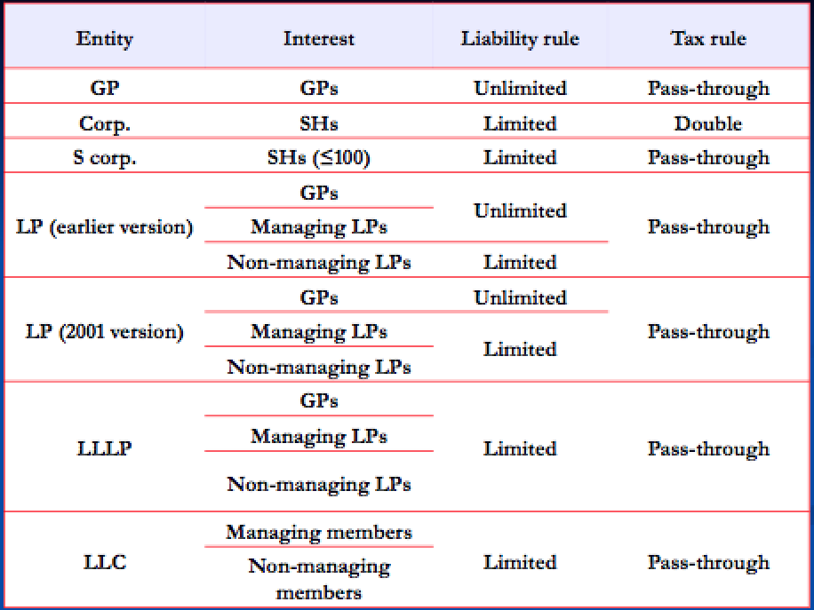

Limited Partnership – similar to general partnerships, but with particular internal structure.

(1) Formation, Liability and Powers of Limited Partnership –
- ULPA §201(a): “…a certificate of limited partnership must be executed and filed in the office of the Secretary of State.”
- ULPA §404(a): “Except as provided in this Act or in the partnership agreement, a general …has the rights and powers and is subject to the restrictions of a partner in a partnership without limited partners.”
- ULPA §404(b): “Except as provided in this Act, a general partner… has the liabilities of a partner in a partnership without limited partners to [third parties].”

Old Liability Rule –
- ULPA §303(a): “…a limited partner is not liable for the obligations of a limited partnership unless…he participates in the control of the business.”
  - “…However, if the limited partner participates in the control of the business, he is liable only to persons who transact business with the limited partnership reasonably believing, based upon the limited partner’s conduct, that the limited partner is a general partner.”
- ULPA §303(b): “A limited partner does not participate in the control of the…solely by…consulting with and advising a general partner with respect to the business of the limited partnership;…”

Holzman v. De Escamilla – Structured as LP since farmer had no assets. Outcome – court says can pierce LP veil: LPs “advised and consulted” about crops to plant. had veto right over expenditures since controlled checkbook…
- Outcome Reversed by ULPA §303 (2001).

New Liability Rule – ULPA § (2001): No liability as limited partner for limited partnership obligations. An obligation of a limited partnership…even if the limited partner participates in the management and control of the limited partnership.

Frigidaire Sales Corp. v. Union Properties, Inc. – Created an LP and were limited partners managed by a corporation created to be GP, but were shareholders of the corporation. Just need to make sure can’t pierce corporate veil (no comingling assets, observation of formalities, etc.). Outcome – court found Union Properties (the corp) not liable for debts and torts.
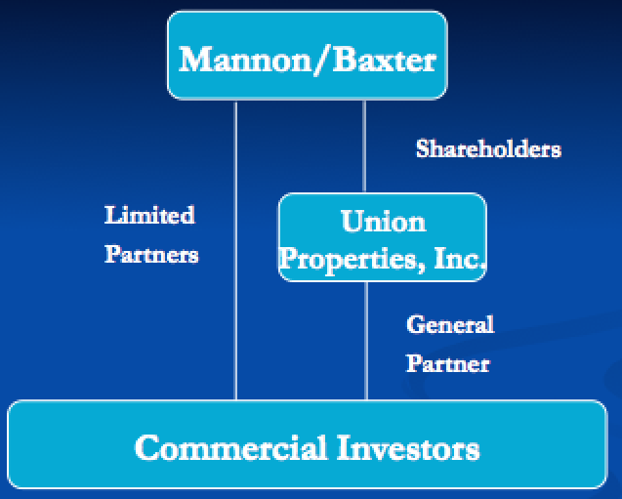

(2) Fiduciary Duty of GP to LPs –
RULE - GP in general has fiduciary duty of loyalty/goof faith to limited partners, but that fiduciary duty can be revised by the clauses in the LP Agreement, especially if all parties were sophisticated/big players. (El Paso Pipeline).
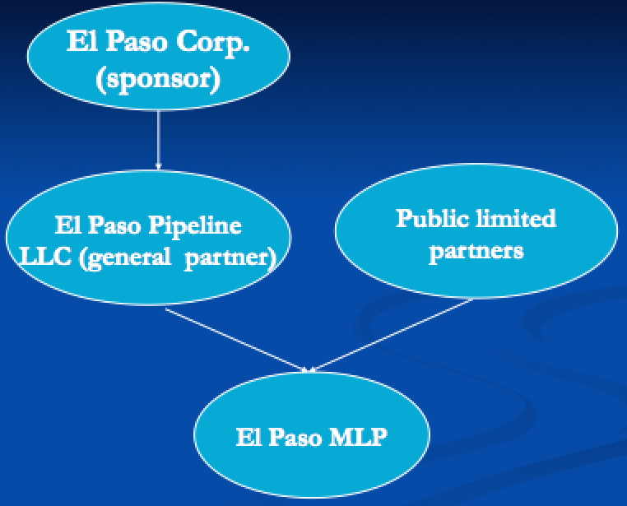

Limited Liability Company (LLC) –

(1) Formation of LLCs –

Duray Development LLC v. Perrin – Perrin signs contract on behalf of himself and on behalf of Outlaw LLC BUT LLC hadn’t been formed at time of signing. Have disclosed principal, but principal is not yet in existence, so Perrin likely liable under traditional agency law (effectively partially disclosed principal).
  - Outcome – Perrin is protected, de facto LLC (declares is an LLC and person who’s signing is protected from liability under agency theory) and LLC by estoppel (entity is not an LLC but courts won’t let party claim is not an LLC) imported into LLC law.

(2) Governance of LLC (Operating Agreement) –
RULE – operating agreement typically trumps state statute preferences (Elf Atochem) and fiduciary duties (Fisk Ventures, McConnell).

Professional manager –
RULLCA §407(c): “In a manager-managed limited liability company…:
    - (1) Except as otherwise expressly provided in this [act], any matter relating to the activities of the company is decided exclusively by the managers.
    - (2) Each manager has equal rights in the management and conduct of the activities of the company.
    - (3) A difference arising among managers as to a matter in the ordinary course of the activities of the company may be decided by a majority of the managers.
    - (4) The consent of all members is required to…(C) undertake any other act outside of the ordinary course of the company’s activities…”

Member-managed –
RULLCA §407(b): “In a member-managed limited liability company…:
    - (1) The management and conduct of the company are vested in the members.
    - (2) Each member has equal rights in the management and conduct of the company’s activities.
    - (3) A difference arising among members as to a matter in the ordinary course…may be decided by a majority of the members.
    - (4) An act outside the ordinary course…may be undertaking only with the consent of all members…”

Elf Atochem North America Inc. v. Jaffari – Elf sues (derivative suit) Malak Inc. on behalf of Malek LLC in DE Court of Chancery claiming breach of fiduciary duty to Malek LLC by Malek Inc. Outcome – court says Operating Agreement (w/ its arbitration clause) trumps.
  - DE §18-1001: “A member or an assignee of an LLC interest may bring an action in the Court of Chancery in the right of an LLC to recover a judgment in its favor if managers or members with authority to do so have refused to bring the action or if an effort to cause those managers or members to bring the action is not likely to succeed.”
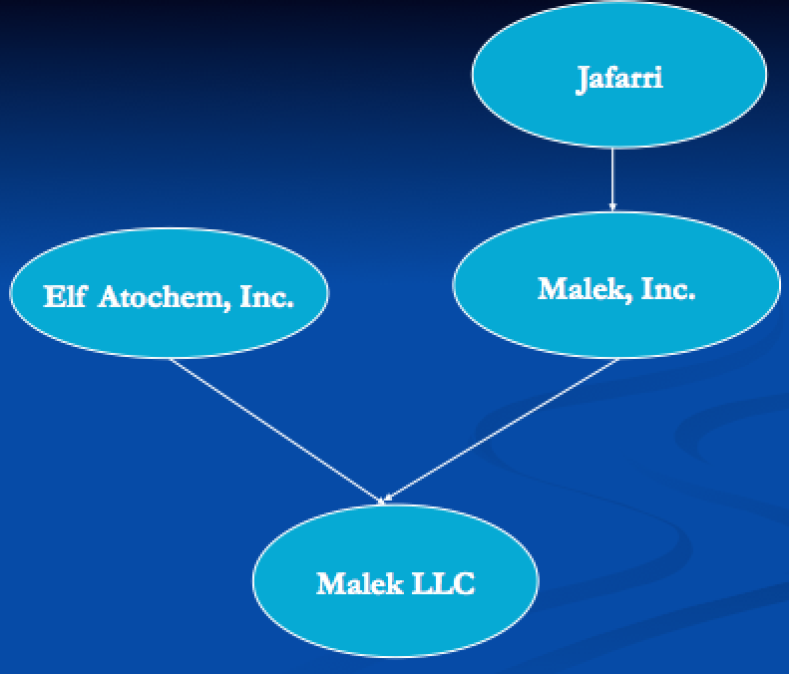

Fisk Ventures LLC v. Segal – Segal asks Johnson to waive senior debt claim and Johnson refuses. Outcome – court rejects: won’t interpret good faith and fair dealing to mean you can’t do what contract says you can do.

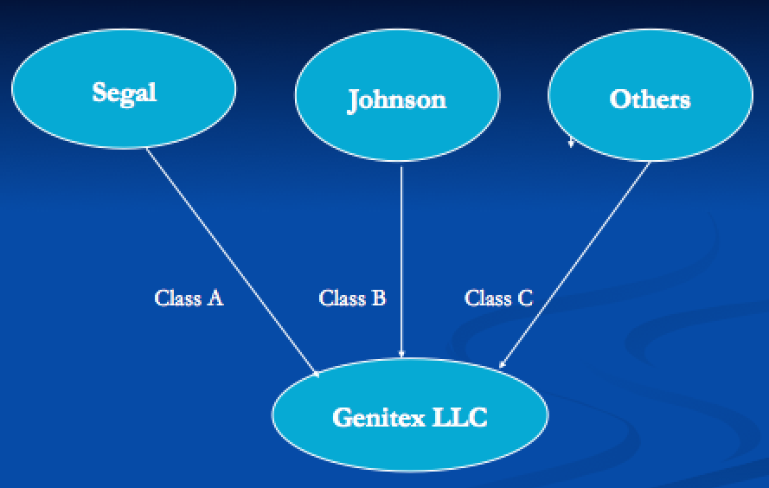

(3) Piercing the LLC Veil – (if fails, then try dissolution)
RULE – can pierce the LLC veil, but hard to do b/c courts don’t care about formalities like they do in corporate sphere.

NetJets Aviation, Inc. v. LHC Communications LLC – Outcome – court found Zimmerman could be personally liable: was using company as another bank account (comingling, treating company’s assets as his own).

(4) Fiduciary Obligations in LLCs –

- RULLCA) §110(c): “An operating agreement may not:… subject to subsections (d) through (g), eliminate the duty of loyalty, the duty of care, or any other fiduciary duty…”
- RULLCA §110(d) exceptions allow parties to virtually eliminate any aspects of fiduciary duty, BUT can’t be manifestly unreasonable. “If not manifestly unreasonable, the operating agreement may:
  - (1) Restrict or eliminate the duty…to refrain from competing with the company in the conduct of the company’s business…;
  - (2) Identify specific types or categories of activities that do not violate the duty of loyalty;
  - (3) Alter the duty of care, except to authorize intentional misconduct or knowing violating of law;
  - (4) Alter any other fiduciary duty, including eliminating particular aspects of that duty.
  - (5) If not manifestly unreasonable, the operating agreement may: ‘prescribe the standards by which to measure the performance of the contractual obligation of good faith and fair dealing…’”

McConnell v. Hunt Sports Enterprises – Outcome – court found for McConnell: operating agreement has clause exempting him from fiduciary duties, “Members shall not in any way be prohibited from or restricted in engaging or owning an interest in any other business venture of any nature, including any venture which might be competitive with the business of the Company.” (Common in LLC operating agreements).

Additional Capital in LLCs (Limited Liability in Force) –
RULE – limited liability trumps operations agreement provision unless owners explicitly make selves individually liable. (Racing Investment Fund)

(5) Dissolution of LLCs –
RULE - if can’t pierce veil, then can make claims on members if assets have been given out to them after dissolution (a practical solution to avoid creditor having to go through litigation). (New Horizons)

New Horizons Supply Cooperative v. Haack – Outcome – LLC never wound up properly, should have filed dissolution (de facto dissolution) and any liquidity that flowed back to sister should have been given to New Horizons, sister could be required to pay. Burden on sister to prove she didn’t receive the liquidity from asset sale
- Take-aways – if can’t pierce veil, then can make claims on members if assets have been given out to them after dissolution (a practical solution to avoid creditor having to go through litigation).

Limited Liability Partnerships – Limited Liability extended to general partner.
RUPA §306(c): “An obligation of a partnership incurred while the partnership is a LLP, whether arising in contract, tort, or otherwise, is solely the obligation of the partnership. A partner is not personally liable, directly or otherwise, for such an obligation solely by reason of being or so acting as a partner.”

Business Trust –
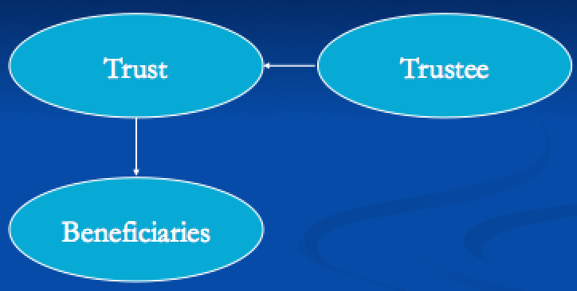

Old Form – Not originally a business vehicle. Trouble w/ using trust as business vehicle:
  - (1) Duration, (2) Decision making – had to be unanimous among trustees, (3) High fiduciary duties (required diversification). (4) Corporate tax rules
New Form –
- IRS 1990s. Business trust became a stripped-down empty shell for anything manager wants to do.
  - E.g. MD Statutory Trust Act: “shall be liberally construed to give maximum effect to the principle of freedom of contract and to the enforceability of the governing instruments.
- Common uses: real estate investment trusts, pension funds. Common feature is passive investment pool.
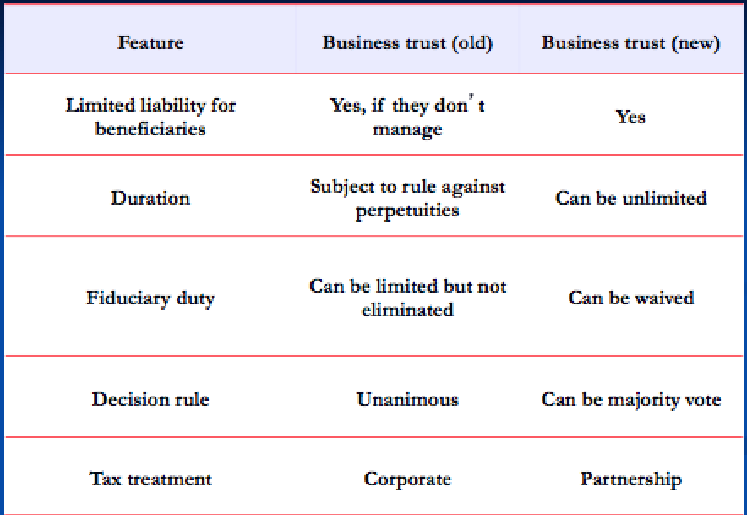

Public Benefit Corporations – discussed previously in context of charitable giving. A company that is interested in making a profit but also interested in some type of public benefit (not a profit-maximizing form). If doesn’t make profit, director’s won’t be liable for breach of fiduciary duty. Authorized in almost every state in US.

DGCL §362(a): “…shall be managed in a manner that balances the stockholders’ pecuniary interests, the best interests of those materially affected by the corp’s conduct, and the public benefit or public benefits identified in its certificate of incorporation…”

DGCL §362(b): “Public Benefit” means a positive effect (or reduction of negative effects) on [persons/entities] other than stockholders in their capacities as stockholders…

Three forms that do the same thing – business trusts, limited liability partnership, benefit corps.
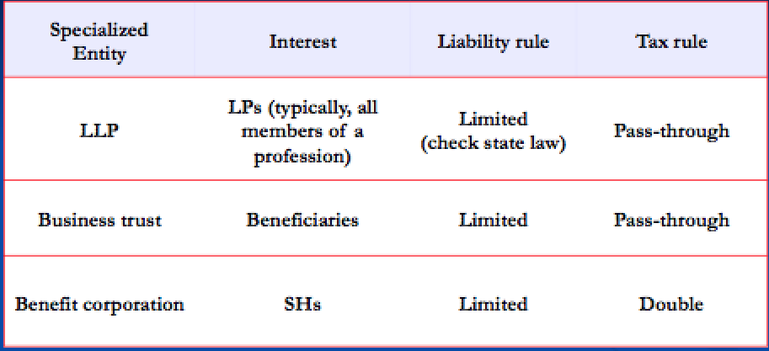

Securities Law –

(i) What is a security? If not a security, is not subject to Federal Securities Law (have very different requirements).

§2(1) of Securities Act of 1933 – “Unless the context otherwise requires, ‘security’ means ‘any note, stock, treasury stock, security future, bond, debenture, investment contract,…,or, in general, any interest or instrument commonly known as a ‘security.’” is circular.
    - States can define differently than fed. If acts like a security, then likely is a security.

Robinsin v. Glynn – Glynn lies and says he passed a test to get more money from Robinsin, Robinsin brings lawsuit under securities law. Outcome – court finds (i) have investment of money, (ii) in common enterprise, BUT (iii) Robinsin had management roles (on BoD) the investment didn’t satisfy Howey

Investment Contract – SEC v. Howey
- Investment of money,
- In common enterprise,
- In which profits are to come solely (expanded by lower courts to “substantially”) from the efforts of others.

SEC v. Howey – investor bought two rows in orange grove coupled with binding recommendation that buyer should hire the seller to cultivate and market product. Looks like purchase of real property, but Outcome – found it was a security (an investment contract).

Usual/Functional Characteristics of Stock –
- The right to receive dividends
- Negotiability
- Ability to be pledged
- Voting rights
- Capacity to appreciate in value

(ii) Registration Requirement –

Fed Securities Law of 1933 (covers initial offering of securities, contains Registration Requirement)
  - Disclosure Requirement – any type of security (no matter how speculative), can be sold provided adequate disclosure. Implemented through Registration Requirement.
  - Registration Statement

Penalties for offering or selling unregistered security? –

1933 Act §5(a): “[It shall be unlawful for any person, directly or indirectly:] to sell [a new issue of a] security through the use or medium of any prospectus or otherwise [unless a registration statement is in effect]…”

1993 Act §12(a)(1): essentially right to return/rescission/damages if sold security. Strict liability (i.e. even if didn’t intend to issue security w/o registration, are still liable).

How can you avoid having to comply with registration requirement?

(1) If the instrument is exempt from registration.
§3(a)(11): Any security which is a part of an issue offered and sold only to persons resident within a single State or Territory… (not used much)
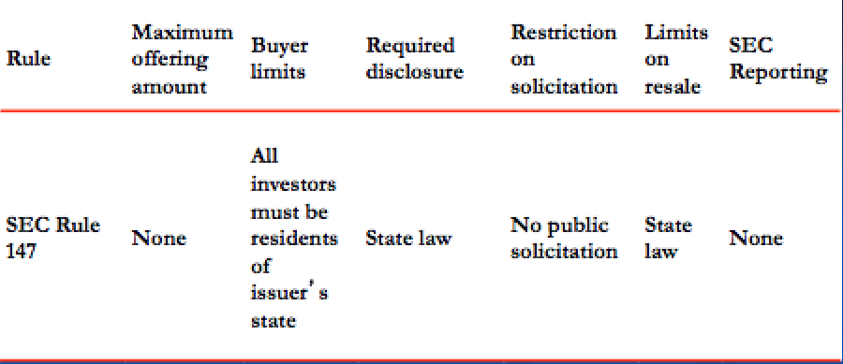
US treasuries, municipal bonds, commercial paper, bank deposits, federal agency issues (partial list).
  - Common features of the above exemptions: have government’s credit behind them, are low risk. Majority are safe, majority of buyers are big boys.

(2) If a transactional exemption applies.

Transactional Exemptions for Initial Offers – Statutory private placements, Reg D, Reg A, Reg S, Crowdfunding.
  - Common features of above exemptions: transactions not involving an issuer, underwriter, or dealer.

(i) Private Placements –

§4(a)(2) Sec. 5 doesn’t apply to transactions by issuer not involving any public offering.

Factors to determine whether offer is public (Doran, LP interest = security)
      - (i) number of units sold (here, Only offered to 8 people, only 1 person accepted the offer)
      - (ii) size of offer (here, very small)
      - (iii) manner of offer (here, done face to face between offeror and offerees);
      - (iv) number and nature of offerees (here, people were sophisticated)
      - BUT Outcome – court still calls it a public offering.
        - Court added another requirement that (v) offerees need to be given access to info that a registration statement would have contained.

Vague, when in doubt, look to SEC safe harbor rules (attempts to be very clear and technical).

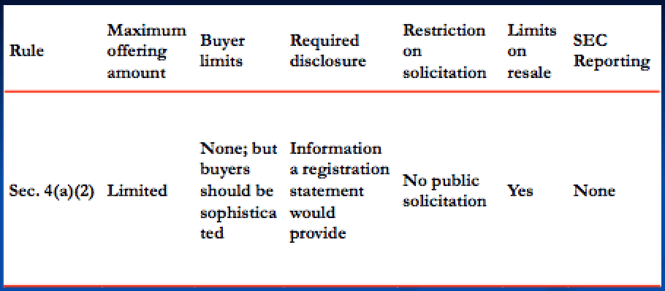

For Reg D, Reg A, Crowdfunding, Reg S and 4(a)(1) of ’33 (Resale Exemptions) look to full outline.

Liability for Misstatements in a Registration Statement –

§11(a) of ’33 Act (Prima facie case): “In cases any part of the registration statement, when such part became effective, contained an untrue statement of a material fact or omitted to state a material fact required to be stated therein or necessary to make the statements therein not misleading, any person acquiring such security (unless it is proved that at the time of such acquisition he knew of such untruth or omission) may, either at law or in equity, in any court of competent jurisdiction, sue:
  - (1) every person who signed the registration statement;
  - (2) every person who was a director of…or partner in the issuer at the time of the filing of the part of the registration statement with respect to which his liability is asserted…;
  - (4) every accountant, engineer, or appraiser, or any person whose profession gives authority to a statement made by him, who has within his consent been named as having prepared or certified any part of the registration statement, or as having prepared or certified any report or valuation which is used in connection with the registration statement, w/r/t the statement in such registration statement, report, or valuation, which purports to have been prepared or certified by him;
  - (5) every underwriter w/r/t such security.

Two Types of Due Diligence Defenses – Escott
- (i) Affirmative due diligence (exercised care to verify, hard to make out, §11(4)(b)(3)(a))
  - Must make reasonable investigation, negligence standard, must make same investigation you would undertake if you were a sensible person managing his own property.
- (ii) Lack of reasonable grounds (easier to prove)
  - (c) – no requirement for investigation so long as no “red flags”

Due Diligence Defense under §11(b)(3):
Look statement by statement to determine which are expertised (e.g. if have quantitative eval made by invest bank).
  - Expertise Statements – (not attorneys under §11)
    - Standard for expert: affirmative due diligence
    - Others: lack of reasonable grounds
  - Unexpertised Statements everyone has affirmative due diligence requirement.

Escott v. Bar-Chris – Issue – who can be liable when a registration statement contains material (“important”) misstatements? Everybody who signed, everybody who was a director of the issuer, anybody who was accountant/engineer/appraiser/etc. (§11).

(iii) Main Securities Anti-Fraud Rule: Rule 10b-5 –
Contrast §10b-5 vs. 11 – 10b-5 more demanding of plaintiff.

§10(b) of ’34 Act: “It shall be unlawful for any person, directly or indirectly, by the use of any means or instrumentality of interstate commerce or of the mails, or of any facility of any national securities exchange…[t]o use or employ, in connection with the purchase or sale of any security…any manipulative or deceptive device or contrivance in contravention of such rules and regulations as the Commission may prescribe as necessary or appropriate in the public interest or for the protection of investors.”

Rule 10b-5: “It shall be unlawful for any person, directly or indirectly, by the use of any means or instrumentality of interstate commerce, of the mails or of any facility of any national securities exchange, …(a), (b), (c)…in connection with the purchase or sale of any security.
- (a) To employ any device, scheme, or artifice to defraud,
- (b) To make any untrue statement of a material fact or to omit to state a material fact necessary in order to make the statements made, in the light of the circumstances under which they were made, not misleading,
- (c) To engage in any act, practice, or course of business which operates or would operate as a fraud or deceit upon any person,…
- Privately enforceable (implied right of action).
- Two branches / separate torts: (i) fraud, (ii) insider trading.

Elements of Rule 10b-5 Fraud CoA –
  - Security
  - Interstate commerce
  - Materiality
  - Reliance
  - Standing
  - Scienter
  - Damages
  - Purchase or Sale
  - Manipulative or deceptive conduct

MATERIALITY – Basic v. Levinson.
Advice – what to do when have a deal in the works but don’t want to announce it?
  - Can say “no comment” – people will assume you are in negotiations.
  - Have company adopt a written policy that they never give comments about merger negotiations, can just direct press to the policy, and can always waive the policy if need to.

Basic v. Levinson – Management denied 3x falsely that it was in merger negotiations, Outcome? – merger info “important, significant.” Basic gives three different definitions of materiality (functional, policy-based, and rule of thumb).

  - Policy-based Test: Not that it would have changed the investor’s decision, but that a reasonable investor would have thought it important. From TSC v. Northway.

  - Functional Test: From SEC v. Texas Gulf Sulfur.
    - (P x M) ÷ S > W. Court using simple economic model to describe a legal issue.
      - P = probability an event will occur, the main fluctuating variable
      - M = magnitude of the event if it occurs, can be considered constant
      - S = size of the company, can be considered constant
      - W = threshold of materiality, the only true constant.
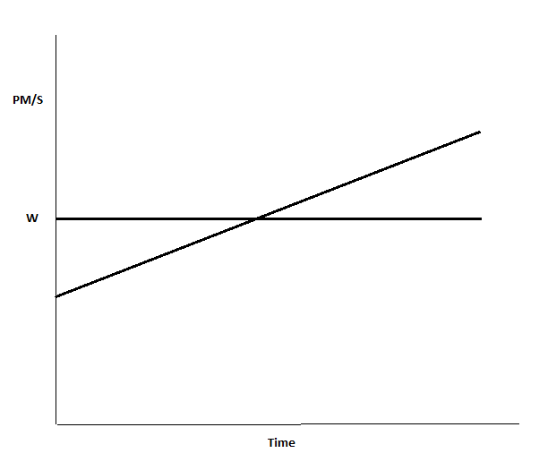

- Rule of Thumb Test:
- ‘agreement in principle’ rejected..
- ‘indicia of interest in the transaction at the highest corporate levels.”

RELIANCE – satisfied if the plaintiff traded in reliance on the integrity of the market price, Basic.
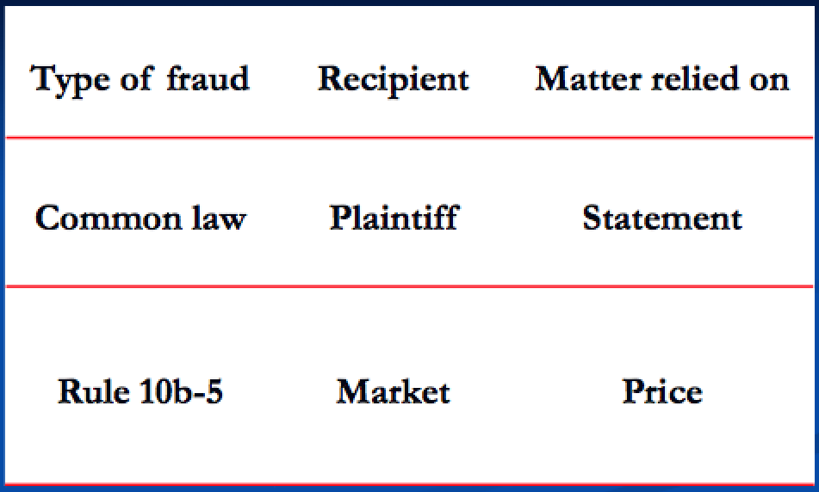

Elements of CL “Fraud on the Market”: Burden on plaintiff to prove.
(1) Statement by defendant; (2) statement is false; (3) statement is intended to induce reliance by someone; (4) plaintiff actually relies on the statement; (5) reliance causes detriment to plaintiff.

Reliance in Fraud & FoM – shows causation.
  - View as defendant making statement to the market. For 10b-5 purposes, the reliance requirement is satisfied if the plaintiff traded in reliance on the integrity of the market price.
    - Efficient Market Hypothesis – market price of shares traded on well-developed markets reflects all publicly available info, and, hence, any material misrepresentation

  - Rebuttable presumption of reliance. Court will presume that plaintiff’s point of view w/r/t reliance is correct unless defendant can prove otherwise, assumes is almost always true that traders rely on the integrity of the market price.
      - To defeat class cert, defendant would be required to rebut each and every plaintiff’s reliance individually (expensive, burdensome).

Halliburton v. Erica John Fund – Outcome – continued viability of FoM Theory.

  - (1) Plaintiff’s preliminary showing – must show:
    - (i) Market efficiency – some markets assumed to be efficient (e.g. NYSE, NASDAQ).
      - Halliburton II – ’market professionals generally consider most publicly announced material statements about companies, thereby affecting stock market prices.’”
        - easier to establish market efficiency (don’t need to pay high fees of expert witnesses b/c don’t need them, just need to show stock is tracked by the market and evaluated by specialists watching market).
    - [(ii) Materiality – PROF thinks doesn’t have anything to do with presumption but was just added to screen out frivolous cases.

  - (2) Allowable rebuttal evidence –
    - (i) Trading Impact – means plaintiff didn’t rely on integrity of market price when plaintiff traded. (PROF thinks is more useful than (ii)).
    - [(ii) Price Impact – (PROF doesn’t think is as useful as (i)). The idea that the misrepresentations didn’t affect the market price, so plaintiffs not entitled to class action since will lose one way or another
        - Will induce defendants to let truth dribble out rather than come clean

Other Issues under Rule 10b-5 Fraud CoA –
  - Liability for tips
  - Scienter
  - Standing
  - Statements of opinion
  - Breaches of fiduciary duty
  - Application to complex/”exotic” financial instruments.

LIABILITY FOR TIPS – a statement to a small group of people.

West v. Prudential Securities, Inc. – False tip spread that affects price of stock. Outcome – Court refuses to apply FoM to private info
  - Take-Away –tips generally can’t get FOM theory recovery, efficient markets theory doesn’t work for tips.

SCIENTER – defendant has to have bad mens rea to recover under 10b-5; intention to deceive or manipulate, or recklessness as to truth or falsity of statements.
  - Plaintiffs have heightened fraud pleading standard (particularized allegations). To prove defendants subjective/internal mental state w/o deposition is hard, compensate by writing 200+ pg complaints.

STANDING – only allowed to sue if have been damaged.

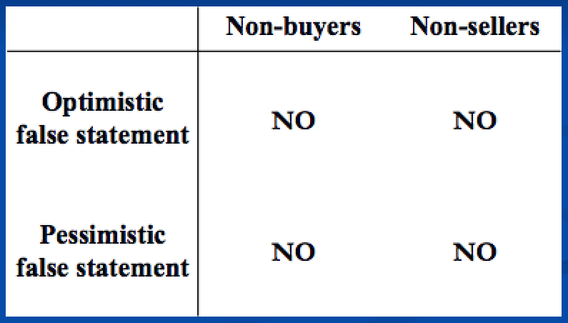

STATEMENTS OF OPINION –

Omnicare (2015), whether ’33 Act §11 liability applies to 10b-5 –
    - (i) There is no §11 liability for pure statements of opinion, even if they turn out to be objectively false. Liability only attaches to false statements of fact…
    - (ii) There can be §11 liability if opinion not honestly held when the statement is made…
    - (iii) There can be §11 liability if the statement implies facts that are not true (i.e. if it omits to include facts necessary to correct a false inference that a reasonable investor would draw from the statement.”
      - (a) Statement of opinion vs. statement that you have a particular opinion (e.g. if know that claims are substantiated but say you believe they’re not). Liability only for the latter.
      - (b) Also have liability if opinion logically implies facts that are not true.

BREACHES OF FIDUCIARY DUTY & 10B-5 –

Santa Fe Industries, Inc. v. Green – SCOTUS. Santa Fe owns 95% of Kirby, wants to get full ownership (squeeze-out). Issue – Does 10b-5 cause of action extend to squirrely actions that aren’t necessarily false statements? Outcome – 10b-5 doesn’t cover breach of fiduciary duty, breach of fiduciary duty is for states to decide.
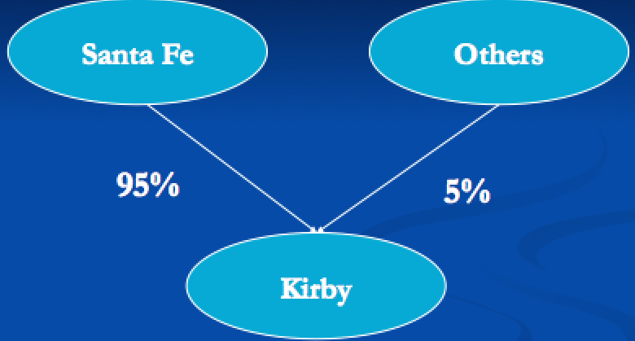

“EXOTIC” FINANCIAL INSTRUMENTS –
Provided the instrument is a security, doesn’t matter if exotic, still have a securities fraud remedy (broadened securities fraud law).

Deutschman v. Beneficial Corp. – Call option holders say bought call options when company was lying to market to keep price excessively high. Outcome – Next court says doesn’t matter if options are gambling or not, it’s a security so has remedy under securities fraud law.

(iv) Insider Trading Rules – 10b-5 is almost a common law rule, is vague and muddy.

Common Law Approach – no recovery for insider trading. No duty of disclosure of insider info during arm’s length transaction. (NOTE: no inherent duty b/w officers and potential shareholders). (ERODED)

Goodwin v. Agassiz – Geologist theory. Outcome – breach of fiduciary duty extended to cover this type of case (though traditionally wouldn’t apply). BUT plaintiff still loses b/c:
    - (i) Court said geologist theory wasn’t material
    - (ii) Couldn’t recover b/c identity of buyer and seller wasn’t known

Federal Remedy for Insider Trading – Rule: disclose or abstain. Texas Gulf.

SEC v. Texas Gulf Sulphur Co. – strike in Timmons. Is fact-specific unsettled issue where/how/when disclosure is made is sufficient. Today: courts would likely say as soon as have disclosure to a wide-distribution of media (e.g. NY Times website). A statement is misleading for purposes of Rule 10b-5 if “a reasonable investor, in the exercise of due care, would have been misled by it.”

Extensions of Texas Gulf and Federal Remedy–
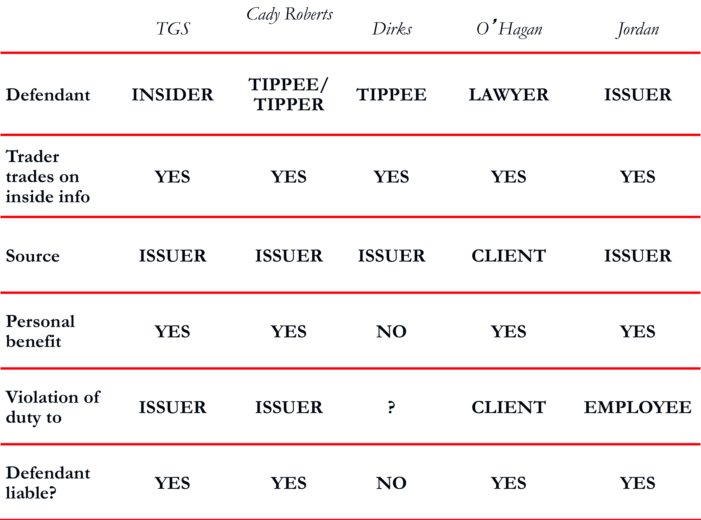

Liability for Tippees – Dirks

Dirks v. SEC – SCOTUS. Outcome/Analysis – Dirks is not liable as a tippee, though is clearly someone who received info and passed it on (seemingly w/in Cady, Roberts).

Dirks Two-Factor Test for Tippee Liability –
  - (i) DUTY “There is no general duty to disclose before trading on material nonpublic info…[A] tippee assumes a fiduciary duty to the shareholders of a corp not to trade on material nonpublic info only when the insider has breached his [or her] fiduciary duty to the shareholders (below) by disclosing the info to the tippee and the tippee knows of should know that there has been a breach.”
  - (ii) BENEFIT “The test is whether the insider personally will benefit, directly or indirectly, from his disclosure. Absent some personal gain there has been no breach of duty to stockholders. And absent a breach by the insider, there is no derivative breach.”

SEC Response to Dirks –

  - (i) Regulation FD (W/r/t Role of Analysts) – Issuer can no longer provide confidential, non-public briefings to analysts.
  - (ii) SEC Office of the Whistleblower

Liability for Insiders – O’Hagan

US v. O’Hagan – O’Hagan at law firm, finds out that the stock of Pillsbury will go up, inside trades. O’Hagan is not directly on the matter, no duty to Pillsbury (is working for the company that will take over Pillsbury), source of info is O’Hagan’s client who wants to take over Pillsbury. Outcome – court found liability for O’Hagan, found clear violation of duty to the client.

- Justification for the duty / personal benefit rule that SCOTUS adopted (Dirks)
  - Securities Exchange Act §10b and 10b-5 both seem to have requirement of bad behavior beyond merely trading on inside info.

- What is a qualifying duty? What kinds of behavior violate a “duty of trust or confidence”?
- SEC Rule 10b5-1(a): …in breach of a duty of trust or confidence that is owed directly, indirectly, or derivatively, to the issuer of that security or the shareholders of that issuer, or to any other person who is the source of the material nonpublic info.”
- SEC Rule 10b5-2: “A person has a duty of trust or confidence, inter alia: (non-exclusive rule).
  - When someone agrees to maintain info in confidence.
  - When the recipient of the info knows or should know that the speaker expects the recipient to maintain confidentiality.
  - When someone receives info from a spouse, parent, child or sibling.
- O’Hagan – duty of professional ethics
- Carpenter v. US – SCOTUS 4-4 split, a journalist who wrote a gossipy column for WSJ. Implicit Issue – what duty did the journalist violate? Professional Journalists Code of Ethics.

- When is there a personal benefit?
  - Law not as established on the element of what is a personal benefit.
- Direct benefit: being paid for info, making profit off of trade on info.
    - Dirks – “…when an insider makes a gift of confidential info to a trading relative or friend.” indirect benefit can be a gift, a gift counts as a benefit in that it boosts reputation of giver, reciprocation assumption.

US v. Newman – Outcome – Newman and Chiasson should not have been convicted, reversed and no new trial b/c (1) insider (Ray) didn’t receive sufficient personal benefit from tip given to Goyal; (2) they weren’t aware (no Scienter) that Ray had given Goyal info in exchange for personal benefit.
    - NOTE: Dirks says tipee “knows or should know” but Newman says tippee must know.
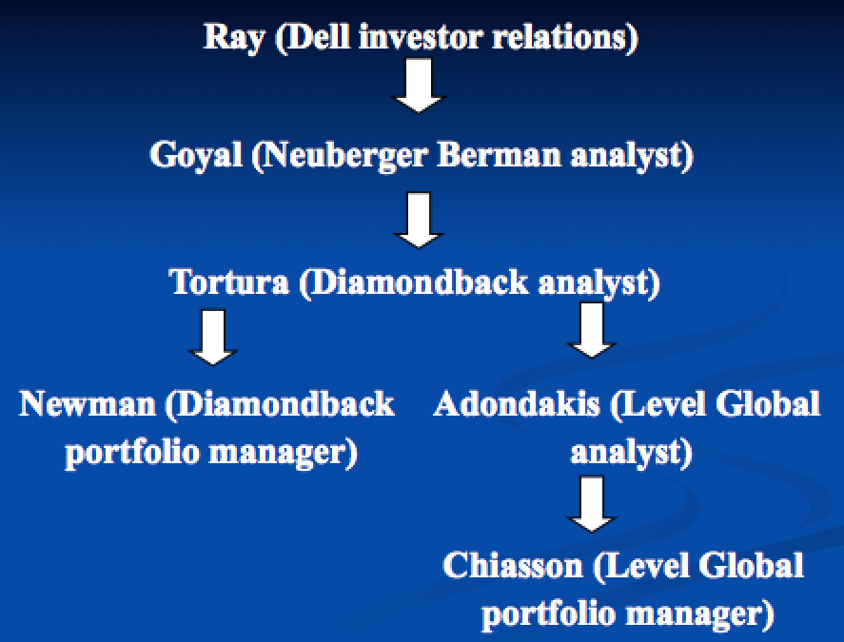

Newman elements of insider trading ( Court finds elements not met)
    - (1) Insider was entrusted with a fiduciary duty
    - (2) Insider breached his fiduciary duty by:
      - (a) disclosing confidential info to a tippee
      - (b) in exchange for a personal benefit;
    - (3) the tippee knew the info was confidential and divulged for personal benefit; and
    - (4) the tippee used that info to trade in a security or tip another individual for personal benefit.

Newman definition of personal benefit – includes pecuniary gain, any reputational benefit that will translate into future earnings, the benefit obtained by giving a gift to a relative or friend.
    - “An inference [of personal benefit] is impermissible w/o proof of a meaningfully close personal relationship that generates an exchange that is objective, consequential, and represents at least a potential gain of pecuniary or similarly valuable nature.” Trying to circumscribe idea of gifts to a friend that could become so broad.

US v. Salmon – calls brother. Outcome – 9th Circuit upholds conviction (not sbjt to 2nd Circuit Newman). Chain of close relatives, everyone in chain understood that there was an initial violation of a duty from banker to brother.
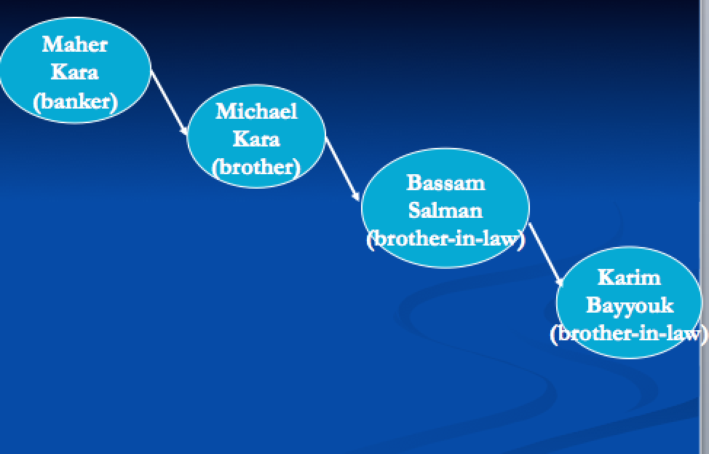

- Use versus possession?
- SEC Rule 10b-5.1: Subject to the affirmative defenses in paragraph (c) of this section, a purchase or sale of a security of an issuer is “on the basis of” material nonpublic info about that security or issuer if the person making the purchase or sale was aware of the material nonpublic info when the person made the purchase or sale.
  - HYPO – CEO gets info that company will fall short of earnings expectations and sells shares BUT has definitive proof that had plan to sell stock before earnings info but is an issue of use vs possession, liable under 10b-5.1.

Short-Swing Profits –

1934 Act §16(b) – a clear-cut rule designed to get at 10b-5 insider trading issues. “For the purpose of preventing the unfair use of info which may have been obtained by such beneficial owner, director, or officer by reason of his relationship to the issuer, any profit realized by him from any purchase and sale, or any sale and purchase, of any equity security of such issuer…within any period of less than six months,…shall inure to and be recoverable by the issuer, irrespective of any intention on the part of such beneficial owner, director, or officer in entering into such transaction of holding the security…”
  - “This subsection shall not be construed to cover any transaction where such beneficial owner was not such both at the time of the purchase and sale, or at the sale and purchase, of the security…”
  - Coverage beneficial owner, director or officer covered (analysts, tippers, tipees, etc. not covered).
  - “inure” – the issuer enforces or derivative suit
  - “irrespective of any intention” SL. Statute is a hard-edged rule w/ SL, regardless of intent are not liable so long as avoid the statute.

Definitions of 16a-1(f) –
  - “Officer” – President, Principal financial officer, Principal accounting officer, Any vice-president of the issuer in charge of a principal business unit, division or function, Any other officer who performs a policy-making function, or
    - Any other person who performs similar policy-making functions for the issuer.
  - “Beneficial owner” – one who owns “More than 10% of any class of equity security” registered w/ the SEC. Convertible instruments (convertible from debt to equity) count as equity here.

Reliance Electric v. Emerson Electric – Outcome – was two separate transactions so can be treated differently, not liable under 16(b).

Foremost-McKesson Inc. v. Provident Securities Companies – Outcome – (SCOTUS) if you buy securities that make you a 10% owner then that transaction doesn’t qualify for 16(b). Provident was only a 10% owner at the time of sale, not of purchase.

Calculating Damages Under 16(b) – HYPO in slides – under statute, doesn’t matter the temporal order at which you bought, you just subtract either 500 from 250 or 250 from 500 and whichever is positive must be disgorged.

Unconventional Transactions Factors – not subject to 16(b).
- Whether transaction was volitional.
- Whether you had an influence over the transaction itself.
- Whether you had access to confidential information.

Kern County Land v. Occidental Petroleum – Occidental buys more than 10%, then have a merger in which Occidental is required to sell its shares. Outcome – SCOTUS says not liable, was unconventional transaction (see first factor above).

Mergers –

Types – sales of substantially all assets (“substantially” subject to business judgment), statutory mergers, short-form (“freeze-out”) mergers.

Protections of Minority Interests in Corp Control Transactions –
- Approval by (disinterested) directors
- Approval by (disinterested) shareholders
- Appraisal
- Requirement of business purpose
- Litigation for breach of fiduciary duty

Sales of Substantially All Assets – acquirers typically have fewer protections work-arounds and litigation.

(PA) De-Facto Merger Doctrine – can’t structure transaction to circumvent protections to minority SH

Farris v. Glen Alden – List (big corp) wants to eliminate minority shareholders of Glen. Step (1) List assets in exchange for Glen Alden stock. Step (2) List dissolved. Shareholders of former Glen Alden complain they were unfairly treated: diluted Glen stock and gave too much for List assets. Outcome – though parties complied w/ PA rules, List was in the wrong, explicit intent in structure was to avoid giving appraisal rights to the Glen shareholders, didn’t have plausible alternative reason for structuring the way it did.
  - NOTE: was book value since shares not publically traded, can’t know if was truly bad deal for Glen.

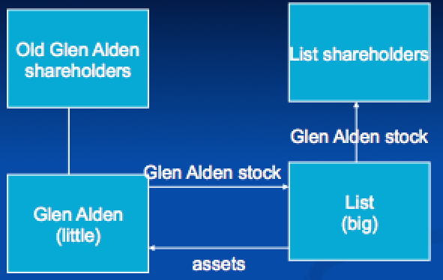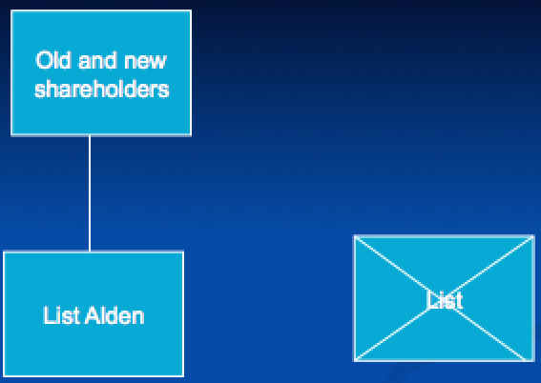

PA Rules on Sales of Substantially All Assets –
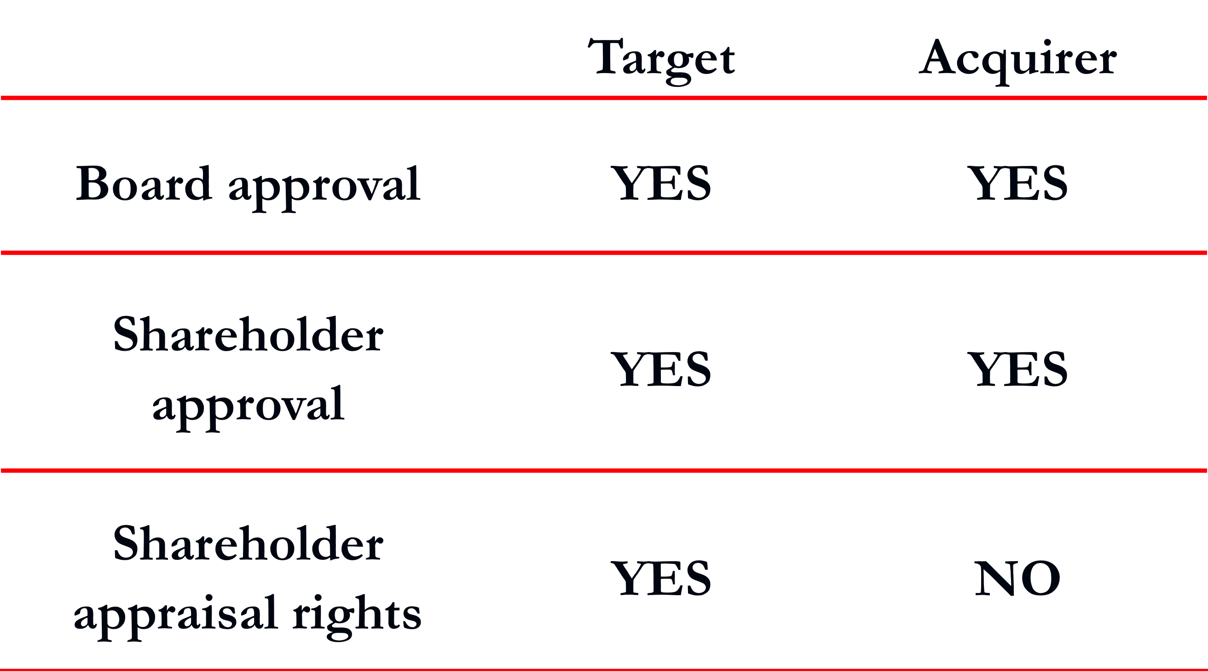

§311 of PA Corp Code – Effective for Farris. “The shareholders of an acquirer (by sale, lease, substantially all asset transaction) who pay in stock, securities or otherwise shall not be entitled to rights and remedies of dissenting shareholders.”

§908 of PA Corp Code – Effective for Farris. “The right of dissenting shareholders shall not apply to purchase by a corp of assets…they shall have no right to dissent from any such purchase.”

PA Corp Code §1904 (effective 2015) – doctrine of de facto mergers…is abolished.

(DE) Corp Code (1963) – most courts follow DE.
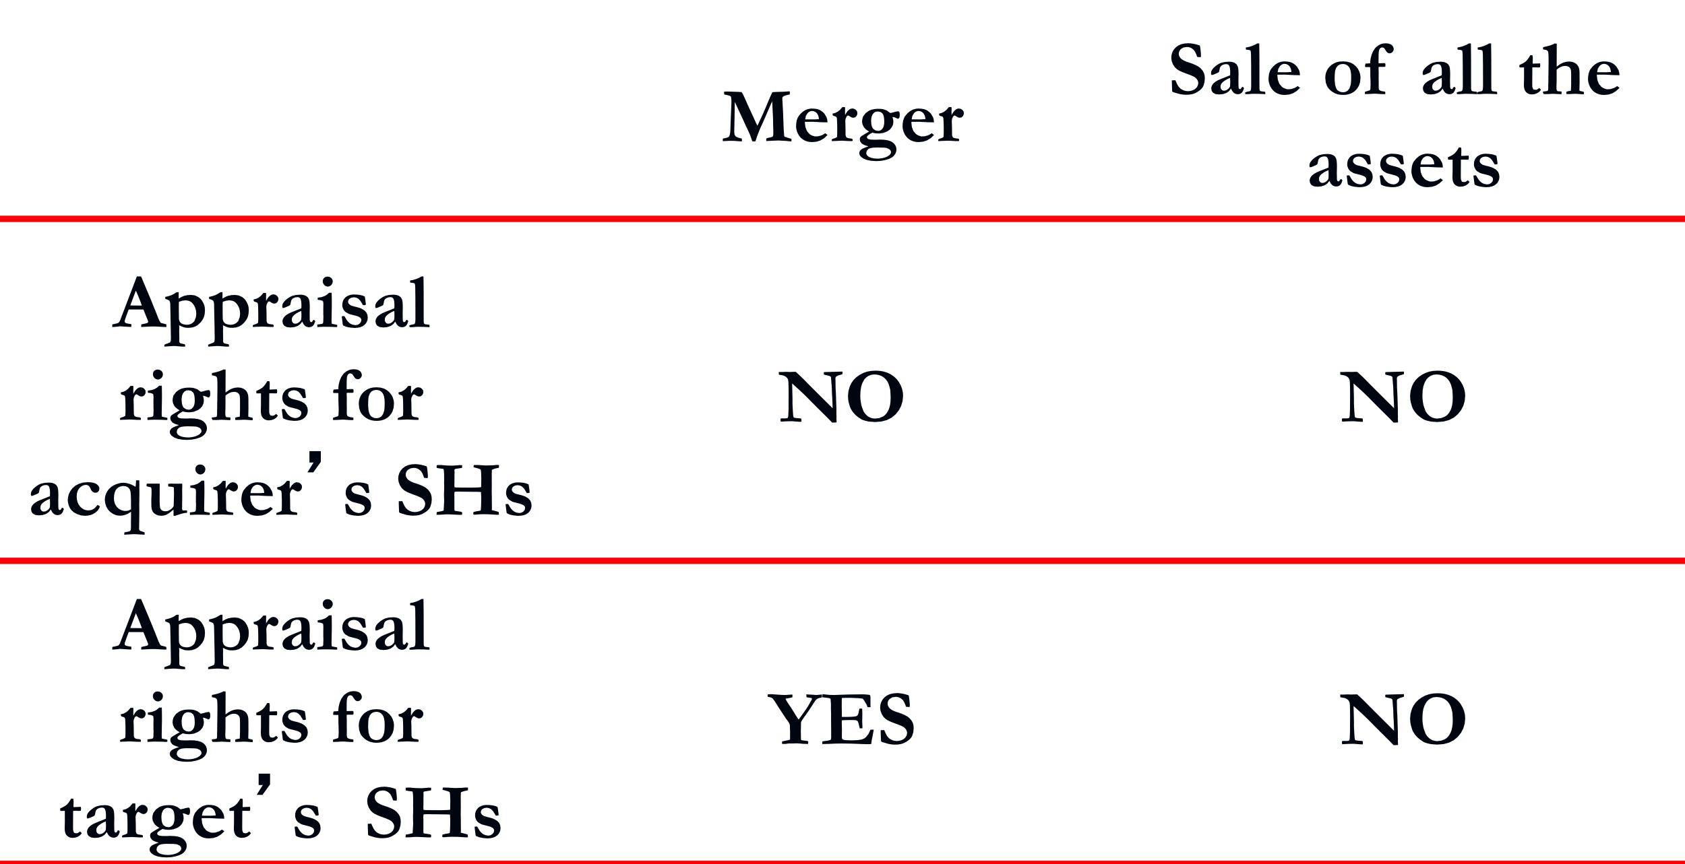

Hariton v. Arco Electronics – DE. Arco (small??) agrees to sell all assets to Loral Electronics (big??) in exchange for Loral’s shares and then will dissolve (like Farris). Outcome – DE court says was just a sale of the assets, so will treat it as as such (form governs, won’t be trumped by free-floating notions of fairness).

Statutory Mergers –

DE Corp Code §251
- (a) – “Any 2+ corps…may merge into a single corp, which may be any 1 of the constituent corps or may consolidate into a new corp…
- (b) “The BoD of each corp which desires to merge/consolidate shall adopt a resolution approving an agreement…and declaring its advisibility…”
- (c) “The agreement…shall be submitted to stockholders of each constituent corp at annual or special meeting...[where it will be] considered and a vote taken for its adoption or rejection. If majority of outstanding [voting] stock approves, it will be certified by secretary. If approved by constituent corps, it shall be filed and become effective.

DE Corp Code §262 – Any stockholder of a corp who holds shares of stock on date of making a demand, who continuously holds such shares through effective date of merger/consolidation, who has neither voted nor consented in writing to the merger/consolidation shall be entitled to an appraisal by Ct of Chancery of the fair value of the stockholder’s shares of stock…
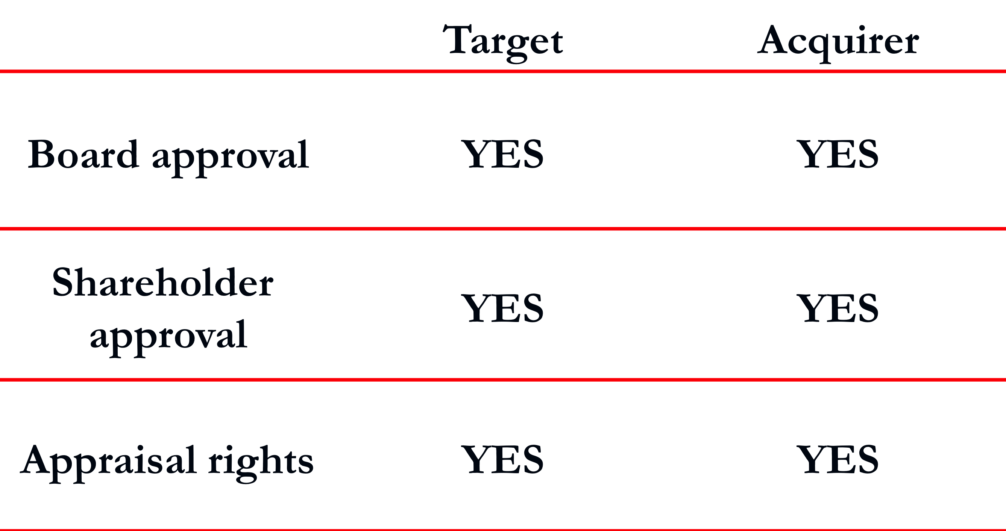

Advice – If have interested/controlling shareholder whose votes are necessary for transaction, hold disinterested vote.

Weinberger v. UOP, Inc. – Signal decides to purchase majority in UOP, have minority shareholders owning the rest, wants to get rid of minority shareholders. Presented to shareholders of UOP, majority of whom approve.
  - Outcome – applies “entire fairness” –
    - Was deal validly approved by target’s disinterested shareholders? No, didn’t get report.
    - Did defendant demonstrate the presence of entire fairness? Court distinguished two kinds of fairness: (i) was it a process of fair dealing; (ii) is it a fair price from finance point of view?
      - (i) Got fairness opinion written by vacationer, rushed decision (4 days), conflict of interest by using directors of both companies to do study.
      - (ii) Discounted cash flow method (prediction of profits going forward and discounts them to present value) should be used.
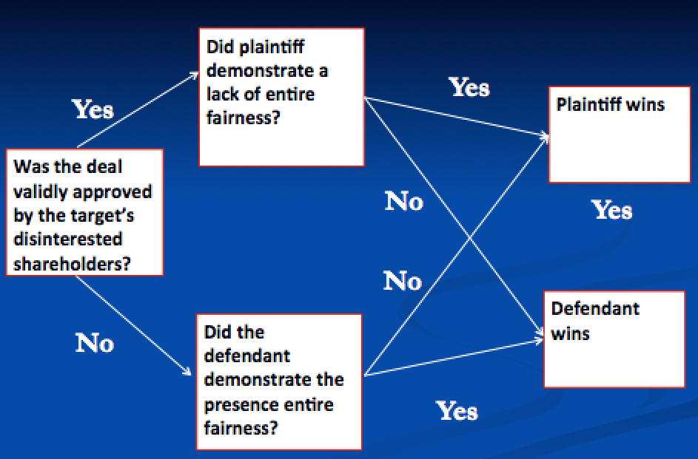
NOTE: “entire fairness” = (i) was it a process of fair dealing; (ii) is it a fair price from finance point of view

Take Away – insist that financial advisor is paying attention, give enough time to evaluate, don’t appoint own people to do basic feasibility study or have them in room when there’s discussion (need independent committee of minority directors).

Kahn v. M&F Worldwide Corp. – an approach where things were done right. Controlling minority shareholder of MFW wants to take it private. Uses the right legal and finance advisors and comes up with $24/share w/ two conditions: (i) board must appoint special negotiating committee independent (disinterested) directors to do negotiations; (ii) must have approval from disinterested shareholders. Outcome – minority wanted to be subject to business judgment rule, not entire fairness standard that original jurisprudence flow chart would land him, so he imposed both target independent directors approval and target disinterested shareholder approval protections.

REVISED JURISPRUDENCE
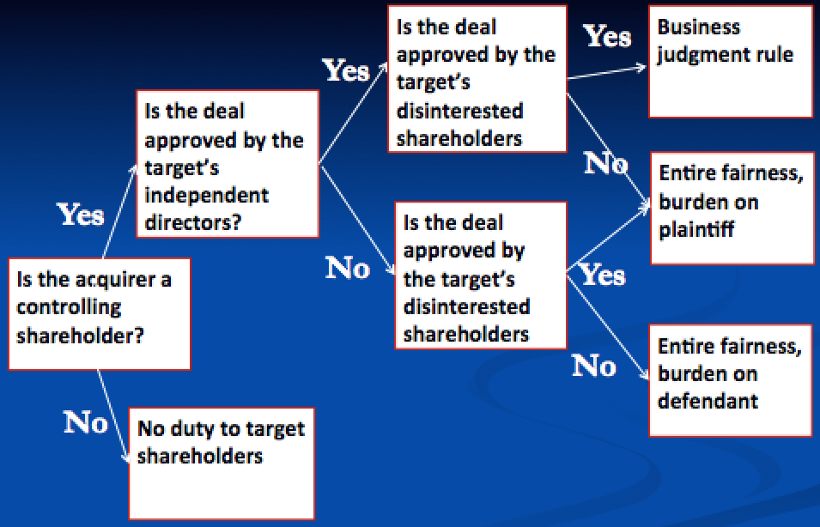

Short-form (Freeze Out) Mergers – ??
Business Purpose Requirement for Mergers – only in MA, last ditch option to challenge merger (but unlikely to succeed unless facts like below), if not business purpose then assume acquirer is doing for reasons unlikely to benefit minority.
  - Coggins v. NE Patriots – old owner (Sullivan) of Patriots is ousted, Sullivan wants back in so buys 100% of voting shares, fans own non-voting shares. Sullivan wants to get rid of fan non-voting shares. Outcome – Sullivan’s merger won’t fly, failed fair dealing prong (not quite DE “fair dealing” prong) (no legitimate business purpose), was obvious he was just being irascible.
    - Remedy – unwound or, more likely, damages will be awarded if no legitimate business purpose.

Takeovers –

Contested Takeover –
Greenmail – practice of buying enough shares to threaten takeover, forcing owners to buy back at higher price to keep control.

Cheff v. Mathes (DE 1948) – Holland Furnace Company worried that Maremont wanted to take it over. Maremont greenmails. Maremont alleges Holland directors are entrenching themselves (paid Maremont $ to keep their jobs). TEST – business judgment rule. Outcome – Entrenchment wasn’t the “sole or primary purpose.” Fending off takeover artist threat is a legitimate business purpose (threat: firing its workforce, restructuring).

Hostile Tender Offer – easiest way to take over (if proxy contest then any increase in share value goes to others). See full outline for details.

Unocal v. Mesa – Mesa wants to take over Unocal, offers two-tier offer (see slide for chart, once get the desired number of shares (front-end), then will freeze-out any remaining shareholders (back-end, here offers junk bonds and not cash)). DE court sees offer as “grossly coercive” Unocal initiates self-tender to everyone but Pickens at price higher than Pickens’ offer ($72), condition is only if Pickens’ offer succeeds will it consummate its own self-tender.
- Outcome – there is a fiduciary duty, but modified business judgment rule applies, “enhanced scrutiny.” “Reasonable in relation to the threat posed,” from Cheff. “Defensive tactic” can be any defensive strategy.
  - Held that company could engage in extreme/discriminatory defensive actions if the threat faced is extreme (like the “grossly coercive” Pickens’ two-tiered offer).
- Aftermath – self-tender forced through. Unocal had to take on massive debt and had disastrous affects on share price, left it easier for Pickens’ to buy remaining depreciated shares.

Discriminatory self-tenders now illegal (SEC Rule 13ee-4(f)(8)). BUT still have other strategies.
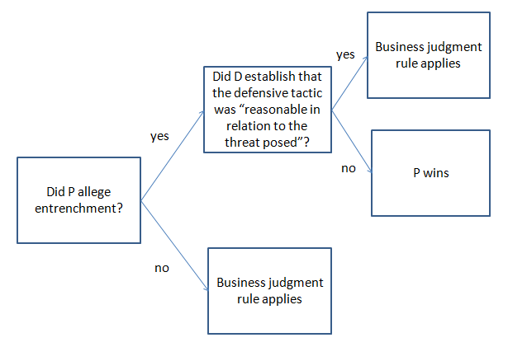

Poison Pills – If a third party announces that they intend to acquire more than a certain % (listed in Pill), then the rights separate from the stock and can’t be put back together. Pill can always be rescinded by directors prior to when rights separate from stock (if price is sufficiently high??), or if written into Pill then can rescinded at any time.

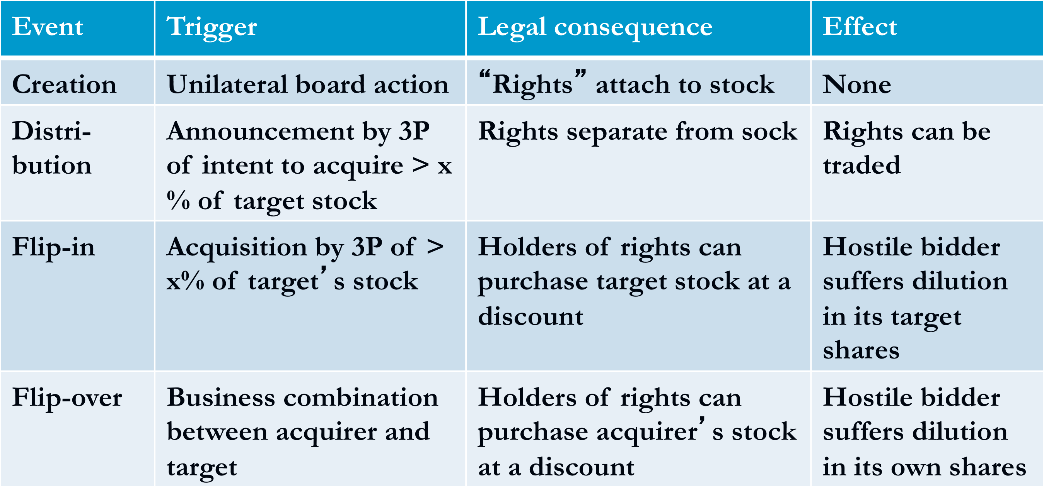

Revlon v. MacAndrews & Forbes – Outcome – poison pill upheld as bargaining leverage. Lockup, no-shop and cancellation fee all struck down Revlon Duty – duty to conduct a fair auction of the company when the sale of the company is inevitable. “When board began to negotiate w/ Forstman, it became apparent to all that the break-up of the company was inevitable. The duty of the board was thus changed from preservation of entity to the maximization of company’s value at a sale for the stockholders’ benefit.”

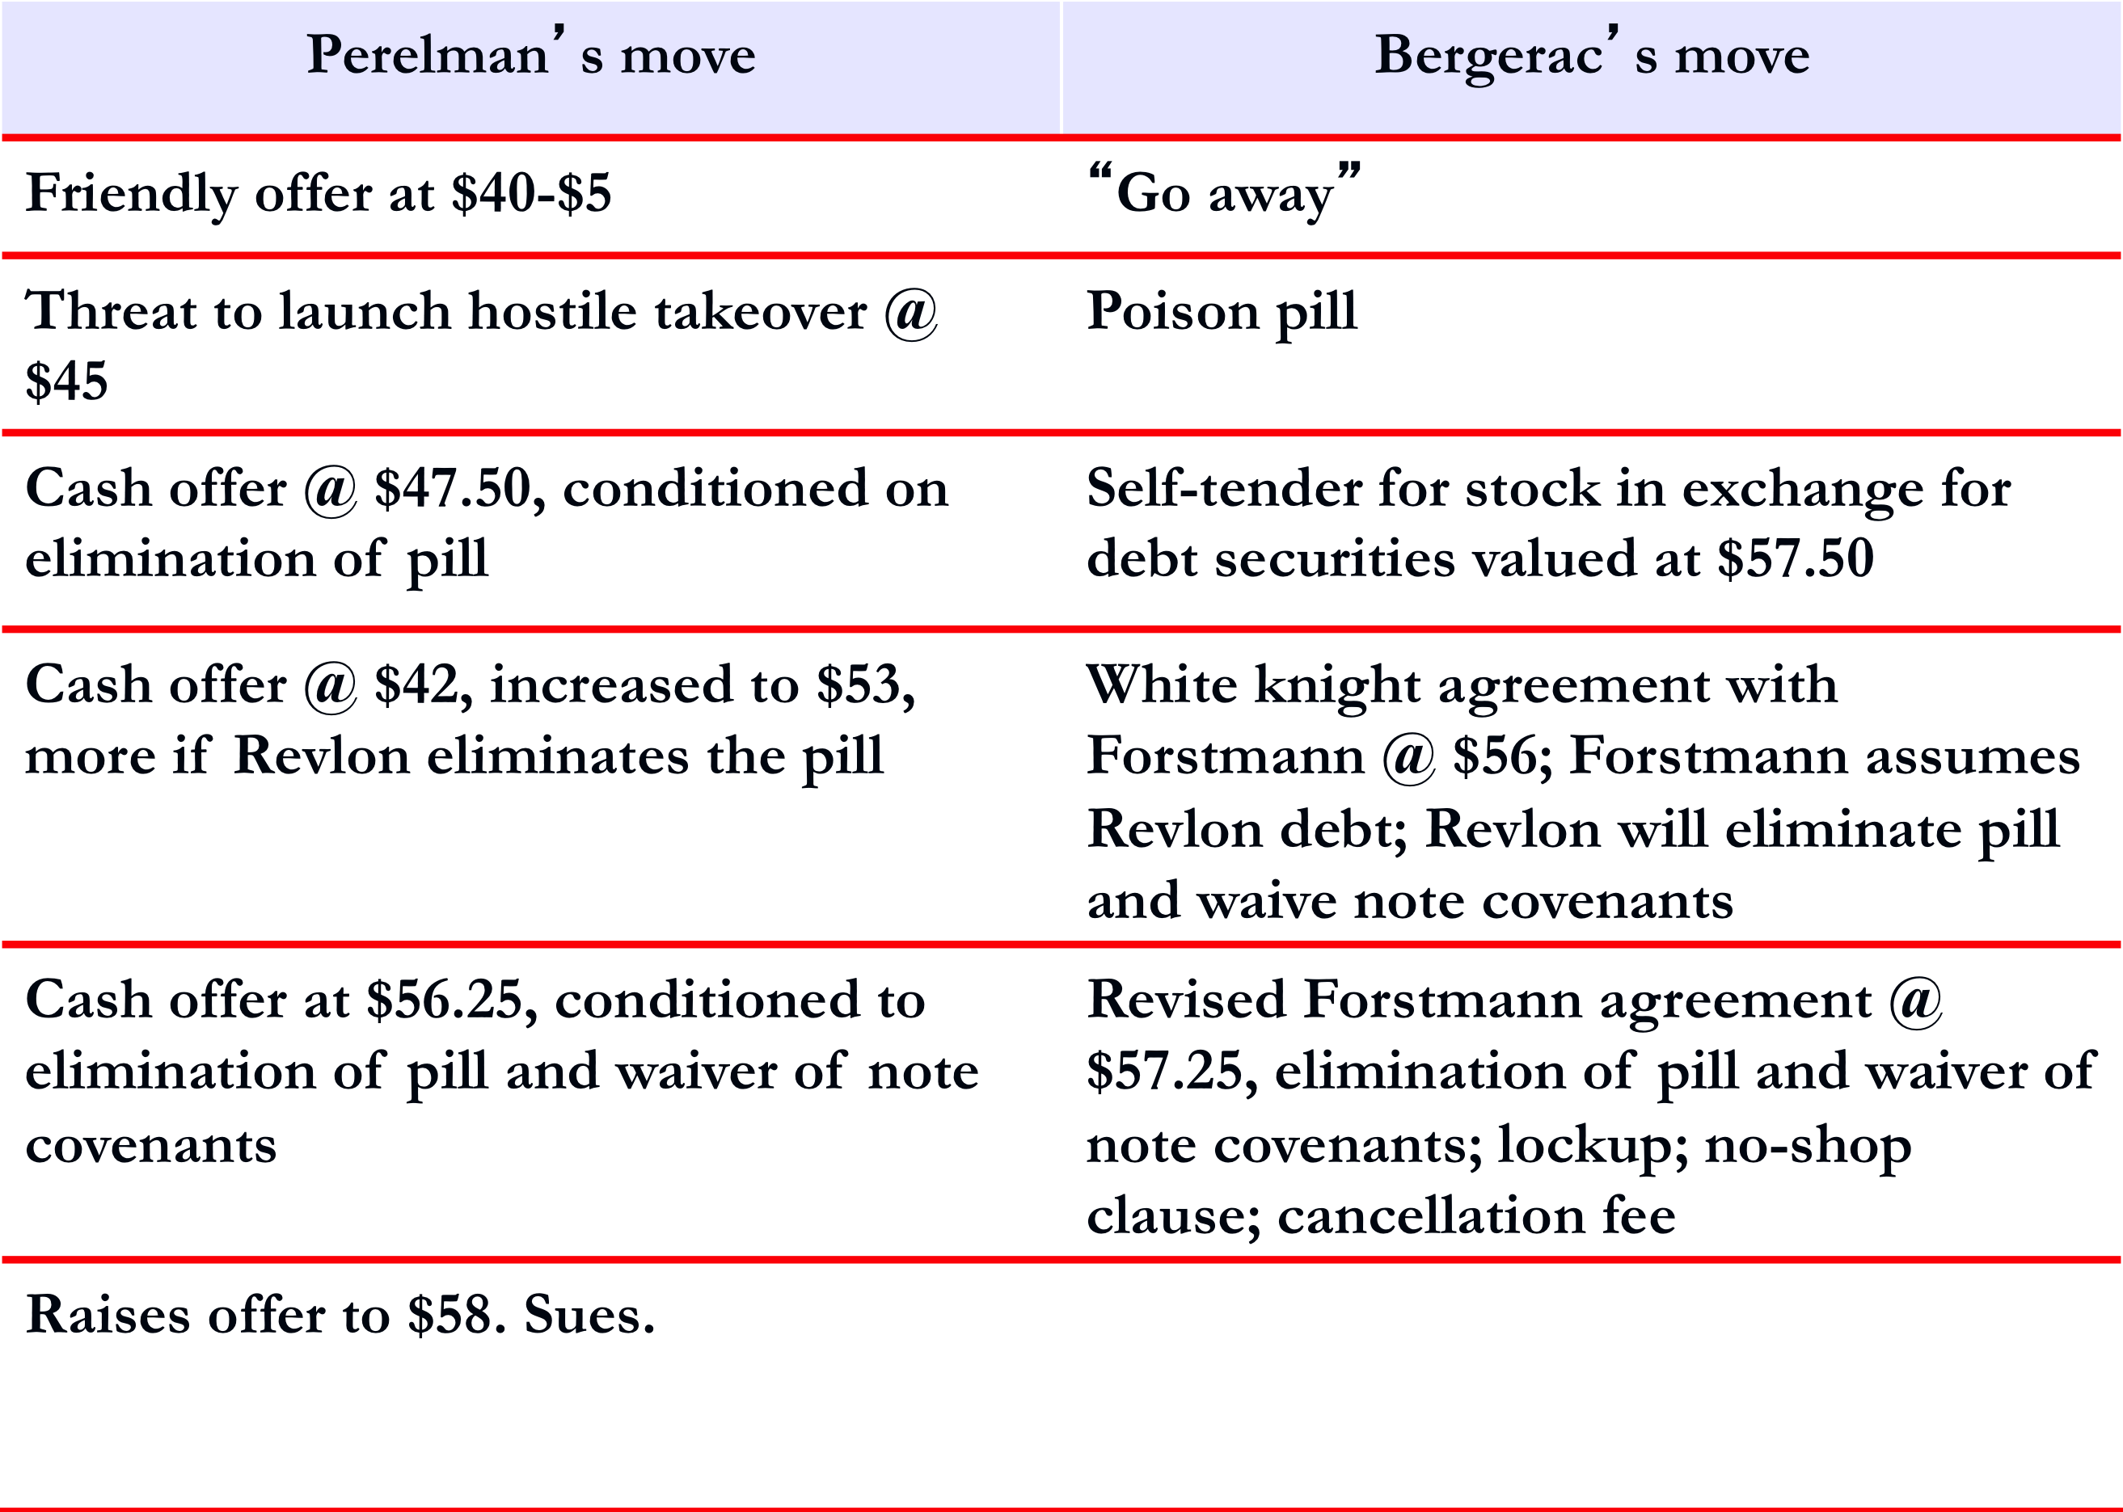

Paramount Communications v. Time, Inc. – when is the company “for sale”? Time wants to acquire Warner (really is a merger of equals, friendly, didn’t want anyone else to come in). Paramount tried to outbid Time for Warner in cash. Investment bank values Paramount offer as “grossly inadequate,” Paramount raises offer. Outcome – Revlon Duty does not apply. (i) Interest in maintaining their company structure would be more valuable in long term; (ii) The sale wasn’t imminent, company couldn’t have been considered “for sale.” Court accepts that there’s a corporate culture at Time that needs to be preserved.

An activity which can be carried on safely only with exercise of great skill and care (high probability of harm) and involves grave risk of danger to persons or property PxL (expected harm) is high.
Uniform Partnership Act (UPA) – non-binding but followed in many states. UPA (1914), RUPA (1997).

