WHAT IS PROPERTY?
Penner/Blackstone: A right to a thing good against the whole world
- Exclusion thesis: rt to exclude, grounded in interest in use, widely protect
- Productive use (reap what you sow); privacy, liberty (insulation); safety, security
GREY: A bundle of rights with regard to a thing (skeptic/realist theory)
- rts can be split up/transferred, no set def. for why diff from other legal rts
- Right to exclusive possession is merely another stick in the bundle
“Bundle” includes: Right to exclusive possession [right to possess + right to exclude]; Right to use & enjoy [Active + passive]; Right to convey/transfer; Right to destroy
- Governance model favored where uses conflict, gov’t determines best use
**General shift over time: exclusion (Penner) → governance (Grey)**
COASE THEOREM: w/o transaction cost, higher value use wins, other compensated
BUT limitations/assumptions of Coase Theorem
- Frictionless bargaining (0 transaction costs) is a myth
- Placement of legal entitlements may produce inefficient outcomes (eg Jacques)
- limited available info; limited time to decide → inefficient outcome
NATURAL RIGHTS V. POSITIVISM: what is the source of property rights?
- 30s/40s - INS v. AP (natural rights theory – associated w/ judicial power, ancient principles out there, natural connection b/w person and labor)
- Positivism has basically won (Holmes/Brandeis)- look to state law
 | Property Rule (injunction) | Liability Rule (damages)
Plaintiff (excluder) | 1) P can stop D (or set price to allow D to continue) Jacques, Pile | 2) D must pay P’s damages to continue Golden Press
Def. (entrant) | 3) D can continue w/o liability Hinman, Hendricks | 4) P can stop D if it pays D’s damages/losses

Tragedy of the Commons no caring for/maximizing use of lands open to all
- Anti-commons: where too many have rt to exclude; no one able to use
~hold out: if too many permissions required, rts to larger resource never assembled
- Semi-commons: when given resource is subject to private exclusion rights in some uses/dimensions but commons for other uses/dimensions
- Governance structure can stabilize both anti-commons & semi-commons
Demsetz:
- changes in tech/economy alter CBA of enforcing particular prop regime (Moore). property rights emerge or change when economic or technological changes alter the costs and benefits of any particular property regime.
Radin:
- Moral basis for treating certain things as property. Anti-commodification: some prop so tied up w/ personhood not even you can sell it (Arabian dissent, Moore): Grant inalienable right over this
ACQUISITION OF PROPERTY
KEY: Who put in effort? What conduct do we want to incentivize/protect? Context?
By Capture or Conquest
Pierson: RULE OF CAPTURE Post in pursuit of fox, Pierson seized fox & killed it.
- Fox = ferae naturae (wild); prop in such animals is acquired by “occupancy” only
- = taking for 1st time, something that previously did not belong to anybody
- Majority RoC - mere pursuit is not enough
Capture is required (can be less than literal and physical possession),
- Within “certain control,” e.g.: Limiting liberty of animal (net/traps, wounding); Manifest clear intent to capture OR actual capture: bodily seizure etc.
Ghen v. Rich (whale case): CUSTOM dictates meaning of w/in certain control
- “constructive possession” enough such that whaler wins over the subsequent finder (who has “actual” possession). Did all he could in context to bring under control. Protect industry/investments.
Keeble (duck case): D, from own land, fired guns near P’s decoy duck pond
- Eve mere pursuit (as part of lawful, profitable, useful trade is protected against violent/malicious interference. P awarded damages, though no actual poss’n.
Eads v. Brazelton (sunken ship) - possession requires > mere notice of intent
- D found ship (discovery), formed intention to go back & signified by marking with trees not enough, must use due diligence to get control
Popov (baseball case) P had ball first, but can’t show actual possession. Unusual.
- held P had a “pre-possessory interest”; baseball sold & profits split
Hammonds: (gas reinjected into ground) – held no trespass
- LO says gas company taking her gas out from under property
- “Found” oil & gas governed by RoC: whoever acquires actual poss’n gets it, regardless of whose land it’s under
→ First possession - who had it first?
- One may establish a “root of title” to property by being first to possess something that is unclaimed by anyone else at the time
- What counts under circumstances? Nature of thing possessed, local/industry custom, what is possible/usual in context, intent
~Title is relative! Who had it first as bw two parties; 3rd party claims irrelevant - jus tertii
By Creation - property in the form of information (IP)
- Information - non-rivalrous good: use by x doesn’t diminish use by y
- Why create prop rights in info: incentivize people to produce, not to ensure that it is allocated efficiently (But too much - monopoly, limit supply, stop free-flow info)
Eldred (2003): Congress extended Disney copyright, Ct deferred ~positivism~
INS v. AP - INS cannot copy AP stories until value of news expires; a
- quasi-property rts (as against a particular actor/practice) to protect from unfair comp
- news itself is public/common prop; particular “form” (exact words) IS protected
- natural rights idea (“you shall not reap where you have not sown”)
- Why? Ex ante - maintain financial incentives/investments in news; Ex post: unfair/wrong for INS to take AP’s hard work and profit
By Find, Accession, Ad Coelum
- First in time (prior possession) generally > subsequent possession
M’Intosh: Discoverers have unique right to possess. Tribe has right to occupy but not right to convey. Since D can trace title back to U.S., he has superior title to the land.
Haslem (manure): finder acq’d prop int by enhancing value (gathering up) & did not abandon (intent reqd to abandon). Later guy loses.
Armory (chimney sweep finds jewel, stolen) – finder 1 > thief 2
Clark v. Maloney (logs after flood) – finder 1 > finder 2 (discourage theft)
Anderson (trespasser takes logs, sues) – thief 1 > thief 2
Accession - Title for some things follow title to other things; constructive prior poss’n
- Offspring of livestock belong to owner of livestock (increase)
- LO owns all plants/minerals (non-fugitive; cf. oil or wild animals)
- Transformation of property (Wetherbee – wooden hoops, keep bc increased value but pay orig owner cost of wood. Good faith!).
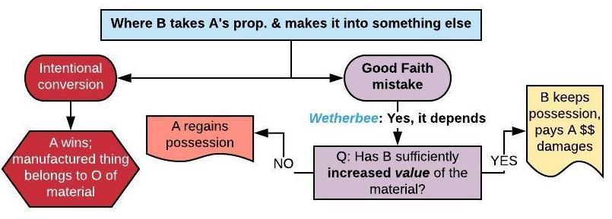
- Ad coelum: Edwards: D owns part of cave w/in prop line, trespass for survey OK
Fisher v. Stewart - Accession > capture+Trespass (P finds bee hive on D’s land, told D; D gets honey; P sues) Ratione soli: wild animals on land belong to LO. Disc trespass.
Hannah v. Peel - First possession > Accession (brooch case)
- Consider: Lost in ordinary sense (v. mislaid); State of object (dusty windowsill); “For a considerable time” (v. short); F’s conduct commendable (v. dishonest/ trespasser); LO never physically in poss’n of premises (v. prior/current occupant)
Rule: Finder > LO generally, but LO > finder if:
- LO knew of thing’s existence before “found” - constructive poss’n
- Thing "mislaid“/intentionally placed there & accidentally left behind
- Finder = trespasser or agent/employee or licensee of LO
ADVERSE POSSESSION: Did they act like an owner of that particular property would?
- Ouster = Adverse entry that: 1) Was actionable as trespass v. TO or predecessors in title & 2) Resulted in actual possession, to start SOL clock
- Privity = “rsble connection” (valid transfer) from previous possessor; shared interest.
- Actual: would TO know? Neighbors? Exclusive: not literal (can give permission)
- Adverse/hostile claim of right: cannot have permission
  - Maj rule = state of mind irrelevant, conduct asserts claim of right (Scott)
  - Min rule = good faith req, must believe you own land (faulty deed/color of title) (Carpenter)
- Taxes: not standard element, relevant to show bona fide claim
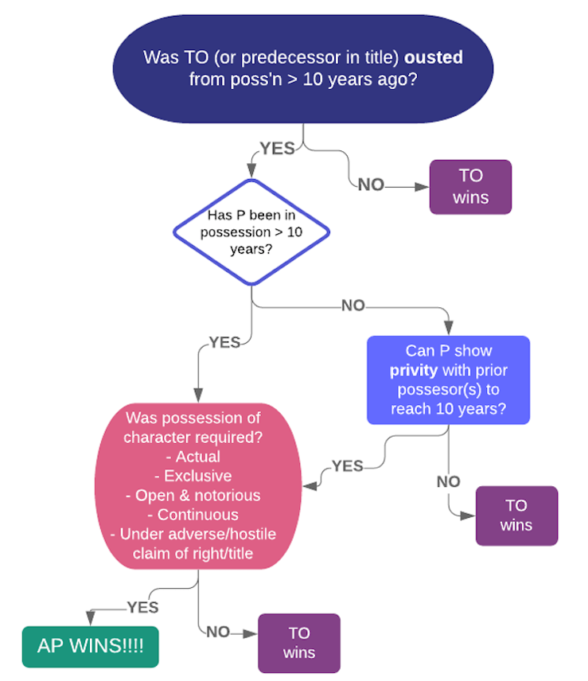
Scott –paint fence blue, gave hunting licenses, harvest. Majority rule yes AP
Carpenter: Minority rule: good faith (NY stat) – P knew she had no legal right no AP
Howard v. Kunto: summer home; erroneous deed yes AP
- Continuous? seasonal use of summer home counts (that’s how TO would use it)
- SOL? Privity w prior owner bc of common erroneous belief they owned the land
Ewing v. Burnett: lot for digging sand/gravel majority rule yes AP
- Character of prop; he periodically removed gravel & that’s what land was for. Sued those who entered w/out permission. Had no permission, color of title.
Why allow AP claims? Penalty for sleeping on your rights; reward productive use (resource exploitation); connex w land, reliance & invstmts; clear up errors in conveyance
VALUES SUBJECT TO OWNERSHIP (OR NOT)
Moore (1990) - Suit for conversion - cells used to make patented cell line
- No conversion; cells ceased being his prop. once left his body. Yes informed consent claim; this enough to protect patients’ rts & interests in ed research.
- Protect docs/med research from massive expansion of liability; would stunt research.
- Dissent? So intimately tied to personhood can’t market (Radin), Q for leg.
Hecht (Frozen sperm, probate ct): sperm cells are property; strong indiv interest (reproductive autonomy), public interest weak.
Newman (Corneas of dead kinds = prop for purposes of DP claim by parents.)
Rights of Publicity
Midler (Ford hires singer to mimic) - tort b/c appropriation of core aspect of identity (voice as distinctive & personal as a face).
White: absurd extension of Midler robot evoked aura, implicated rights
- Dissent: not evoking anything particularly distinctive about her identity, only evoking role she played in a context. IP rights are not free.
Notes: rt of publicity usually protects mostly celebs seeking to protect/maximize $ on their identity/brand; refusal to treat body as prop & protect its use arguably has adverse distrib effects on low income people bc more likely to sell body parts/be taken advantage of.
Public Rights
Causby - surface-O’s claim: flights too low, lowered value of chicken farm.
- Navigable airways basically = navigable waterways – fed govt controls
- Overhead flights = taking only if flights “are so low & so frequent as to be a direct & immediate interference with the enjoyment & use of the land.”
- Here: U.S. had taken an easement $2,000 in damages
Navigational Servitude: public has right of access to navigable bodies of H₂0
- Public can sue to enforce; structures that interfere with public’s use of waterways may be enjoined under servitude (docks, bridges, dams,)
Illinois Central RR state can’t give public trust land away, so state gets it back
- Grant void, RR can still probably get $ damages (based on reliance)
- exception to non-derogation doctrine (once you’ve sold property, can’t get back)
Legal source of public trust doctrine?
- Decided in era of federal CL (Swift) but then Erie state law doctrine
Boundaries of the public trust:
- non-tidal bodies of H₂0: land below mean high-water mark w/in public trust
- tidal bodies of H₂0: land below mean high-tide line (incl. wet beach, which is land between mean high-tide and low-tide lines) w/in public trust
LMF – sought injunction granted b/c open water cannot be taken away
- primary purpose must be public & benefit must be direct – Loyola’s use (private)
- protect for future generations – cant let people of today vote away tomorrow’s land
Matthews (NJ 1984) (before - public had normal right to use wet sand beach)
- HELD: to get adequate reasonable use of access to wet sand beach, need access to dry sand beach - subject to public rt of access (below vegetation line)
State of Oregon ex rel. Thornton: wanted to limit strip of beach to customers
- HELD: still own up until MHTL, but can’t exclude from dry sand beach
  - Legislation: “priority” to give public access to dry sand beach where such use has been sufficient to create easements (~custom~)
Test for Customary Rights: (how case was actually decided)
- Ancient/Long use + Continuous + free from disputes + reasonable + certainty – visible boundaries (vegetation line is a clear boundary) + Obligatory/as of right: Public’s use never questioned (like no interruption); Public acted as if they own right to use beach, no one asking for permission from Los + Not repugnant to other laws/customs
WHY: Confirm expectations of parties/public; social value of recreational use/enjoyment of natural space (Rose); right to use wet “meaningless” w/o dry sand
- Rose: social benefits that society gets (normative justification)
  - Democratic need to come together, important in urbanized world
- Demsetz – Public now more able to access beaches (tech- tourism, cars)
  - Benefits >costs: value of explicitly-defined public spaces has risen
OWNER SOVEREIGNTY (RT TO EXCLUDE) & ITS LIMITS
“that sole & despotic dominion which one man claims & exercises over external things of world, in total exclusion of the rights of any other individual”
Trespass - Both criminal & civil actions maybe be brought
Jacques - intentional trespass, Ps repeatedly refused D's request to cross
  - Punitive damages award granted though no actual harm
  - Categorical/absolute right to exclude
  - *Bright line rule- baseline entitlements against which to contract
Hinman - P trying to rely on “ad coelum” trespass for airplane above property; loses.
- No liability absent serious interference w use & enjoyment.
- Bargaining with each owner of air rights would be dif. Public benefits from air travel. Fewer productive uses of airspace so less need to protect owners’ rt to excl
- rt to exclude limited to land’s surface area and subjacent space; for superjacent trespasses - balancing (not absolute exclusion) approach.
Hamidi - Intel claims trespass to chattels (computer servers), loses
- actual harm required; $ of self help attempts don’t count as harm. no trespass to land b/c intangible intrusions.
- Dissents - Brown: Intel’s substantial investment in system. Mosk: Intel has no recourse, exercised all reasonable self-help efforts
Building encroachments: bright line rule or balancing test? (shift over time to balance)
Pile: absolute rule: D must remove minor encroachment underground by tearing down wall because P’s right to exclusion=baseline legal right, P not willing to sell the right
Golden Press: balance harm to owner v cost of taking down encroaching structure. slight, unintentional, good faith encroachment fine as long as not actually interfering w/ P’s use of land & removal would be unconscionably costly.
Considerations: incentivize precaution taking vs. unfairness
Self-Help
- Utilized more than legal rems. Controversial if force, generally can use rsble force.
- Most jxs allow self help repo if legal right + peaceable; some only for commercial; some never allow (Wiley).
- Note: no DP claims bc no state axn.
Berg v. Wiley - T violated lease, remodeled & violated health code; lease gave W (LL) right to retake if breach; B left. W changed locks w/ police escort.
- LL may use s-h to retake leased premises from T in poss’n if:
  - legally entitled to poss’n & means of reentry are peaceable.
- High standard for “peaceable” → Ct required W to pay treble damages
  - if T doesn't voluntarily leave, LL cannot use self-help!
Williams v. Ford Action in conversion, took car in night; P was in default
- Similar rule as Berg→ but Ct says NO breach of peace b/c no actual violence
WHY these standards: discourage violence; endowment effect. More tolerant of self-help repossession of personal prop. than real prop (greater risk of violence, more risk of absconding w prop/damage.
EXCEPTIONS:
Necessity: to avoid serious injury to self or others
Ploof - Storm, asshole’s servant unties ship necessity.
- need sudden, not pre-planned circumstances making bargaining impossible
- affirmative right—asshole had to pay damages for impeding that right.
Vincent - D stay docked in storm; damage to dock → liable for damages but OK to stay.
- privilege of necessity allows to stay on dock BUT priv incomplete (pay $)
2 ideas: shifts rt to exclude from LO to person entering under necessity (prop rule) vs. LO still has rt, but can only vindicate by seeking $ (liability rule)
Custom
McConico - P warned D not to hunt on his land; D still rode over, hunted deer.
- Customary right to hunt on unenclosed & uncultivated lands never disputed; OK.
- Still good law - undeveloped & unfenced areas are still open to hunting and fishing unless posted (“No Trespassing sign”)
Public Accommodations – owners have duty of nondiscrimination - NJ law:
- Shack - no trespass “property rights serve human values”
  - When you open property to others for your economic advantage (ex., workers, tenants, customers) → sovereignty limited to the extent needed to protect other people to whom you have opened
  - Here: migrant workers, super isolated – live and work on land
- Uston - hotel kicks out card-counter if open to pub + for own $ benefit, flips presumption: Casino has burden to justify excluding him and didn’t here
Constitutional trumps
- Lochner era (~1900s-30s): broad, nearly absolute rt to exclude BUT racist
- 1937/New Deal era – slightly less racist, EP/free speech rights expanded
  - authority to define prop rights put more in hands of the states
  - Property rights/economic liberties narrowed in scope, weakened
- Balancing test: weigh CL rt to excl against Const rts/interest. Rt to excl strongest in home, weakest in pub places. If no state axn, no const argument.
Marsh v. AL - Marsh distributing leaflets in company-owned town; no trespass
- Owner has diluted interest in exclusion b/c: opened up to general public for own $ benefit, functionally same as other towns, can’t “pick and choose” who can come in/out. Public has strong interest bc vulnerable/isolated/dominion.
- State action: enforcing trespass-police carried out, criminal sanctions
Shelley v. Kramer – whites sued to enforce racially restrictive covenant. Injunction = sufficient state action tro trigger const scrutiny.
- state action? injunction that would enforce covenant -14th Amend scrutiny
Bell v. Maryland - 12 Black students convicted of criminal trespass for sit-in
- supervening change in state law → Court vacated judgment of MD CoA, remanded BUT Black dissent defended trespass, social order argument
Civil Rights Act of 1964: Title II protected these trespasses, never resolved
State Action: Deny discrimination in public vs. not in homes by defining this
FORMS OF OWNERSHIP
- Convey: Grant (sale/gift) during life of grantor ("Inter vivos“), Devise: leave by will
- Inheritance = acquisition by heirs if O dies intestate (w/o a will) or fails to leave all
O → A [& his heirs] =A has Fee Simple Absolute (all property rights)
O → A & his heirs as long as land used for farming = A has Defeasible Fee
O → A as long as land used for farming but if land ever used for nonfarming purposes, revert to O = A has FS Determinable, O has Right of Reverter
O → A but if land ever used for nonfarming purposes then O shall have right to reenter = A has FS Subject to Condition Subsequent; O has Right of Entry
O → A as long as land used for farming, but if land ever used for nonfarming purposes, then to B = A - FS Subject to Executory Limitation; B - Executory Interest
O → A for life = Life Estate: all rts til A dies, then reverter to O or remainder to 3rdP
- Defeasible = automatic reversion, subc cond subsq = reversion at discretion of O
- Remainder: must be capable of becoming possessory immediately upon end of LE + incapable of divesting prior possessory interest or vested future interest
Conflicts over time
Waste -act by life T that does permanent injury to inheritance (future interests)
- Affirmative: “misfeasance;” unreasonable act, causes “excess” damage to future interests (beyond normal wear/tear); defined re: normal use
- Permissive: “nonfeasance;” unreasonably fails to take some action w/r/t property, which causes “excess” damage to future interests (Ex: failure to repair roof, not paying taxes, allowing an adverse possessor to remain)
- Ameliorative: substantially changes prop but increase in market value
  - E.g., Brokaw (grantor’s interests (“my residence”), future interests
  - Distinguish from Melms (brewery) b/c there not suitable for residence.
  - some jurisdictions won’t view that as waste; some modern courts might be more willing (Brokaw ct)
Restraints on Alienation – Cts take dim view, dead hand control
- BUT typically uphold restraints for a limited period of time if they appear to be reasonably related to some family estate planning objective
- Why we care - autonomy, efficiency (want in hands of who values most)
- Toscano – conveyed lodge w restrict. Court strikes down restraint on sale but upholds use restrictions (even though same practical effect as retrix on sale).
  - OK to limit how lodge can use property (common!), esp. for organizations w/ articulated purpose eg school, charity (burden worth it)
  - Dissent: both restrix have same effect, should be treated alike/struck down.
- ***Restraints on use presumptively valid (unlike restraints on alienation)
Rule Against Perpetuities: No interest is good unless it must vest, if at all, no later than 21 years after some life in being at the creation of the interest
- Bracket clauses & identify all interests created
- Figure out which future interests, if any, are subject to RAP & as to those:
  - Identify “lives in being” at time of grant,
  - & imagine “what might happen” to cause vesting to occur as remotely as possible after death of “lives in being”;
  - if >21 yrs after “lives in being,” invalidate clause creating it
Symphony Space RAP applies to commercial properties
- Buy-back option invalid: b/c no measuring life, limit is a flat 21 years from date of the grant, interest could vest 21 years after this (2003)
- Crossed out entirely (instead of severing) - no rescue for sloppy drafting.
Proposed Reforms:
- “Wait and see:” wait for CL RAP period, see if interest in fact vests remotely
- Interpretation & implication: add savings clause/otherwise reform interest
- perpetuities savings clauses – refer to invalidation under RAP, specify backup plan
Transferring Ownership/Real Estate
Proving & Recording Title:
- Why? protect markets/good faith purchasers vs. title defects in seller’s chain of title
- Nemo Dat - “one cannot give that which one does not have”
  - Owners must be able to trace ownership back in time through series of legitimate transfers to legitimate original acquisition
Recording statutes: (O A (T1), then O B (T2). A never recorded. B has no idea)
- Notice: subsequent bona fide purchaser wins unless he has notice - recorded interests give “record notice” (B > A, regardless of when records)
  - Notice: Actual (you actually know); Record (it’s been recorded); Constructive (should have known for some reason)
- Race-notice: a subsequent bona fide purchaser wins only if she has no notice and records first (B > A, but only if he records transaction before A)
- (pure) Race: whoever records 1st wins (small minority of jurisdictions)
LIMITS: If recording act fails to apply (nemo dat); need for surveying and physical inspection; Mugaas v. Smith- AP claim wins over recording!
Conflicts between concurrent owners
- Tenancy in common (TC): each T has separate (independently descendible, conveyable, devisable) but undivided interest - no (RoS)
- Joint tenancy (JT): the same as TC except that there IS a RoS:
- 4 unities: Time: vested/acquired at same time; Title: acquired by same instrument (or AP); Interest: legally same (e.g. all FS/life estates) but don’t have to be proportionally =; Poss’n: each has rt to possess whole
- personal friction b/n co-Ts (usually siblings), but law provides background rules
Severance - Dividing one of 4 unities turns a JT → T/C
- Each co-T may sever unilaterally (w/o other T(s)’ permission)
- Can a mortgage sever a JT? Harms - NO: mortgage = lien, disappears if JT dies
- Can a lease sever? Lease = convey prop interest, or lease = mortaage/lien/K?
- If > 2 co-Ts & one severs = “destroying” T has only destroyed JT as to their interest - remaining interests remain as JT until also destroyed
Partition: Ends co-tenancy completely by dividing prop or its value;
- does not require any reason or justification; an absolute right
- “In kind:” physical division- default, avoid forcible dispossession of T(s) in poss’n
- By sale: if in kind is impracticable or all parties’ interests better served
  - E.g., property fully occupied by single house; use being made of one part of property is nuisance to rest; many co-Ts
Delfino – (trash biz and home): presumption is partition in kind
- Division of land feasible here & D lived + has biz on land. Don’t like forced sales esp if someone is living on property (unless they could buy person out??)
- BUT presumption softening as land less unique, more fungible
  - by sale - advantages of sending land toward highest/best use
Ouster: one co-T absolutely denies other co-T’s rights of ownership & poss’n
- Exclusive use not enough, Co-T(s) must necessarily exclude others:
  - Act of exclusion OR use of such a nature that it necessarily prevents other co-T(s) from exercising their rights
  - Might lead to AP, but requires overt repudiation to start clock
  - almost at level of one co-T saying explicitly to other(s): “you have no interest in this property, it’s all mine”
Gillmor: Acting in a way that necessarily excludes co-T sufficient for ouster
- D&P owned equal shares of land for cattle grazing, D in exclusive poss’n
- P requested D alter use to allow her use, D continued use of land at max capacity which made her use impossible; mere exclusive possession isn’t sufficient for ouster
- can sue for share of rent/profits if ousted
PAYMENTS
- Rent (3^{Ps}): if one co-T rents, must share evenly w/ co-Ts (proportional to interest)
- In general, no obligation for co-T in exclusive poss’n to pay rent to co-Ts
  - BUT, if co-T ousts other co-Ts, ousting co-T may have to pay ousted a proportion of FMW
- Repairs/improvements: co-Ts in exclusive poss’n who make repairs or improvements have no right of contribution from other tenants, except:
  - If co-Ts stood by and let improver proceed to his detriment.
  - If co-T acted in good faith, believing himself to be the sole owner.
  - If repairs were essential to preserve/protect common property.
ENTITY PROPERTY: Separating Management & Possession
- permit mgmt of resources to be separated from use/enjoyment
The Lease & Landlord-Tenant Law Lease =
- financing device (like loans)
- risk-spreading (T: minimize risk of over-investing, LL: if Ts defaults, easier to retake than foreclose on a mortgage, advs > when multiple Ts)
- entity [managing complexes of assets (apt bldgs, office bldgs, malls)]
- Term of years - Fixed time at which lease terminates or ends
  - SoF: in writing if > 1 yr; no notice req before terminating lease
- Periodic tenancy - Automatically rolls over for stated period of time
  - Requires notice for termination
- Tenancy at will – LL/T can terminate at any time for any reason (notice req.)
- Tenancy at sufferance - When T holds over after right ended (Berg)
~STATUS → CONTRACT~
Old CL: “T” = status. Rights/responsibilities largely determined by law.
- T: right of possession in exchange for payment of rent.
- LL: has FSA subject to term of years (rights of lease + rights of T)
- Tenancy: Defeasible (could end on occurrence of some condition), usually on condition subsequent giving LL a right to reenter (Berg)
- Leases: short and simple, background rules (agricultural land)
Newer CL: Rise of market economy → freedom of contract (K). Focus on
- Intent (expectations/agreement) → what lease says that parties agreed to
- Diff rules of interpretation, default rules, substantive rules, remedies
- (+) lets people make decisions for themselves, bargain for what they want; (-) Unequal bargaining power, especially for urban, multi-unit dwellings.
→ ***COMMERCIAL LEASES
TODAY: CL reforms protecting T > lease → ***RESIDENTIAL LEASES
Paradine – independent covenants (Prince Rupert seizes land, expelling T)
- Do we care who ejected tenant? → YES, defense if LL or LL’s agent responsible for evicting T (implied obligation not to throw T out)
- Indep covs - all covenants must be performed w/o regard to whether other covenants have been/can be performed; frustration of purpose no excuse.
T’s covenant to pay rent generally independent of actual enjoyment of poss’n unless LL/agent evicts T from all or part of the premises
Smith: – if no actual eviction, can still have constructive eviction.
- LL builds wall encroaching on leased premises; doesn’t interfere w/ T’s use; T stops paying rent altogether; LL sues for rent. Ct finds for T.
- rent charged for whole of land. Constructive eviction duty to pay excused.
- covenant of quiet enjoyment (CQE)– at a minimum, I the LL won’t evict you; if I do evict you, suspends your obligation to pay rent.
What happens if squatter/holdover in poss’n when new T’s leases begins?
  - English rule: LL responsible; American rule – T responsible
  - ^can be modified by parties in contract
Blackett: noise = constructive eviction.
- LL sues T for rent; T claims constructive eviction (noise from lounge)
- LL (as LL of lounge too) had power → duty to do something (breach of CQE)
Sutton (Lead from paint in grass → dead cows) – CAVEAT LESSEE
- Buyer beware! CQE implicit; otherwise no implied warranties land suitable for purposes which T rented, even if LL aware. (Could make express warranties in K, but even then, remedy for breach is damages not excused from rent).
- Dist. Smith v. Marrable [short-term, furnished home (personal v real)]
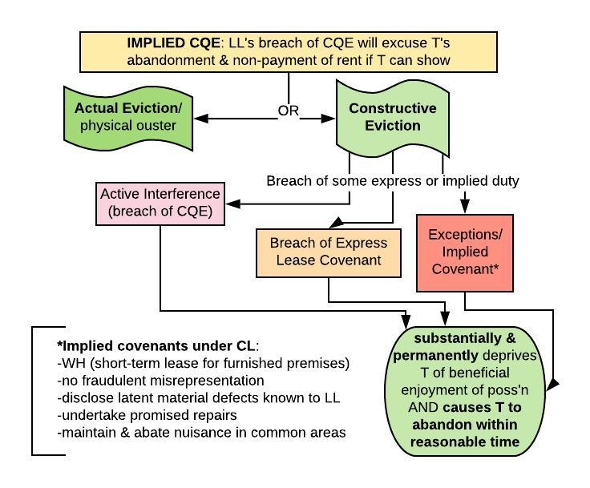
Implied Warranty of Habitability duty to pay rent dependent on L’s IWH
- Shift from market to societal standard for housing conditions
- Allow T to stay while claiming uninhabitable (bc market) – no more abandonment req
- Allow patent defects as breach for IWH
  - Or LL will just be upfront & T will feel like they can’t leave
- IWH cannot be waived (otherwise LLs would put in Ks in reintroduce market forces)
- improve housing supply w/ public intervention (vouchers, public housing)
Javins - housing code violations, Ts withheld rent; LL sued to eject; Ts win
- Brown: if serious housing code violations @ time of lease, void, T evicted
- IWH - for leases of urban dwelling units covered by code
  - must be material departure from std of habitability as set by code
- Public policy: too concerned re unequal bargaining power to leave this to K/market
Allow waiver when consideration given? (-) LL bargaining power/paternalism; protect 3rd parties, (+) freedom of K, may price out low-income people
Abandonment Q - How long is T on the hook?
- Treat as offer to surrender leasehold, and accept surrender.
  - Lease ends, T off hook for rent, not damages (Leased rent - FMV)
  - *best option for LL if value of property has gone up
- Reenter & re-let as T’s agent (at least if lease allows):
  - LL can re-let premises on T’s behalf; T still on hook (for lease rent - any rent that LL collects on T’s behalf & LL owes T any surplus)
  - *best option for LL if value has gone down/difficult to find new T
- Do nothing & sue T for rent as it comes due under the lease (Sommer shuts this
Sommer – duty to mitigate, option 3 dead
- D said he couldn’t pay rent, 3rd party wanted D’s unit; LL denied; LL sued D for rent
- LL had duty to mitigate damages by making reasonable effort to re-let
- LL has burden of proving reasonable diligence, consider whether LL showed or advertised (T may rebut by showing suitable Ts were rejected)
- Generally, duty to mitigate non-waivable (like stipulated damages)
- ex of shift to K law
~Lost volume principle: if by re-letting T’s abandoned apt, LL can’t rent another available apt, T might still owe damages; BUT T: “my apt unique”
Kendall v. Pestana: SJC airport hangar
- Lease said needed written consent before lessee could transfer, failure would render lease void at option of lessor.
- Held: Consent to transfer commercial lease may only be withheld for commercially reasonable objection
  - financial stability of assignee; whether proposed use suitable; whether use will require alterations to property; the legality of the enterprise
- Unclear if you can K around this. Also unclear if applies to residential leases (discrimination bigger problem in that context?)
Coops, Condos & Common Interest Communities: ownership >T in LL/T context
- Managing entity is a body of the residents → more democratic
- Rules/restrictions in all 3: Can be included in original title document; might come up later through rules promulgated by governing body Owners don’t have all sticks of bundle → Governance strategy of mgmt
  - give up autonomy, liberty in favor of collective self-governance
Condo: Residents own interior spaces (FSA)
- Condo Ass’n (all resident/O’s) owns exterior, walls, common spaces
- Res/O pays maintenance fees, is constrained by rules of Ass’n
- Typically free alienability, no Board approval of sales
Nahrstedt - Whether cat restriction was unreasonable since only inside
- Restrictions from declaration or master deed of condo: strong presumption of validity cat restriction falls here, upheld bc rationally related to health, sanitation concerns
- Whereas rules promulgated not entitled to presumptive validity
  - Subject to reasonableness, fetter discretion of board
- Dissent (Arabian): pet ownership has substantial benefits, confined to unit
Cooperative (esp in NY) - Title in whole bldg held by a coop/corporation
- Corp = residents, govern thru elected Bd; own: (1) shares (2) long-term lease in unit
- “maintenance” fees & rules., Coop Board must approve sale of indiv units
40 W 67th St v. Pullman - man acting crazy, harassing old couple
- business judgment rule: defer to Coop Board decision so long as Bd acts: (1) for purposes of the coop, (2) w/in scope of its authority, (3) in good faith. If competent evi reqd, decision of Bd can serve as competent ev.
- approach to co-op disputes: (1) Look at rules that would apply in LL/T law (here, it was the RPAPL) (2) Give a little extra deference to the Board as long as BJR is met.
Why is standard to evict coops lower than to evict reg Ts? Ts more vulnerable than co-op owners (w/ share in governing board, power in rulemaking, $)
Common interest communities: Homes owned in FSA, subject to covenants, enforced by Homeowners’/Neighborhood Ass’n.
- e.g., use restrictions, lot setbacks, requirement or prohibition of fencing, aesthetic regs, payment of fees for maintenance of common areas
THE LAW OF NEIGHBORS
Nuisance → defines scope of right to use/enjoy property
- O1's active right to use/enjoy ends where O2's passive right begins
- Who can claim? Owners/occupants, anyone in poss’n - Ts/adverse p
WHY a different, more relative std than trespass?
- Physical invasions generally avoidable, can be bargained over
- Hard-edged rule more difficult (noise, smells, dust → diffuse harms)
- Would hinder some socially valuable uses of property!
- Threshold test: if harm crosses threshold → nuisance (Campbell)
  - D’s utility is basically irrelevant, presumptive right to injunction
  - Gives some strong protection for use and enjoyment of land
    - But net effect - some useful activities shut down
  - Over-enjoinment problem? – can’t undo an injunction
- Balancing of harm and utility (Restatement, Del Webb, Boomer)
  - Under-enjoinment: D isn’t forced to internalize externalities
  - But can use regulation which considers full range of harms
Hendricks - well on one prop can’t have a septic field on other
- Harm reciprocal - only one use can win, Court says no nuisance
- Having well reasonable; 1st in time principle; sewage more “invasive”?
Adams - IRON MINE - non-trespassory invasion (dust) → NUISANCE
Campbell (burning bricks) P mansion, D neighbor w/ brickyard – threshold test
- D there first but started burning bricks after, gas killed plants and trees but only entered when wind carried (not continuously). Protex for luxury.
- Meets threshold – nuisance (w/o valuing brickmaking)
- But q of whether damages or injunction? here, mischief was substantial and irreparable → injunction
Boomer - pollution from cement plant’ threshold test = NUISANCE but remedy balancing
- remedial discretion → permanent damages awarded (Rule 2)
- Social cost: jobs; tax revenues; huge investments, avoid holdout problem
- P’s lands will be subject to a servitude (easement to commit a nuisance)
- Value = difference in market value of affected lands
- Doesn’t capture: value LOs ascribe, health effects, harm to 3rd parties → So systematically tilted against Ps
Del Webb - retirement community v. cattle lot; harm > utility, but P must pay D
- public nuisance, when 1st in time not defense, seems unfair
- Balancing test – harm outweighs benefits in the area injunction.
- BUT developer bought land for cheap and getting the windfall. He created the incompatibility, so should pay.
**ASK in enjoinable nuisance: Should P pay b/c P created incompatibility?
When we ask what property rights someone has w/r/t land → state law.
When it comes to the right to U&E → issue of state nuisance law
Remedies: remedial discretion, injunction default but Ds often want damages
- Injunctions can spur innovation
- Under-enjoining more fixable than over enjoining (leg, zoning, other regs can shut down incompatible uses –even if not enjoined – but cant undo an injunction, though can sell/buy it)
- Institutional competency – who should decide uses? Leg better positioned?
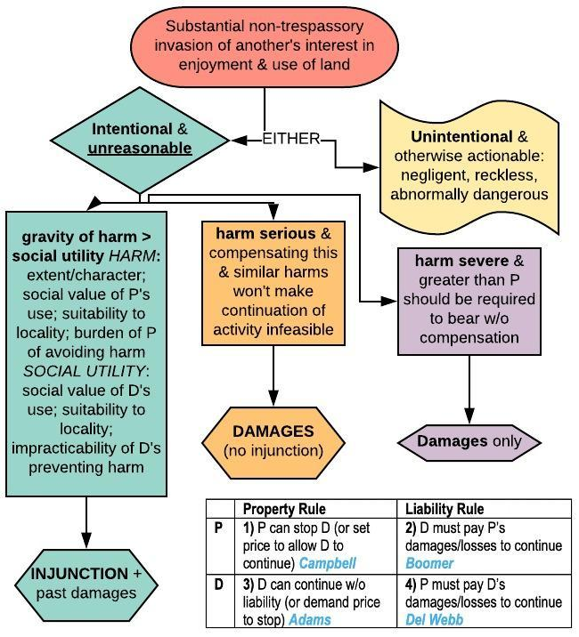

Servitudes → Owner waives right to exclude certain kinds of intrusions by another and gives other a right to use (not revocable at will)
- Easements appurtenant - Belongs to another parcel of land
- In gross - Belongs to a particular grantee
- Profit à prendre - Rt to enter land in order to extract something of value
- Affirmative - permit some affirmative act on ST (*virtually all easements*)
- Negative - permit to demand owner of ST desist from certain actions (rare)
Creation (Grant: granted in sale. Reservation: I sell this to you, but I retain the right.)
- Express grant/reservation –explicitly, separate doc or as clause in sale
- Implied grant/reservation –severance of DT & ST at some point in past
  - Based on prior use OR necessity: Unity of title/common O followed by severance of DT/ST under … circumstances (apparent prior use &/or necessity) AT TIME of severance
  - Courts reluctant re: implied reservations bc seems like derogation of grant
  - Prescription - requirements/theory similar to AP
    - Requirements: 10 yrs, use open, notorious, continuous, no permission, act as if right to use (BUT exclusive use not reqd)
  - Estoppel – permission/assurance + reliance
To bind successors (easement runs w land): notice (actual or constructive) + intent to run (not for prescription or estoppel)
Right of way: most common; right to cross someone’s prop to get to yours
Policy: enforce encourage bargaining ex ante, but potential for extortionate power/unfair
Exs: Boomer (dust), Thornton (public access to dry beach)
Baseball Publ. - wall sign = easement not lease (no possession) nor license (irrevocable)
Schwab - Implied grant/reservation? → NO
- No. P sold portion w public road access (created necessity)
- Not truly landlocked; water access
Holbrook - Estoppel - YES (road for construction to home, spent $) HIGH STD
Warsaw - Prescription - YES (driveway for truck access) EASIER STD for DT
- Where valid prescriptive easement, not required to compensate FMV of easement or costs of removing/relocating encroaching structures which interfere w/ use of easement (prop right backed w/ liability right).
- ST can’t interfere w DT’s rt of access (had to tear down)
Misuse: Penn Bowling - Express easement, new DT builds building serving DT + adjacent land, using easement to service both → changed nature of use
- Bright line rule: when easement appurtenant to one lot, aren’t allowed to use if for non-appurtenant lot that you later or separately acquire
  - Gray area: expanding scope - reasonableness determination of whether use has changed so much no longer w/in original scope
- Misuse insufficient to constitute forfeiture, waiver, abandonment
- Injunction appropriate when cant tell whether using for DT or other (remanded)
Covenants: O agrees to certain restrictions on use of land for benefit of other(s)
- ASK: Circumstances giving rise to a restriction? Who can enforce the restriction? Against whom? **Existence of common plan relevant at each stage!
- Enforceable reqs: intent, notice, “touch & concern”
  - defenses: pub pol; equitable defenses (laches, estoppel, unclean hands, waiver, abandonment (Peckham), changed conditions (Bolotin), Const
- Reciprocal restriction? Implicit promise, pattern/expectations, common plan, maps.
Tulk (Eng): expanded category of equitable servitudes beyond CL easement
- square garden covenant, had notice of it
Sanborn - gas station - Ps sued to enjoin. ~reciprocal negative easement~
- When O of related lands conveys part of land to another w/ restrictions intended to benefit retained land, same restrictions apply to retained land
- Inquiry notice
- enforceable v each successor w/ knowledge until easement expires, or outdated
  - Should have noticed plot of land traced back to O, related parcels conveyed w/ strict use limitations, observe lots surrounding
Conservation easements: Negative: ST can’t do x & in gross: enforced by gvm’t/trust
  - (-) perpetual nature, use of tax subsidies, lack of public oversight
Bolotin - Owner of undeveloped lots off Wilshire wants to go to commercial; can’t
- explicitly restricted to single-family residential use, but useless for this purpose
- DTs paid for right to stop neighbors from using land inconsistently w/ covenant
- Changed conditions - require changes w/in neighborhood; not just at border
NOW Q: Have “changed conditions rendered the purpose of restrictions obsolete,” such that “enforcement of restrictions … will no longer benefit the [DTs]”?
Peckham - daycare, covenant against home businesses upheld
- Court shoots down 4 diff possible reasons for not enforcing covenant
  - Abandonment: need proof violations have eroded general plan, when covenant “habitually and substantially violated” → not true here
  - Laches: need (1) knowledge/reasonable opp. to discover cause of actions, (2) unreasonable delay, (3) damage to D resulting from delay
  - Equitable estoppel: need (1) admission, statement, act inconsistent with claim, (2) action in reasonable reliance (3) injury
  - Public policy: Q for legislature to decide
Zoning
- State/local law; democratic; reflect local prefs; rational planning/governance
- Zoning def state action; constitutional constraints (DP, Takings, EP, 1st amend)
- Nuisance law AKA “judicial zoning”, covenants AKA “private zoning”
- Preexisting non-conforming uses usually grandfathered in (prevent Takings claims)
Euclid: Rational core of zoning: separate incompat uses. Class/de facto race segreg OK.
- Use restrixs (“Euclidean zoning”); P wants to use land for industrial but cant.
- P argues SDP (econ liberty) (facial challenge); city argues police powers/nuisance.
- Held: Zoning valid exercise of police pow (like nuisance law), reg for general good.
  - SFR <-> indust – OK, nuisance. [Purely res dx usually sustained: prev fire & accident, reduce noise]
  - SFR <-> MFR? Apts/class = proxy for race. Ct: OK bc MFR basically a nuisance in context: block sun/light/air, traffic, commercial (?), destroy character of ‘hood.
Mount Laurel (NJ): state constitutional protection vs. exclusionary zoning
- Zoning restrix made MFR basically impossible Class & de facto race segregation.
- Held: zoning unlawful; under state const, must promote general welfare (incl of people who don’t live there now but would want to).
- If zoning makes afdbl housing imposs, burden shifts to govt to show reason. Tax rev/$ burden of more kids, purely local prefs don’t cut it (bc must promote gen welfare).
- Note: govt didn’t have to create afdbl housing, just couldn’t make it imposs
Eminent Domain
5th Amend: “nor shall private prop be taken for public use w/o just compensation”
- Just compensation = fair market value (FMV)
Kelo (2005) - economic dev project for depressed town
- Private A private B: Not OK if sole purpose is B’s benefit; OK if for use by the public/public benefit.
- part of integrated economic development plan; tax rev + jobs = public benefit
Berman: urban renewal in blighted area; ED private B OK
- Thomas wants to overturn; concern re impact on poor coms + no comp for subjtv value/displacement
Midkiff: Ct upholds state process for land redistribution - forcing big LOs to sell land (ED)
- Legislature came up with the plan; part of comprehensive econ development plan (one-to-on transfers raise susp of purpose to benefit private B).
- Incidental (even if significant) benefit to private B OK, as long as primary benefit & purpose is to benefit the public
holdouts: pub doesn’t benefit if one LO blocks valuable devel; ED aims to prevent.
deference to leg here bc courts not good at guessing leg’s purposes
Takings: Literal taking? Rise to level of constitutional Taking?
Inhere in title:
- Background principles of state’s prop & nuisance law (Lucas; police pows not determ)
- Actual necessity, easements, preexisting servitude, limit on title that run w land. Lucas
- Statutory restrictions – not necessarily (Palazzolo)
- Acting in police power; prevent serious pub harm/pub nuisance (Mahon) (cf Lucas)
Balancing:
- Singling out v comprehensive plan (Penn); extent $ harm; RIBES/prior statutes (Murr)
- Reciprocity of advantage (height restrix: burdened, but benefited in form of light/air)
Physical Invasions
Factors: Open to public; extent of econ impact, state v. fed (cf KA & Pruneyard)? Perm?
Kaiser-Aetna: invested in pond to create marina; gov’t claimed navigational servitude
- Literal taking? YES, rt to exclude (inherent limitation?); Taking? YES
- Huge RIBEs, severely impacted by govt limiting their right to excl. Not open to pub.
- State law said pond was private prop, subj to navig servitude after made navigable
- Unclear if holding is this phys govt servitude, or all phys govt servitudes = taking
Pruneyard - Literal taking? YES, rt to exclude. Constitutional Taking? NO
bc no impact on use/value, no harm to RIBEs; open to public; state auth to define prop rights so OK to impose this limit (distinguished from KA - federal gov’t). Judicial taking.
- Conc. (Marshall): States’ power to redefine prop rights not unlimited; “sphere of private autonomy” secured/ protected by prop rights (from Substantive DP)
- Cf. Marsh – no fed const rt, but CA free speech rights go farther
Loretto - gov’t required cable to be installed. Literal taking? YES, phys invasion; Constitutional Taking? YES, per se.
- permanent physical invasion – takes rts to excl, possess, use, dispose of prop
- even tho no harm to value or use; no privacy issues
Nollan - Conditioned house permit on pub easement for beach access. Taking if imposed outright bc PPO, so taking here too.
- PPO bc pub gets permanent, continuous right to cross prop per se taking.
- Dist. KA (classic rt of way easement v nav serv); dist Pruneyard (closed to pub)
Regulation of Use
Mahon – state law regulating mining subsidence = taking? → YES
- State law: mining cos must leave in place enough coal to not affect surface
- All ct agrees: if state acting w/in police power (esp. prevent serious harm to public/abate public nuisance), no Taking
- Holmes/majority: Subsidence not a pub nuisance; denom = supt estate Taking
- Dissent/Brandeis): Subsidence is pub nuisance, state can regulate bc broad police power; denom = all of mining co’s rights.
Miller - VA law → destruction of all cedars w/in 2 miles of apple orchards
- Literal taking? YES; Constitutional Taking? NO
- defer to legislature; taking of 1 of bundle of rts = taking of prop (conceptual severance)
Penn Central - Grand Central; building barred by NY Landmarks Preservation Law
- Literal taking? YES; Constitutional Taking? NO → BALANCING TEST
- RIBEs based on use as railroad terminal; can continue current uses & make $$$
- Character of gov’t axn: phys invasion more readily a taking; not phys here but reg.
- Is the owner being singled out (arbitrarily)? Majority: Not here; comprehensive plan & nothing arbitrary about singling out Grand Central as an iconic NY landmark.
- Denominator? No conceptual severance → focus on the parcel as a whole.
Keystone - PA law bars mining under occupied land if risk of collapse/subsidence
- Unlike Mahon, denom = parcel as whole; reg only limits mining in supt estate but can still mine all mineral estate; econ burden not big enough no Taking.
Lucas – Reg bars new structures on beach; prevent coastal erosion.
- Limits inhere in title? background principles of state prop & nuisance law
  - leg gets little deference in deciding whether something is a nuisance – it must have reference to the existing CL
  - remanded to decide based on state nuisance CL -- probably no
- Elim all econ viable use per se taking (Denom = whole parcel)
- Other limitations inherent in title: Actual necessity, easements, pre-existing servitude, limit on title that runs w/ land. Statutory restrictions?
Palazzolo - RI regs designate certain waterfront land wetlands; makes it hard to build on most of land. Literal taking? Yes. Taking? Remand to Penn Central; probably loses.
- Statutory regulation doesn’t inhere in title; new owners can challenge as takings
- Hobbesian stick (positivism!) in Lockean bundle (natural rights conception of prop rights) → gives State too much power to redefine property rights prospectively
- price = value as restricted + prob*value if prevail on Takings (Stevens - windfall)
- O’Connor: existing stat restrix should be in balancing test in RIBE. Scalia: nope, just bringing it through the back door.
Tahoe-Sierra - moratorium on land use (32 mths) – not taking
- Denominator = parcel as a whole = geographic & temporal dimensions of O’s interest in the land –> conceptual severance is dead. (Good ruling for regulators.)
- But how to handle if not FSA (lease, life estate, etc)? Open q.
Murr: denominator test if 2+ parcels - Adjacent lots merged as denominator.
- WI law bars devel/sale of riverfront lots w <1 acre buildable land.
- P has two lots & cant build on one. State law treats lots at merged. P sues for taking and says denom = lot 1. Govt says denom is both lots together. Court sides w govt.
- NEW 3-part test to determine denominator when 2+ parcels:
  - Treatment of land under state & local law
    - Incl. lot lines and merger clause
  - Physical characteristics of the land (& likelihood of future regulation)
    - skinny lots; on steep cliff; scenic lake - could expect regs
  - Prospective value of regulated land (preserve nat beauty; increased priv & rec space; if adjacent lots, possible offsetting gains to value of other lot)
- Remanded to Penn Central; probs no taking – no RIBEs bc restrix reg predates acquisition of property (answers debate raised in Palazzolo), no severe $ impact.
- Dissent: mushes up one Q… Formalism better (look to how state law defines prop)
- Note: if D owns parcel, splits it into two lots, then sues for a taking of one claiming that one lot as the entire denominator (to increase $ impact), courts probably treat as opportunistic manipulation of denominator/selling off econ. viable portion.
Implications of Lucas and Palazzolo:
- Constrain legs by tying regulatory capabilities to CL of nuisance; deregulatory ethos.
- Nuisance does well w neighbors & confined externalities. Does poorly w harms that are diffuse, extend beyond parties in lit, latent, or result from aggregate effect. Tends to under-enjoin; allow harms to continue.
- Legal system had decided 2-party nuisance disputes weren’t adequate to deal w harms, so used regs to fill the gaps. But now court is limiting reg possibilities.
- Wildcard: pub nuisance statutes. Palaz implies some stats sufficiently conventional to inhere (eg pub nuisance, as long as applied in predictable way eg ordinary zoning)
- Also show erosion of positivism; suggest quasi-natural rights constraints on how far state can go in regulating property.
Exactions
Nollan-Dolan: 1. Would the exaction/condition be a Taking if imposed outright?
2. If so, the condition is a Taking, unless both:
- it serves same govt purpose as development ban/adequate nexus (Nollan);
- roughly proportional to costs/burdens of permitted development (Dolan)
Koontz – applied to develop portion of property zoned as wetlands denial = TAKING
- Where gov’t denies permit unless O fulfills “condition precedent → Nollan/Dolan test
- District denied b/c Koontz refused to either:
  - (1) reduce the size of his development area and deed an easement to the government on the rest of the property, or
  - (2) fund improvements to District-owned land miles away.
Assuming gov’t could constitutionally deny permit altogether - why not give Os choice?
- Doctrine of unconstitutional conditions: just b/c Gov can deny you access to X, doesn't mean can condition access to X on anything they want potential extortion
Judicial Takings
Stop the Beach Renourishment (2010): Fixed O’s property line at what had been MHTL
- O: State Ct “took” my littoral rights of contact w/ water & future accretions to beach
- Erosion control line = prior MHTL = new permanent boundary nothing was taken
- Pre-existing state law - basis for understanding that any avulsion is now state’s prop
  - Not a taking if it had been done by the legislature
- But they still ask ~Constitutional Taking?~ (hypothetical counter-factual analysis)
  - What’s relevant prop right/denominator? Littoral rights vs. parcel as whole
  - Split 4-4: Scalia idea of judicial takings/test that should apply → no holding
Potential implications: Pruneyard: state constitutional rt of access; Thornton: customary rt to access, public trust that expand scope, eg above MHTL rulings (Mathews; NJ). Are these limits that inhere or taking an existing rt (to excl)? If it takes “established property right,” arguably judicial taking (though justices disagree whether this exists at all).

