Lottery and Room Selection
Participate in Room Selection-Individual Phase II

- To log into the housing portal use your NYU Home NetID and Password.

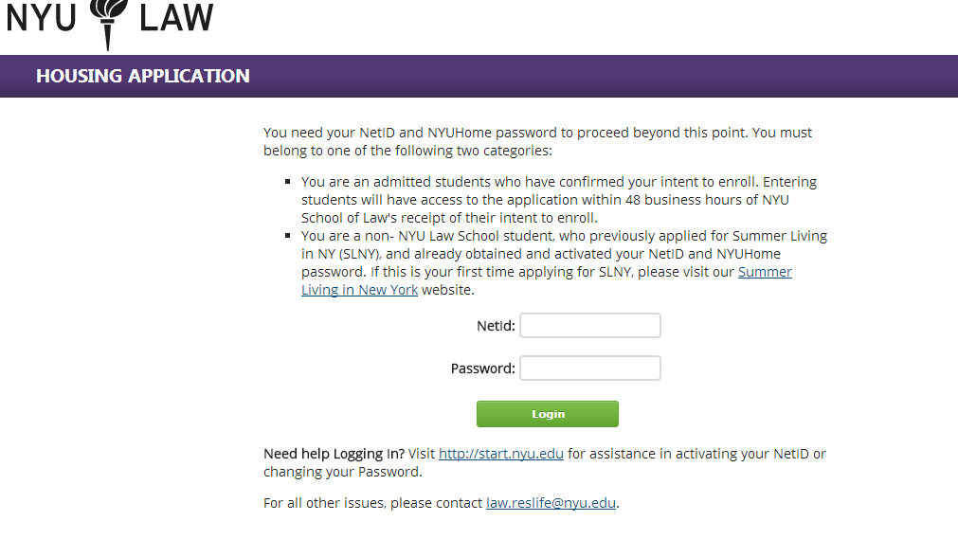

- Next click on the Application tab at the top of the page.

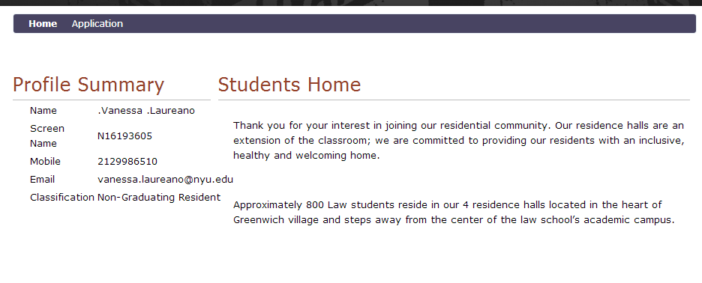

- Click on the Term below, Save and Continue.

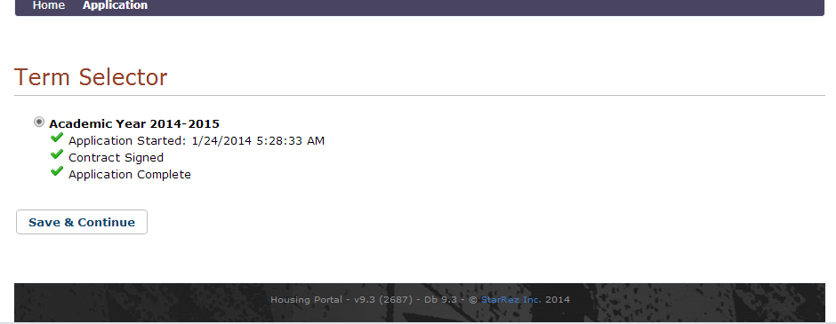

- The portal will bring you back to this page. To view your lottery date and timeslot select bubble #9.

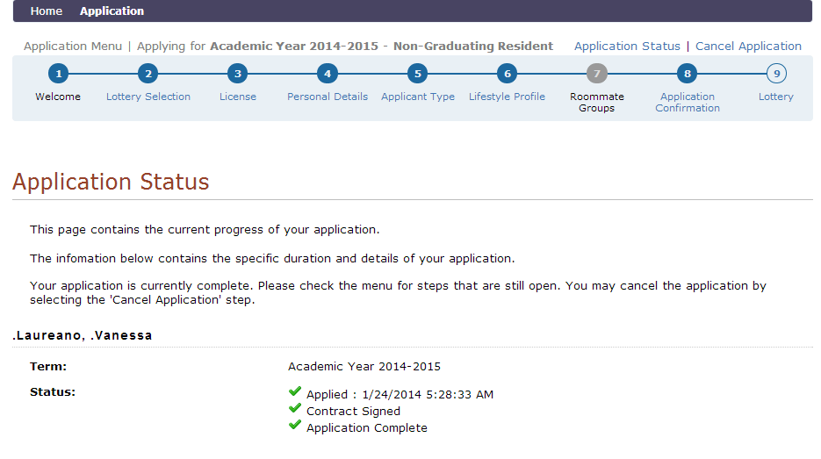

- Once your designated date and timeslot are available, you may enter the Phase II by clicking the Individual Lottery.

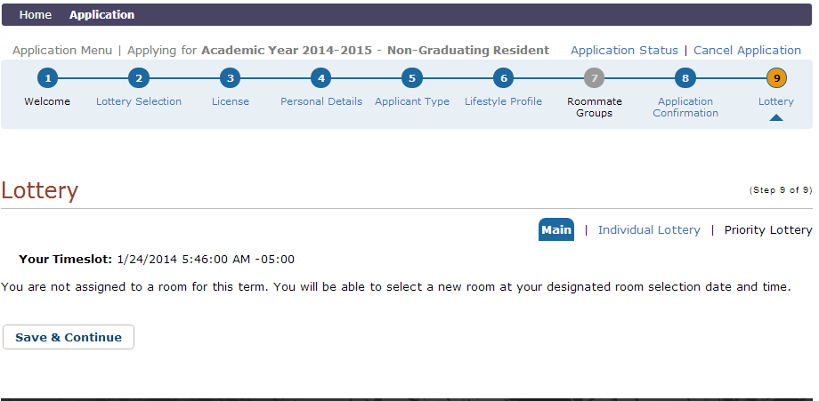

- Next select the building you would like to view.

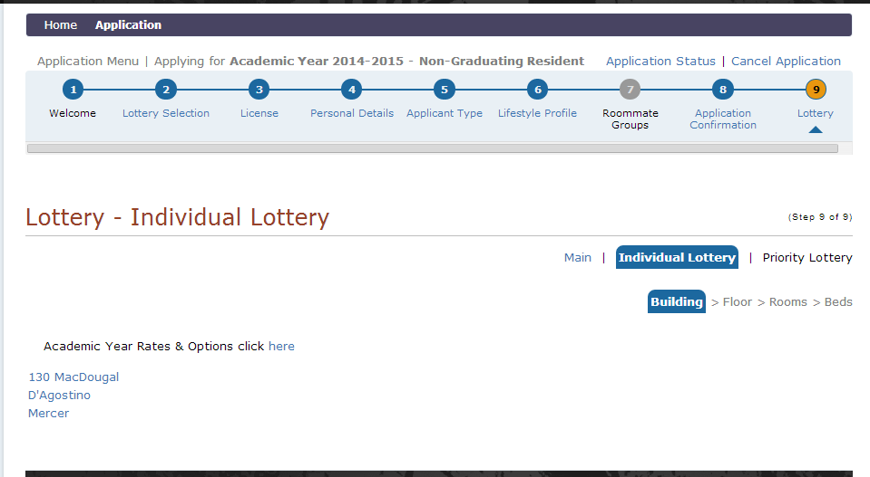

- The following are a list of available selections.
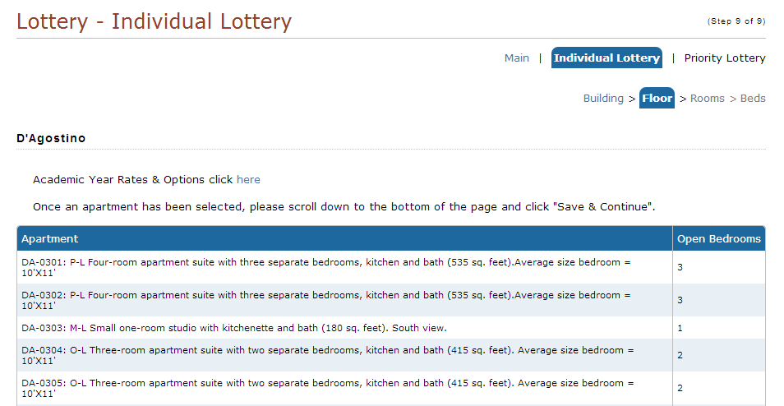

- You can now select the floor/apartment number you would like to view. Click on the apartment and click Save and Continue.

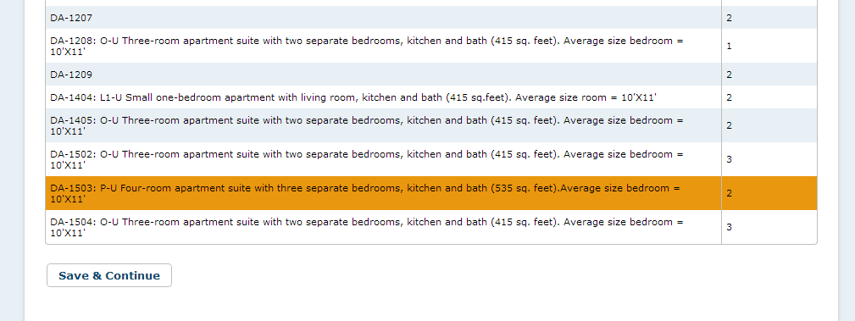

- You can now view the floor plan and select a room within the apartment. You may continue going back and forth within you timeslot until you are ready to select your assignment. Once a room has been released it will go back into the pool of available apartments. When you are ready to continue with your selection click Save and Continue.
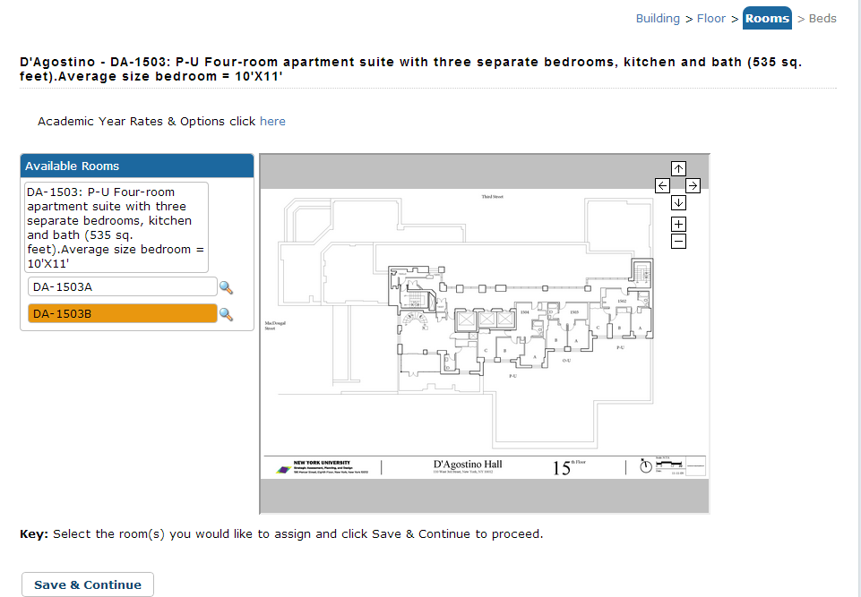
- To reserve your selection click Reserve Beds.

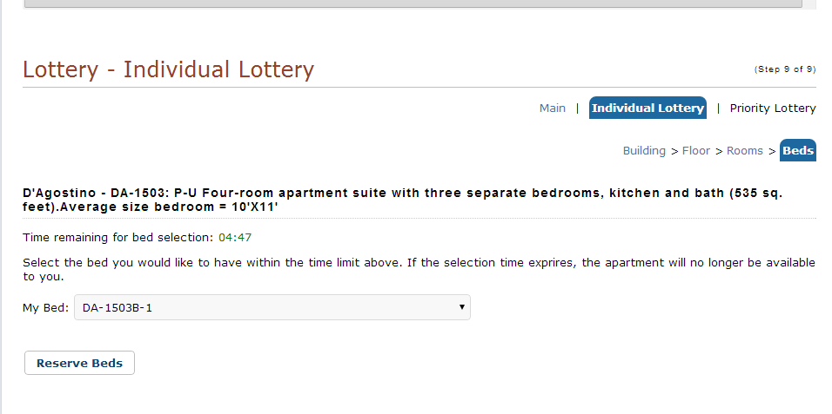

- You can review your selection before confirming.

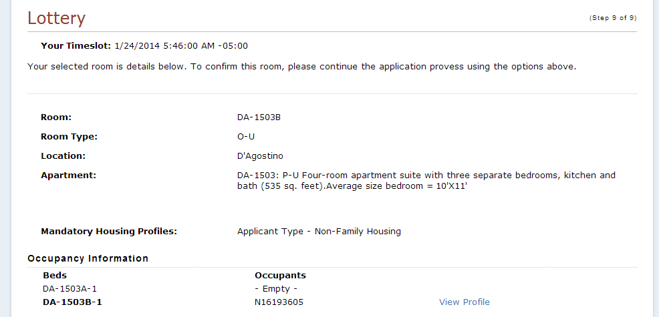

- You may not change your selection beyond this point. To confirm your assignment click Save and Continue.

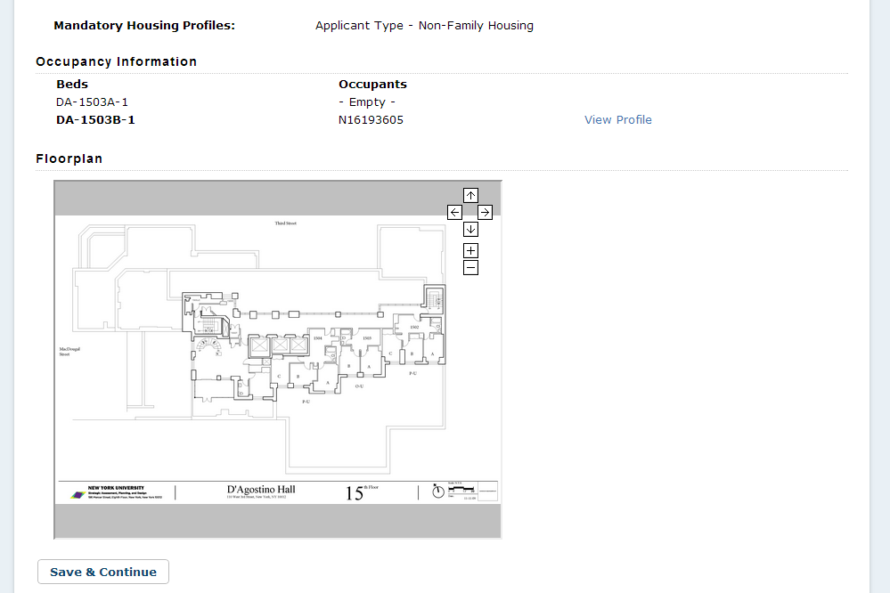

- You have now completed Phase II and no further action is required.

