AMC Conference – Friday, April 11, 2008
NYU School of Law Map of Buildings

1 Vanderbilt Hall
40 Washington Square South
Greenberg Lounge – 1st floor

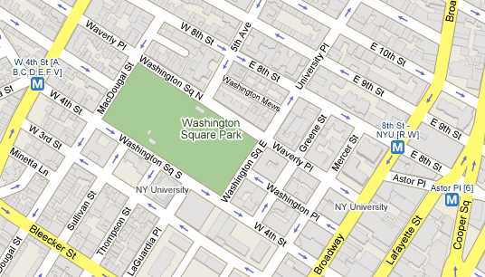
1

2

2 D'Agostino Hall
108 West Third Street
Lipton Hall

