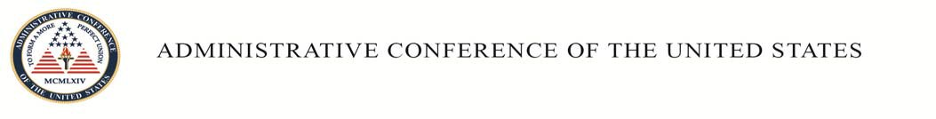

THE WILLIAMS FELLOWSHIP

The Administrative Conference of the United States (Conference) is accepting applications from graduating or recently graduated students of the University of Pennsylvania Law School (Penn) and New York University School of Law (NYU) to serve as a Williams Fellow for a one-year period beginning in September 2016. Named after the Conference’s first Chairman, Jerre Williams, the fellowship is especially well-suited to aspiring academics in administrative law.

THE CONFERENCE

The Conference is an executive branch agency whose principal mission is to recommend empirically based improvements to administrative procedure and related matters to the President, federal agencies, Congress, and the federal judiciary. The Conference also assists individual agencies in improving administrative programs, publishes sourcebooks of enormous value both to the government and public, and provides nonpartisan advice to other agencies and Congress. Most of the research for the Conference is conducted by distinguished academics in law and related disciplines. For additional information about the Conference, please visit www.acus.gov.

JOB DUTIES

Much of the fellow’s time will be devoted to researching and writing at least one substantial report, under the guidance of the Conference’s staff, on an agreed-upon topic designed to support a formal Conference recommendation. The fellow will be encouraged to submit his or her final report for publication. (For a list of reports prepared for the Conference that have been published, please visit www.acus.gov/publication/bibliography.)

Fellows will also be asked to assist the Conference’s attorney advisors in various aspects of their work. Specific functions may include identifying appropriate subjects for reports and recommendations through extensive research and analysis; working with outside consultants in preparing reports and recommendations; supporting the Conference’s committees; preparing workshops and similar events; presenting research findings to the Conference’s members; speaking at meetings of the Conference, professional associations, and law schools about Conference work; and assisting with the implementation of Conference recommendations.

QUALIFICATIONS

An applicant must hold (or expect to receive this spring) a J.D. from Penn or NYU, possess outstanding analytical and writing abilities, and work well with others in a collaborative environment. A strong background in administrative law and related subjects is preferred.

Williams Fellowship
Page 2

Recent graduates who have completed a judicial clerkship or have other equivalent experience are encouraged to apply.

TERMS OF FELLOWSHIP

The fellow will be appointed as a temporary employee of the Conference for a period not to exceed one year. He or she will be paid at the level of a GS 9/1, the current salary for which is
$52,668. Except for sick and annual leave, the fellow will not receive any benefits. The fellow will receive a stipend from either Penn or NYU to help cover the cost of healthcare insurance. For additional information about the stipend, please contact Christine Councill Fritton (in the case of Penn students/graduates) or Lisa Hoyes (in the case of NYU students/graduates).

APPLICATIONS

An applicant should submit a cover letter, law school transcript, resume or CV, writing sample, and a list of references. The cover letter should identify the date on which the applicant is available to begin and include a brief statement of his or her qualifications and research interests. The applicant should also have at least one letter of reference submitted on his/her behalf.

An applicant should email the above-requested materials, except for the letter(s) of reference, to the Conference’s Executive Director, Matthew Lee Wiener, at info@acus.gov (preferably as a single PDF file). “Williams Fellowship” should appear in the subject line of the email. Letters of recommendation should be emailed directly by their senders to the same address. Both “Williams Fellowship” and the name of the applicant should appear in the subject line of the email.

The deadline for the submission of applications is February 5, 2016.

Questions about the submission of the applications should be addressed to Gabrielle Guy at gguy@acus.gov.

[December 7, 2015]

